i ne urnciai ^uDiication or alua—An international Association ot Security Professionals

|  |  |
| --- | --- |
|  |  |
|  | ===3 |

PLUS!

The Caluary Gun Safe,

R Bad Decision by Thomas Stern,  
Reason uihy NOT to yo to class,  
and More!

***************5CW *3.DIGI*T 303 Breck H. Camp CML POBox47070 Atlanta GA 30362-0070

liillillimilliilliMilillliiillmliiilHmliiilllimilill

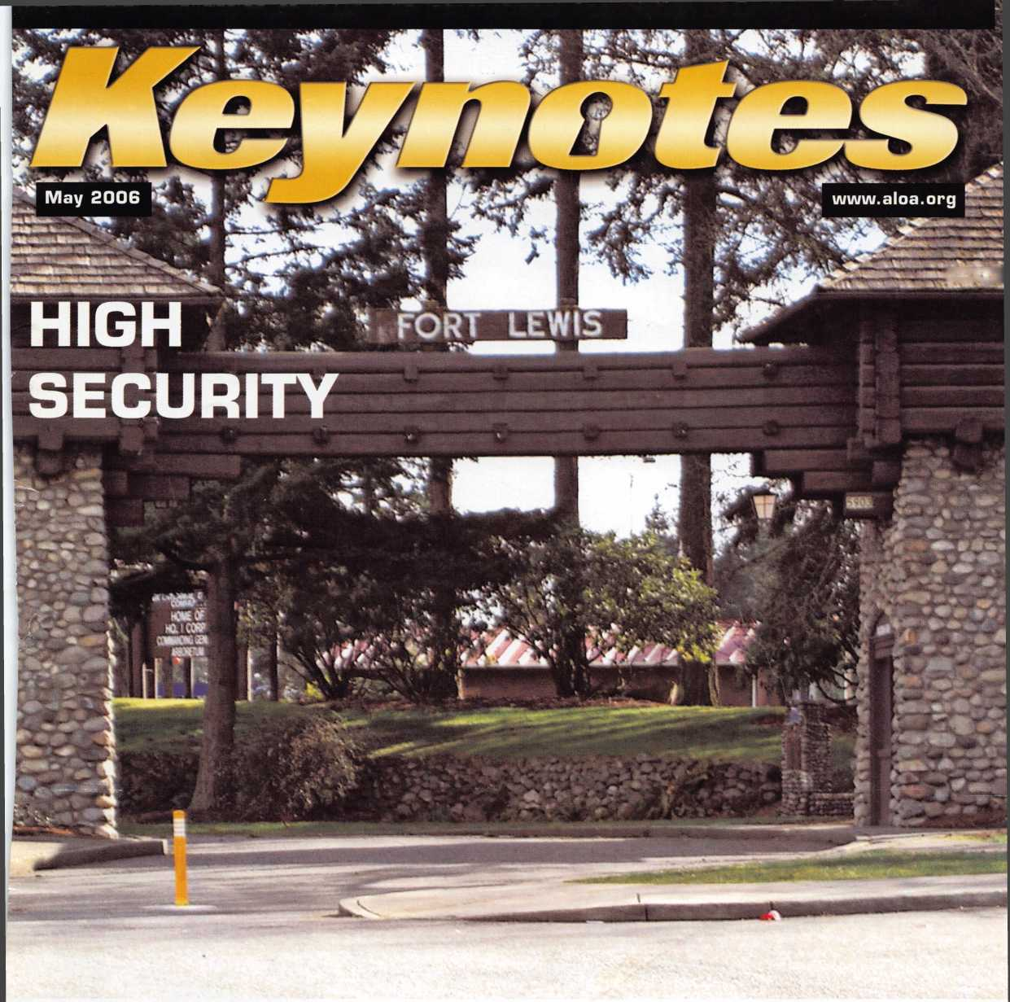

OUR STAND

IT’S QUITE POSSIBLY YOUR MOST

**TRUSTED SIDEKICK.**

Keep it in Good Hands® with Allstate.

You’re in good hands.

Subject to availability and qualified Company, Bridgewater, NJ.The *'Cu]S

ook, IL. Allstate County Mutual Insurance Company, Irving, TX. Allstate New Jersey Insurance nark of Allstate Insurance Company. ©2005 Allstate Insurance Company, Northbrook, IL.

As a small business owner, there are few things you rely on more than your vehicle to keep you going. Your local Allstate agent can help protect it and your small business with services you need including

quick certificates of insurance, ID cards, assistance with the claims process, and more. All from one of the most widely recognized names in the business.

Are you in Good Hands®?

1-800-859-0247

CALL NOW TO LOCATE YOUR NEARBY ALLSTATE AGENT.

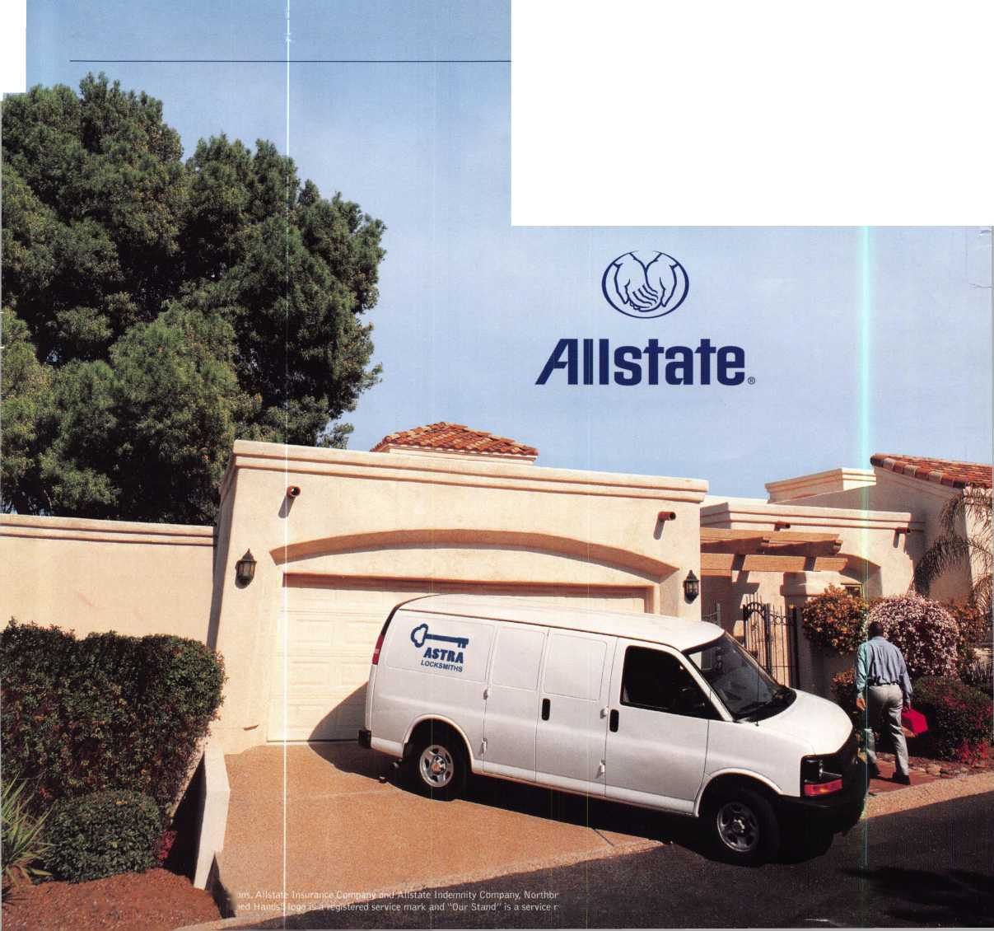

A Name You Know

As a business owner, you know the importance of a good name. Your name is your reputation. Your name stands for all that you offer in products and services. It’s a symbol of who you are. So, we thought you might like to know that Allstate, the name you know for insuring your personal vehicle and your home, also offers a business auto policy to help protect vehi­cles used in your locksmith business.

The following are coverages typically included in our business auto policy that might be important to you as a business owner:

Business Auto Liability coverage

* Higher limits up to $2,000,000 per occur­rence.
* Protects you if you are legally responsible for injuries and damages arising out of the ownership, maintenance, or use of business vehicles.
* Cost is based on several factors, including garage location, type and use of vehicle, and the violation and accident activity of your drivers.
* Additional Insured coverage may be required when you contract with govern­mental agencies or bid on local commercial jobs.
* Generally not available on a personal auto policy.
* Usually is no charge to add an insured to a Commercial Auto policy.

Hired Auto coverage

* Provides liability coverage for those vehicles you rent, hire or borrow for business use.
* The premium for hired auto liability coverage is based on the estimated annual rental cost.
* Tools and Special Equipment
* Provides protection to permanently attached equipment on your vehicle.
* You will need to let your agent know the value of the equipment to include in the cost of the vehicle.

You’re good at your business. Your insurance com­pany should be the same way.

Contact an Allstate agent to discuss your business auto insurance needs. To be referred to an agent, please call 800.859.0247 or email [abisO@allstate.com](mailto:abisO@allstate.com).

Subject to availability and qualifications. Insurance coverage is subject to policy terms.

Allstate Insurance Company

Allstate Indemnity Company Northbrook, IL

Allstate County Mutual Insurance Company Irving, TX

Allstate New Jersey Insurance Company Bridgewater, NJ

allstate.com

© 2005 Allstate Insurance Company, Northbrook, IL

*mmm*

**Get what s  
Coming To You**

ALOA continues to provide you with this and other great benefits and services!

Need information in a hurry?

Use ALOA’s Fax On Demand service.

Just call 310-575-5027 and receive:

1. ALOA Index of Documents (1 pg)
2. Reasons to Join ALOA (2 pg)
3. Locksmith Career Summary (3 pgs)
4. Locksmith School List (1 pg)
5. ACE Class Schedule (1 pg)
6. Certification Information (5 pgs)
7. PRP Category List (1 pg)
8. ALOA Membership Application (1 pg)
9. ALOA List of Benefits (1 pg)
10. ASF Scholarship Application (1 pg)
11. ASF Scholarship Information (1 pg)
12. ALOA Video Library Order Form (1 pg)
13. Safe & Vault Technicians Association Membership

Application/Subscription Form (2 pgs)

1. Recertification Information (4 pgs)
2. Legislation Action Network Newsletter (2 pgs)
3. Various State Law Issues (8 pgs)
4. Industry Position Paper (1 pg)
5. ALOA Convention Class Schedule (3 pgs)
6. ALOA Convention Class Descriptions (30 pgs)
7. ALOA Convention Registration Forms (4 pgs)
8. Board of Directors Nomination Form (2 pgs)
9. ALOA Company Membership Application (2 pgs)

310-515-5021

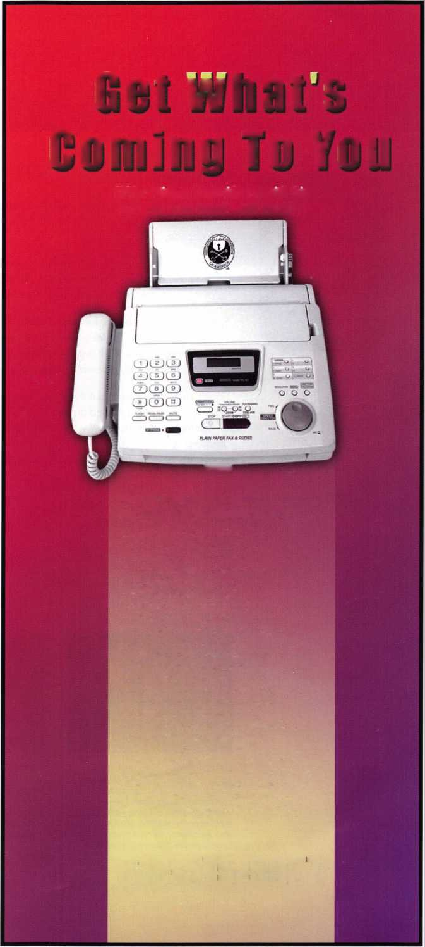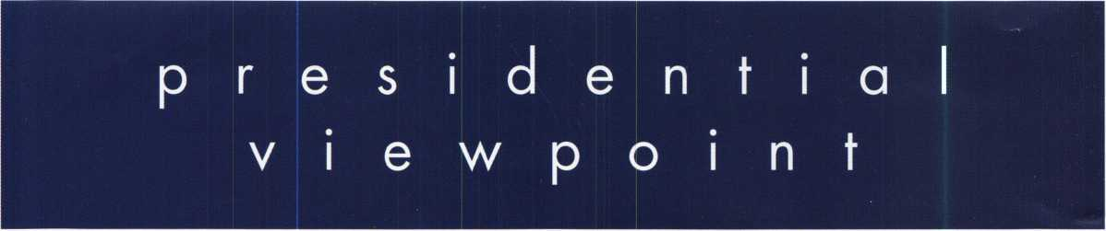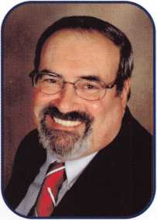

Dear Members,

First, let me congratulate both newly elected and re-elected incumbent directors. Your commitment is what makes ALOA the vibrant association that it is. The next few years should prove exciting as we move into our sixth decade.

One of the items that the current Board is working on, is to ensure that our web presence is the finest we can have. I have appointed a committee to investigate our options and convey the information to the Board. In today's world, the web plays a major role in communication and ALOA needs to be at the forefront.

Speaking of our web site, be sure to check out the new LAN site. Kudos to Tim McMullen and the Legisla­tive Action Network. This new feature will allow us to be pro-active both as members and an association in the legislative community. It is great to have Tim back, helping us find or way through the governmental maze and haze at the local, national and global levels.

I don't know about you, but the closer we get to this year's convention, the more excited I get. There are many special events planned around our Fiftieth Anniversary. If the educational opprtunities among the class­es, seminars and trade show weren't enough, the friendships and memories made among our members and attendees will last a lifetime. It's all happening in Las Vegas this year. If you haven't as yet made your plans, what are you waiting for? Come by car, train or plane. Go home in a '56 T-Bird. Well, someone will, why not you? See you there!

Take 'er easy!

Sincerely,



Robert E. Mock

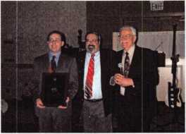

MARCH 2006:

ALOA President, Rober Mock (center), presents a plaque to the Master Locksmiths Association of New Jersey’s President, David Rible, CPL (left), honoring the 75th anniversary of their association as Nick Ambrosi, CPL, Entertainment Committee Chairman looks on.

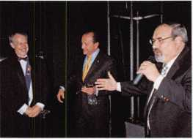

APRIL 8, 2006:

ALOA President Robert Mock (right) presents Dave O’Toole (left) President of ERSI (Esperti Riferme Serrature Italia - The Italian Locksmith Association) with gavels as symbols of friendship and cooperation.

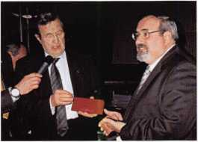

APRIL 8, 2006:

Secretary of ESRI, Dario Casiraghi (left), presents Robert Mock with a hand engraved key in recognition of making Mr. Mock and Honorary Member of ESRI.

Keynotes

June 2006

*mmm*

SCHLAGE

**CAL-ROYAL**

DOR-O-MATIC

j«uffliM(r<2«TX

CHICAGO

**MONARCH**

LCN

Cbm&C

**VisalocK**

OLYMPUS^

Cbm^CL0 CK-'NC.

FORT

ASSA Com®C

NORTO

TIMBERLINE

**SARGENT**

DON-JO

ylRROW

**VON DUPRIN**

**LOOKER AFT gg**

BLANCHI

I LABI MAJOR

**PROL.OK**

*ff^s^rR utcLn.*

l *locksmith Toon MM*

*hat asmai /Inn SB D*

*W& Wedfeay-'*

**LOCKNETICS**

**@m COBRA**

CO.~—BOOTH# 331& 431

Name

E CO. BOOT

Orders placed at the show can enter you into daily  
drawings to win Handheld TVs, 15” LCD TV w/ DVD  
combo, & other great prizes for home & shop.

***ACCESS COOTOOl***

***AUTOMOTIVE Jet***

3 **BIMIHDH** **LOCKCRAFT^**

" ***DETERMINATOR***

*MAJOR HAT A*

P^O-LOK

*Wed#&c&\**

*Peterson*

*locksmith Tools*

**VIV**4 **LAS VEGAS**

**ALOA 50th Anniversary | Convention & Security Expo 4 JULY 9th- 16th. 2006 ° '**

**VBsdtl (tone IH.IL. roafce C<D. [ %% ■§$**

**@ BOOTH #9s 3311 & 4311 4**

Bring this ticket by our booth for a chance to win a SONY DSC-T5 5.1- megapixel digital camera, t

Turn in tickets by 4PM Friday at the show. Drawing held @ 4PM

***LOG ON TO...***

[WWW.HIFIMKE](http://WWW.HIFIMKE). com

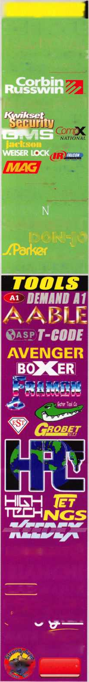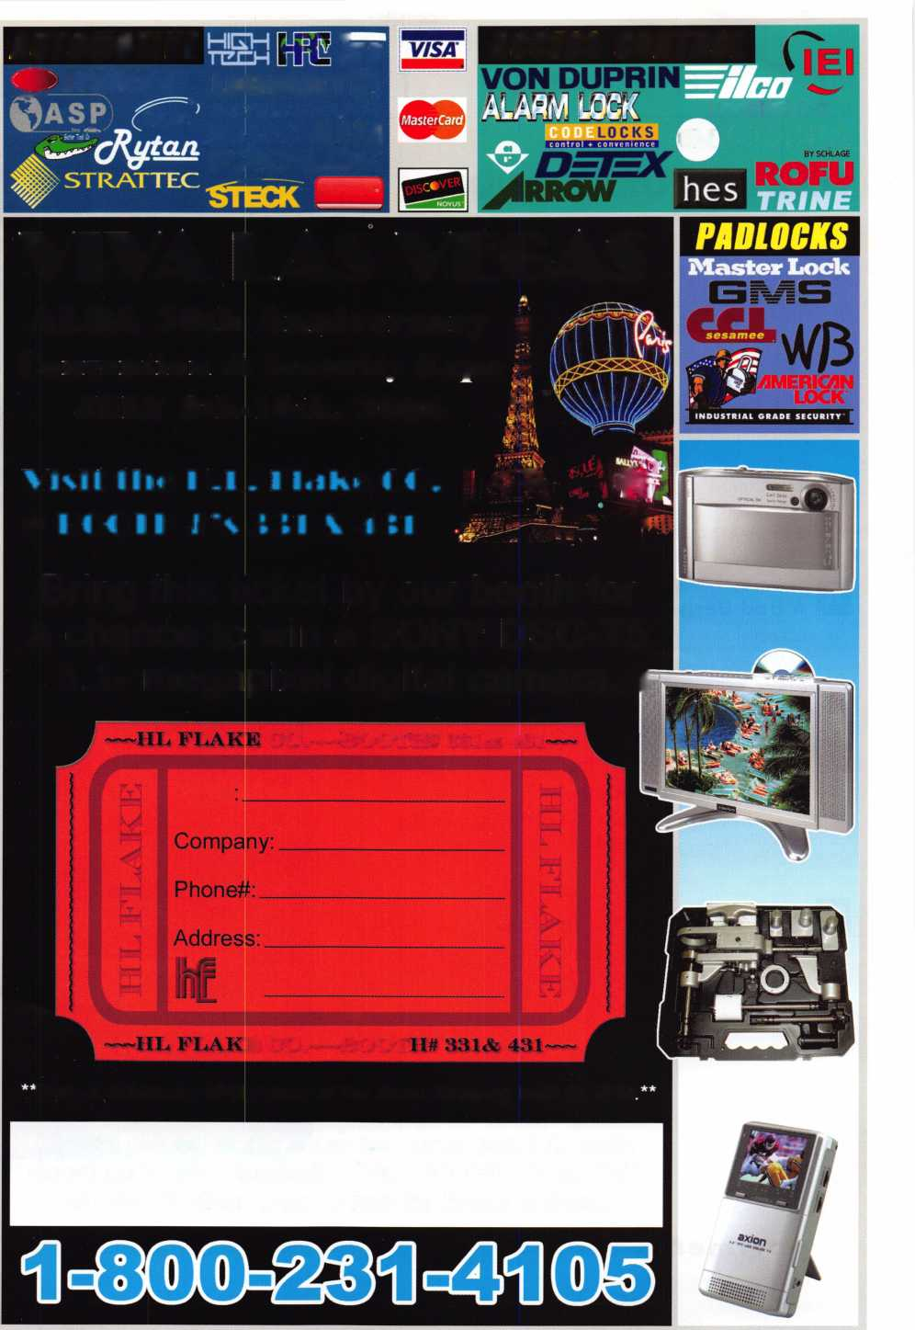

f

e

a

t

u

**res**

HIGH SECURITY 2006

10

Kaba Outfits the U.S. Army

Find out how Kaba Access Controls E-Plex 5000 is a rugged, powerful solution for todays Army.

**14**

The Calvary Gun Safe

Just because the outside looks right doesn't mean the inside is right. See how Sun Welding has redesigned their Calvary gun safes with minimal visible signs from the outside.

by Greg Perry, CML, CPS

20

A Bad Decision

40 bullet holes triggers Thomas Stern to recall memories from being a young police officer.

by Thomas Stern

22

Style & Security at the Milwaukee Art Museum

Read what happens when style and security meet at one of Milwaukee's most prestigious art museums.

**24**

I Can't Afford to Go to Class

Find out why you can't afford NOT to go to one of a variety of classes that are designed for any level of locksmith.

|  |  |  |  |
| --- | --- | --- | --- |
| r |  |  |  |
| AD INDEX | |  |  |
| Allstate | Inside Front Cover | |  |
| Fax on Demand |  | 1 |  |
| HL Flake |  | 3 |  |
| ALOA 2006 |  | 5 |  |
| KABA |  | 11 |  |
| Pacific Lock |  | 13 |  |
| Door King |  | 15 |  |
| INKAS |  | 17 |  |
| ALOA Open |  | 18 |  |
| Safetech 2007 |  | 19 |  |
| Clearstar |  | 21 |  |
| PBP |  | 21 |  |
| Fink Safe & Lock |  | 21 |  |
| IR |  | 23 |  |
| Compx |  | 25 |  |
| Powermate |  | 25 |  |
| Alarm Controls |  | 31 |  |
| Harry C. Miller Book |  | 33 |  |
| Jameson Code |  | 35 |  |
| CCL |  | 37 |  |
| John Koons Locksmiths .... |  | 42 |  |
| A&B |  | 42 |  |
| Turn 10 |  | 42 |  |
| Ultralift |  | 43 |  |
| ASSA | Inside Back Cover | |  |
| L |  |  | A |

**Departments**

|  |  |  |  |  |  |
| --- | --- | --- | --- | --- | --- |
| Presidential Viewpoint | Executive  o  Applicants . | | 7  8 | Calendar...  Core | 6 Classified 36 Legislative 40  9 Associate  Members 38 |
|  | Visit c | ) u r | NEW | w e b s i | ite at [www.aloa.org](http://www.aloa.org) |



Classic 1956 Thunderbird!

sponsored by:

(fit- SSSilSSL

[www.fireking.com](http://www.fireking.com)



SECURITY PRODUCTS

**One Lucky Member Attendee at ALOA 2006 is going home with  
this gorgeous mint-condition 1956 Ford Thunderbird.**

**A ticket will be given to each ALOA Member who registers and attends the  
show. Someone has to win it, and it might as well be YOU!**

**(Must be present to win. Board Members, Exhibitors, Employees,  
Family Members of Employees, and nonmembers are not eligible**

**for this door prize.)**

**u p c o m**

events

i n g



o

D

<

|  |  |
| --- | --- |
| 10 El Horton Memorial Auction Saturday, 11:00 a.m.  Cherokee, IA  Contact: Mark Horton 712-225 | 11 North Jersey Master Locksmith Assc. 6/29-7/2 BILS  12th Annual Flea Market (Busan Intmatl Locks & Security Festival)  Sunday, 9am - 1 pm Pusan, South Korea  3342 Contact: Jeff Sitar 973-777-0620 Contact: Mr. Andrew Song 82118009979  or Pete Sarailian 201-944-7547 |
|  | |
| 7/8-16 Associated Locksmiths of ALOA 50th Annual Conve Las Vegas, NV  Contact: 800-532-2562 c | ntion & Security Expo  r visit [www.aloa.org](http://www.aloa.org) |
|  |  |
|  |  |

|  |  |  |
| --- | --- | --- |
| Jr | 9/15-16 Doyle Security Products  20th Annual Trade Show & Educational Weekend | Z |
| 0l  iii | Minneapolis, MN | o |
| </) | Contact: Chantelle Gallagher | o  V) |
|  | 800-333-6953 |

UPCOMING ACE CLASSES UPCOMING PRP SITTINGS

6/8/2006

6/17/2006

6/24/2006

7/8-16/2006

8/9/2006

8/18-19/2006

8/21-26/2006

9/15/2006

Reno, Nevada • ACE Classes Clark Security Products Contact: Joan Emrick 619-718-7308

Charlottesville, VA • ACE Classes Virginian locksmiths Association Contact: Troy Miller, CMl 434-823-5991

Rogers, Arkansas • ACE Classes AlOA Education Contact: AlOA Education [education@aloa.org](mailto:education@aloa.org) 800-532-2562 x104

las Vegas, Nevada • ACE Classes

AlOA 50th Annual Convention & Security Expo

Contact: AlOA Education

[education@aloa.org](mailto:education@aloa.org)

[www.aloa.org](http://www.aloa.org)

Orlando, Florida • ACE Classes Clark Security Products Contact: Joan Emrick 619-718-7308

Birmingham, Alabama • ACE Classes Alabama Locksmith's Association Contact: Dallas Brooks [dallas287@charter.net](mailto:dallas287@charter.net) 334-826-8990

Dallas, Texas • ACE Classes Associated Locksmiths of America Contact: ALOA Education [education@aloa.org](mailto:education@aloa.org) 800-532-2562x104

Minneapolis, Minnesota • ACE Classes Doyle Security Products Trade Show Contact: Chantelle Gallagher 800-333-6953

|  |  |
| --- | --- |
| 6/08/2006 | Thursday 9:00 am • Dallas, TX • ALOA  Mayra Ocon 800-532-2562 x203 |
| 6/11/2006 | Sunday 8:00 am • Sparks, NV • Clark Security  Joan Emrick 619-718-7308 |
| 6/17/2006 | Saturday 8:00 am • Montgomery, AL • Alabama Locksmiths Assc. Dallas C. Brooks 334-826-8990 |
| 6/17/2006 | Saturday 1:00 pm • Tampa, FL • Florida West Coast Locksmith  Ken Kupferman, CPS 813-232-7600 |
| 7/13/2006 | Thursday 6:00 pm • Las Vegas, NV • ALOA 2006  Mayra Ocon 800-532-2562 x203 |
| 8/6/2006 | Sunday 8:00 am • Orlando, FL • Clark Security Products  Joan Emrick 619-718-7308 |
| 8/20/2006 | Sunday 9:00 am • Toledo, OH • McElheney Locksmith Inc.  Mike McElheney, CPL 419-244-5851 |
| 8/20/2006 | Sunday 8:00 am • Oklahoma City, OK • Oklahoma Master Locksmith Mike McGrew, CRL 918-333-9136 |
| 8/26/2006 | Saturday 3:00 pm * Dallas, TX * ALOA  Mayra Ocon 800-532-2562 x203 |
| 9/7/2006 | Saturday 9:00 am • Dallas, TX • ALOA  Mayra Ocon 800-532-2562 x203 |

Contact the ALOA Education Department for a list of classes and training offered in-house.

**executive**

Volume 52, Issue 6

Additional contact information for the ALOA Board and most Keynotes authors is  
available through "Locksmith Search" on the ALOA Web site- [www.aloa.org](http://www.aloa.org) or by  
contacting the ALOA office at 3500 Easy Street; Dallas, TX 75247; (800)532-2562;

FAX (214)819-9736; e-mail [aloa@aloa.org](mailto:aloa@aloa.org).

Editor

Betty Southerland [betty@aloa.org](mailto:betty@aloa.org)

Advertising Sales

Kim Hammond voice: 817-645-6778

Fax: 817-645-7599  
e-mail: [adsales@aloa.org](mailto:adsales@aloa.org)

Executive Director

Charles W. Gibson, Jr., CAE [charlie@aloa.org](mailto:charlie@aloa.org)

Associate Executive Director

David Lowell, CML, CMST [david@aloa.org](mailto:david@aloa.org)

Convention & Meetings Manager

Jo Anne Mims [joanne@aloa.org](mailto:joanne@aloa.org)

Operations/Membership Manager

Mary May [mary@aloa.org](mailto:mary@aloa.org)

Director of Creative Services

Betty Southerland [betty@aloa.org](mailto:betty@aloa.org)

Director of IT Operations

Greg K. Jackson [greg@aloa.org](mailto:greg@aloa.org)

Contributors

Jerome Andrews, CML Ray D'Adamo, CML

Paul Chandler, CRL Billy Edwards, CML

Claire Cohen, CML Dan Graffeo, CRL,CMST

Brian Costley, CML, CMST Jim Hancock, CPL

Eric Costley, CRL Jeff Nunberg, CML, CMST

Mission Statement: The Associated Locksmiths of America, Inc. is dedicated to enhancing the professionalism, education and ethics among locksmiths and those in related sectors of the physical security industry. With approximately 10,000 members in the United States, Canada and the freeworld, ALOA is poised to help members obtain the knowledge, the strength, and the confidence to perform their role in the physical security field with pride and dignity. But it is only through active involvement and participation that ALOA can fully achieve its potential—and can help members to achieve theirs.

Policies: Keynotes® is the official publication of the Associated Locksmiths of America, Inc. (ALOA). Keynotes9 acts as a moderator without approving, disapproving, or guaranteeing the validity or accuracy of any data, claim, or opinion appearing under a byline or obtained or quoted from an acknowl­edged source. The opinions expressed by the authors do not necessarily reflect the official views of ALOA. Also, appearance of advertisements and new products or service information does not constitute an endorsement of products or services featured by the Association. The Association does not accept responsibility for the inaccuracy of any data, claim, or opinion appearing in this publication, due to typographical errors on the part of the authors, Association staff or its agents.

Editor's Note: This publication is designed to provide accurate and authoritative information in regard to the subject matter covered. It is provided and disseminated with the understanding that the publisher is not engaged in rendering legal or other professional services. If legal advice and other expert assistance is required, the services of a competent professional should be sought.

Authors' Payment: Payment for eligible submissions to Keynotes will be based on the following criteria: topic, time spent and past contributions. Authors who regularly submit to Keynotes9 are generally paid a higher rate. The latter is especially true of authors who write to fit specific editorial needs and submit said copy by Keynotes® deadlines. As a general guideline: Average payment for a 750 word, business or 'light' technical article would be $200. Payment for a 1500 word article involving significantly higher time and research efforts would be $400.

Payment will not be offered for articles submitted by ALOA employees or members of the ALOA Board of Directors (unless material is of a technical nature), nor for articles submitted by a company that promote that company's products or services. ALOA reserves the right not to pay for articles sub­mitted by an individual(s) that promote a particular company's products or services.

Disclaimer: The Associated Locksmiths of America, Inc., (ALOA), reserves the right to refuse any article for any reason. Additionally, ALOA reserves the right to edit, amend or modify any article submitted for publication in order to preserve technical accuracy, clarity, fairness or grammatical cor­rectness. ALOA will make the best efforts to notify the author of any changes. The extent of ALOA's liability for any article or information contained therein will be a notice of correction or retraction in the next possible issue.

Keynotes® (ISSN 0277 0792) is published monthly except for the combined June/July issue by The Associated Locksmiths of America, Inc., 3500 Easy St., Dallas, TX 75247-6416. Telephone: (214) 819-9733; FAX (214) 819-9736; e-mail [aloa@aloa.org](mailto:aloa@aloa.org). Subscription rates for members—$15.00 per year. Periodical class postage paid at Dallas, Texas. POSTMASTER: Send address changes to: Keynotes, 3500 Easy St., Dallas, TX 75247-6416. © Copyright 2003, All rights reserved. No part of the contents may be reproduced or reprinted in any form without prior written permission of the publisher.

Comptroller Kathy J. Romo

Membership Coordinator Shelly Jett

Convention & Meetings Assistant Karen Lyons PRF’/Education Coordinator Mayra Ocon

Mail Room Coordinator Kevin Wesley

Creative Media Specialist Margarita Garza

Accounting Coordinator Joyce Nixon

Executive Assistant Sue Langford

Assistant Education Manager Bob Stafford

Legislation Manager Tim McMullen

Receptionist Shelley Melton

Randy Simpson, CML, CPP Tom Seroogy Robert Stafford, CML Charles Stephenson, CPS

Dave Thielen, CML Dennis Watanabe, CML, CMST

Greg Perry, CML,CPS



President

Robert Mock  
(856) 863-0710  
president@aioa. org

Secretary

John Soderland, CML, CAAST

(414) 327-5625  
secreta ry@aloa. org

Directors, Northeast

Peter Sarailian, CRL  
(201) 944-7547  
nedi rector@a loa. org

Vernon Kelley, CPL

1. 771-3126 ned i rector@a loa. org

Directors, Southeast

Tom Gillingham, Jr., CML, CPS  
(615) 264-0747  
sedirector@aloa .org

Ken Kupferman, CML  
(813) 961-5784  
sed i rector@a loa. o rg

Director, North Central

William Smith, RL  
(920) 893-5282

Guy Spinello, RL  
(815) 394-1000  
[ncdtrecfor@aloa.org](mailto:ncdtrecfor@aloa.org)

Director, South Central

CD Lipscomb, CML, CPS  
(903) 874-3522  
sed i recfor@aloa. org

Directors, Southwest

Gordon R. Racine, CML  
(719) 384-4707  
[swdirector@aloa.org](mailto:swdirector@aloa.org)

Julie McCluney, CRL  
(714) 636-5652  
swd i rector@aloa. org

Director, Northwest

Jim Jeffries, CPS

(877) 241-6978

[nwdirector@dfoa.org](mailto:nwdirector@dfoa.org)

Director, European

Hans Mejlshede, CML  
(453) 539-3939  
[eurdirector@aloa.org](mailto:eurdirector@aloa.org)

Director, Asian

Joe J. Lee,: CRL

(215) 289-2404  
[asiandirector@aloa.org](mailto:asiandirector@aloa.org)

Director, Associate

Paul M. Justen  
(612) 238-4646  
asdi rector@a loa. org

Trustees

[trustees@aloa.org](mailto:trustees@aloa.org)

Randy Simpson, CML  
(281) 240-5959

JohnJ. Greenan, CML, CPS  
(773) 486.2030

William Young, CML, CPS

1. 647-5042

Past Presidents

2003-2005 William Young, CML, CPS  
2001-2003 Randy Simpson, CML  
1999-2001 John Greenan, CML, CPS  
1997-1999 Dallas C. Brooks  
1995-1997 David Lowell, CML, CMST  
1993-1995 BreckCamp, CML  
1991-1993 Henry Printz, CML  
1989-1991 Evelyn Wersonick, CML, CPS  
1987-1989 Leonard Passarelfo, CPL  
1985-1987 Joe Jackman, CML  
1983-1985 Stanley Haney, CPL  
1981-1983 Louis LaGreco, CPL  
1979-1981 John Kerr, RL  
1977-1979 Clifford Cox, CML  
1974-1977 Charles Hefherington  
1972-1974 Gene Laughridge  
1970-1972 William Dutcher, RL  
1968-1970 Constant Maffey, RL  
1966-1968 Harold Edelstein, RL  
1964-1966 William Meacham  
1962-1964 Robert Rackliffe, CPL  
1960-1962 Edwin Toepfer, RL  
1956-1960 Ernest Johannesen

Keynotes • June 2006



Montgomery

Gerrard F. Watts

Thorsby

Gerrard F. Watts

Sponsor: Danny W. Rudd CPL

Forrest City

Wayde E. Thomas

Sedona

Dan Wills

Sponsor: Milton R. Thompson CML

El Centro

Thomas R. Curtis

San Juan Capistrano

Robert J. Swadish

Santa Clara

Ali Sharifi

Sponsor: Robert J. Reynolds CRL, CPS West Hollywood

Marcel Itzhak

Sponsor: Ronnie Haim

*CO*

Colorado Springs

James W. Wright

Sponsor: Randy J. Harrell Greeley

Edward J. Steffins

FL

Coral Springs

Bruce A. Lawner Robert R. Lambert

Miami

David Gonzalez

Miami Lakes

Andres Curbelo

Vero Beach

Brad R. Volpe

GA

Cedartown

Pamela Vice



Loves Park

Duane A. Parks Jr

Sponsor: Somphou Sengbounouvong North Chicago

Robert L. Harnden CRL

IN

Indianapolis

Karen Maples

Kansas City

Adam Hines

Sponsor: Jim Peters

KY

Louisville

Stephen Tinnell

Jefferson

Lori A. Stone

Sponsor: Diane M. Foto CRL

Imp

Baltimore

John D. Phillips CRL

Sponsor: Michael E. Jordan Jr, GVIL Suitland

Calbert Brathwaite

Ml

Farmington

Robert Kowalkowski

NJ

Hackensack

William A. Ferraro CR

Sponsor: Dan Shnaider CRL Paterson

Jean R. Wiart

Sponsor: Charles E. Batcke CRL, CPS Phillipsburg

William Timmann CML

Sponsor: Peter Sarailian CRL

SC

Anderson

George Griffin

Sponsor: Becky H. Griffin Columbia

Randy Ramsey

Sponsor: Ray A. Iglesias CPL

TN

Knoxville

Vance A. Carney Sponsor: Robert D. Butler

Robert J. Maloney Sr Berlon D. Williams Jr

UT

Salt Lake City

Ron R. Firneno

Taylorsville

Kameron K. Howell

VA

Annandale

Walter I. Moreno

Sponsor Tony J. Ashley CRL Harrisonburg

Christopher Curry

Sponsor. Derwin C. Sulph in CRL Richmond

Warren Curley

Sponsor Frank P McGrath CRL Woodbridge

Michael T. llttaro

WA

Federal Way

Andrea M. Stevenson-Jones

Belgium

Brussels

Johan Menu

.NS

Oxford

James W. Simpson R Stephen L. Simpson

Sponsor Robert J Simpson

ON

Ottawa

Harold W. Curley

Sponsor Claude-Guy Dionne

|Penmark

Copenhagen N

Brian DeBlanck

Sponsor Hens MejlshedeCML

Lehna N. Jensen

Sponsor Hans MejlshedeCML

Herds Johansen

Sponsor Hans MejlshedeCML

Jeanette E. Anderson

Sponsor Hans MejlshedeCML Fnederiksberg

Anders S. Jensen

Sponsor Hans MejlshedeCML Herlev

Stig Johan Nielsen

Sponsor Hans MejlshedeCML Oelsted

Per Vodstrup

Sponsor Hans MejlshedeCML

Christian Sorensen

Sponsor Hans MejlshedeCML

Remon Schjerlund

Sponsor Hans MejlshedeCML Soeborg

Michael Anker

Sponsor Hans MejlshedeCML

Jan Hansen

Sponsor Hans MejlshedeCML

England

Herefordshire

Graham I Skdhom

Sponsor Robert Collins

Grant While

Sponsor Robert Collins

Darren Foreman

Meat Britain

Miton Keynes Lee Nightingde



Central Hong Kong

Fok Siu-Sing

Japan

Kitokyushu-Si,Fukuoko

Tomofumi Okai

These applicants are scheduled for clearance as members of ALOA. The names are published for member review and comment within 30 days of this Keynotes issue date, respectively, to ensure  
applicants meet standards of ALOA's Code of Ethics. Protests, if any, should be addressed to the Membership Department and must be signed. Active Membership applicants (a) have worked in  
the industry two or more years. Allied Membership (AL) applicants are not locksmiths, but work in a security-related field. Apprentice Membership (AP) applicants have worked in the industry less than two years.



Keynotes • June 2006

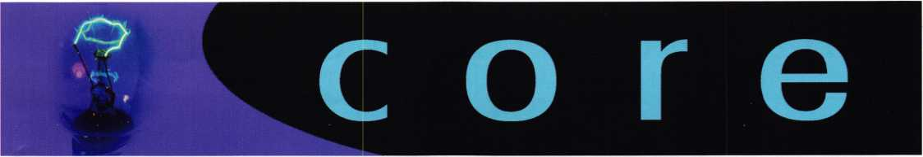

In Memory

Longtime ALOA member Herman Salz passed away.

He has been a member of ALOA since 1973. For years he was active in the Hawaii Chapter. He was 75 years old and died of complications from prostate cancer.

In Memory

Fredrick P. Leimbach, RL died suddenly on April 2, 2006. He joined ALOA in 1958 and missed very few conventions as long as good health was with him. Many people remember Frederick as an instructor at association. Frederick and his wife, Jean, were among the organizers of Penn Ohio Locksmiths Association.

He enjoyed 40 years of locksmithing.

Letter: Legislative Assessment Fee

Editor's Note: The following letter was received from a member who was billed $155.00 for membership. The member refused to pay the Legislative Assessment fee of $25 and sent in a partial payment of $130 on two different occasions. ALOA does not accept partial payments and the check was returned to the member (twice).

$ 155.00 is the 2006 rate for all US members (except Life and Retired).

As per phone conversations with Board Member, Guy Spinello, I am returning the refund dues check #28575 for $130.00 that you sent to me. It is my understanding that the Board will look at this issue and make a determination.

According to a friend, who is a civil rights attorney, if I pay my dues (which I did), I am entitled to all benefits of member­ship unless you have cause.

Dues were paid!

I do have the constitutional right to protest the issue of legisla­tive initiative, which is beyond dues. There are many lobbyists exaggerating their worth, work and need. ALOA does not have one that is seasoned in this arena to serve as a check and balance. ALOA is at the mercy of professional BSer's.

Scary, huh?

Sincerely,

Gilbert Garcia

Editor's Note: The following letter was written in response to Mr. Garcia.

Thank you for your letter of May 10th. I have, again, returned your payment of $130. The bylaws of the Associated Locksmiths of America, Inc., Article III, Section 4 state:

"Membership in the corporation shall automatically terminate whenever a member is ninety (90) days in default of any dues, assessments, [emphasis added] or other financial obliga­tions to the corporation.

The Legislative Assessment created by the Board is in effect for 2006. It has not been reviewed, let alone rescinded by the Board. Therefore, it must be paid for membership to be retained.

Letter: Credit Card Scam

To My Fellow Professionals within our Membership:

The details of a Credit Card scam follow. Hopefully, I can help other fellow ALOA members avoid falling victim to this scam.

Through my company, Brandon Lock & Safe, Inc., of Tampa, I received a call last Friday shortly after noon through the IP Relay Service for the hearing impaired from a gentleman identifying himself (through the operator) as one Mr. Larry Gate, a philan­thropist who wished to donate a safe to Rev. Cecil Jones at an orphanage in Accra, Ghana, West Africa. Mr. Gate stated that he was from New Jersey, en route to Moscow, and that the donation of the safe to the orphanage was "urgent" and that he would appreciate my assistance in coordinating the details of shipment for him.

Initially, "Mr. Gate" ordered a Burglary Safe; but changed his order to an in-floor safe "to save time". I was provided with two MasterCard numbers: one to process for the cost of the safe and the other to process $1,500 for shipping. Mr. Gate stated that he had a freight company that he prefers to work with for "all of his donations" and instructed me to "Western Union" his freight company, Azeteko of Los Angeles, the $1,500.00. He said that "Western Union" was the only form of payment that Azteko would accept for international shipping.

Prior to placing the safe order with the manufacturer, I manually entered the first credit card number into our processing machine and the transaction was immediately approved. Incidentally, both MasterCards shared the identical first twelve numbers and expiration dates... Only the last four digits and the "V-codes" were different.

In the meantime, "Mr. Gate" had called me six more times (each time using the IP Relay Service, which enabled Mr. Gate to pick and choose which questions he wished to answer and did not allow his voice/accent to be heard) and he had e- mailed me twice!

Around 3 PM, my instinct that something was amiss had overtaken me and I starting doing some research. Subsequently, I learned that "Azteko Shipping" of Los Angeles or "Mr. Larry Gate" were not viable through web search engines. However, the name that Mr. Gate had given as the Manager of the Freight company in L.A , did appear... It came up as a "Man Looking for a Man" living in Accra, Ghana!

Further searches revealed that in November, 2005, a Germantown, Tennessee-based specialty advertising manufacturer received an order (also through the use of the IP Relay Service) in the amount of $8,000 for plain T-shirts. The order was placed by Rev. Cecil Jones from Ghana, West Africa, for his "charity orphanage" using two Visa Cards, which both processed, initially, as valid, but were later determined to have been stolen. In this instance, no merchandise was shipped, but the TN manufacturer was charged $450. in processing fees. (He has since changed credit card service companies.) The web site where this information was found also indicates that other Specialty Advertising Distributors had been similarly scammed recently.

Prior to finalizing my daily Credit Card transaction "Settlement", I voided the safe sale. Fortunately, I had not processed the second card for the $1,500. for "freight"; so, I will not have lost anything, other than time, as a result of this episode. In fact, I've learned a few things and I've been reminded to always trust my first instincts.

And, hopefully, through sharing this information, I'll be able to help other ALOA mem­bers avoid unnecessary losses at the hands of these scammers.

Sincerely,

Larry Musall

As you stated in your letter, you certainly have the right to protest any policy or action of the association. You do not, however, have the right to maintain your membership without making the payment(s) established by the Board of Directors.

Sincerely,

Charles W. Gibson, Jr., CAE Executive Director



Keynotes

June 2006

Kaba Outfits the U.S. Army

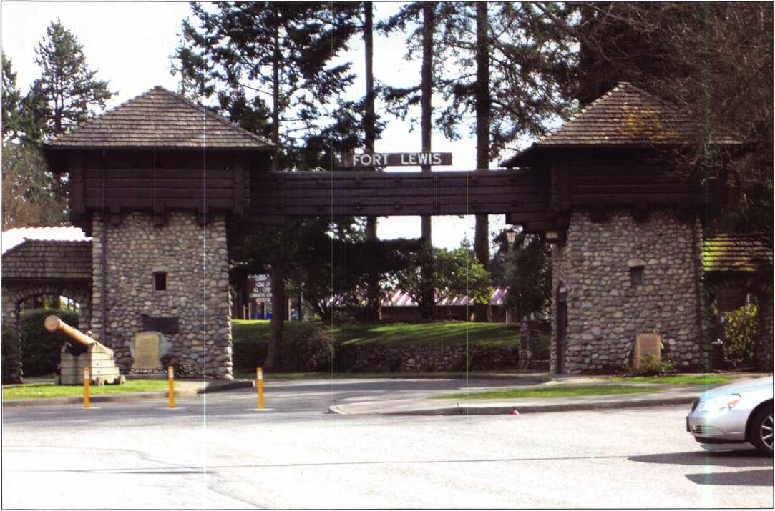

Kaba Access Control’s E-Plex 5000 is a Rugged, Powerful Solution for Today’s Army

Fort Lewis Army base, near Seattle, Washington, has been a busy place these past few years. It’s one of the last stopovers for American troops on their way to Iraq, and often their point of entry on return. “A lot of young men and women rotate in and out of this facility,” says John Overton, who is in charge of access control for the base. “It’s important to keep things running smoothly, so we are always looking for ways to improve operations.”

“One of our biggest jobs is managing personnel turnover in the barracks,” Overton continues. “Whenever a unit ships out, we have to make sure the living quarters are ready for the next group coming in. A big part of that job is making sure those living quarters are secure. For that, you need a very flexible, easy-to-manage access control sys- tern.

**m**

“A key-based system would be a nightmare,” according to A1 Erickson of Renz and Aspass, the Kaba sales representa­tive for Fort Lewis; “when soldiers are leaving for Iraq, turning in their keys isn’t going to be a very high on their priority list. A PIN-based system that makes it quick and easy to change codes is best for this type of application.

“In addition to the management issues, the locks have to be exceptionally durable. These are tough, strong young people who use our facility. Their equipment has to be as rugged as they are.”

“The first time I heard about the new Kaba E-Plex 5000 electronic lock, I knew it could be just the right access control device for Fort Lewis. It is a PIN-based system that provides up to 3000 codes per lock, but doesn’t force you to buy more capacity than you need. In this application, the 100 code model is perfectly adequate. The manage­ment software is very user-friendly, and lets you manage all

Keynotes • June 2006

1»^—

For additional access control features, look to the complete line of E-Plex - with multiple locking devices, audit capability, software based management, access schedules and various finishes.

5000 SERIES

100 access codes - with user and service levels

Easy to install - no wires through the door

Easy to manage - no software required

100,000 openings with 3 AA batteries

Key override available

|gai»

**A Solution for Every Door**

Kaba Access Control 1.800.849.8324 [www.kaba-access.com](http://www.kaba-access.com)

iOj

**KARA**

TOTAL ACCESS

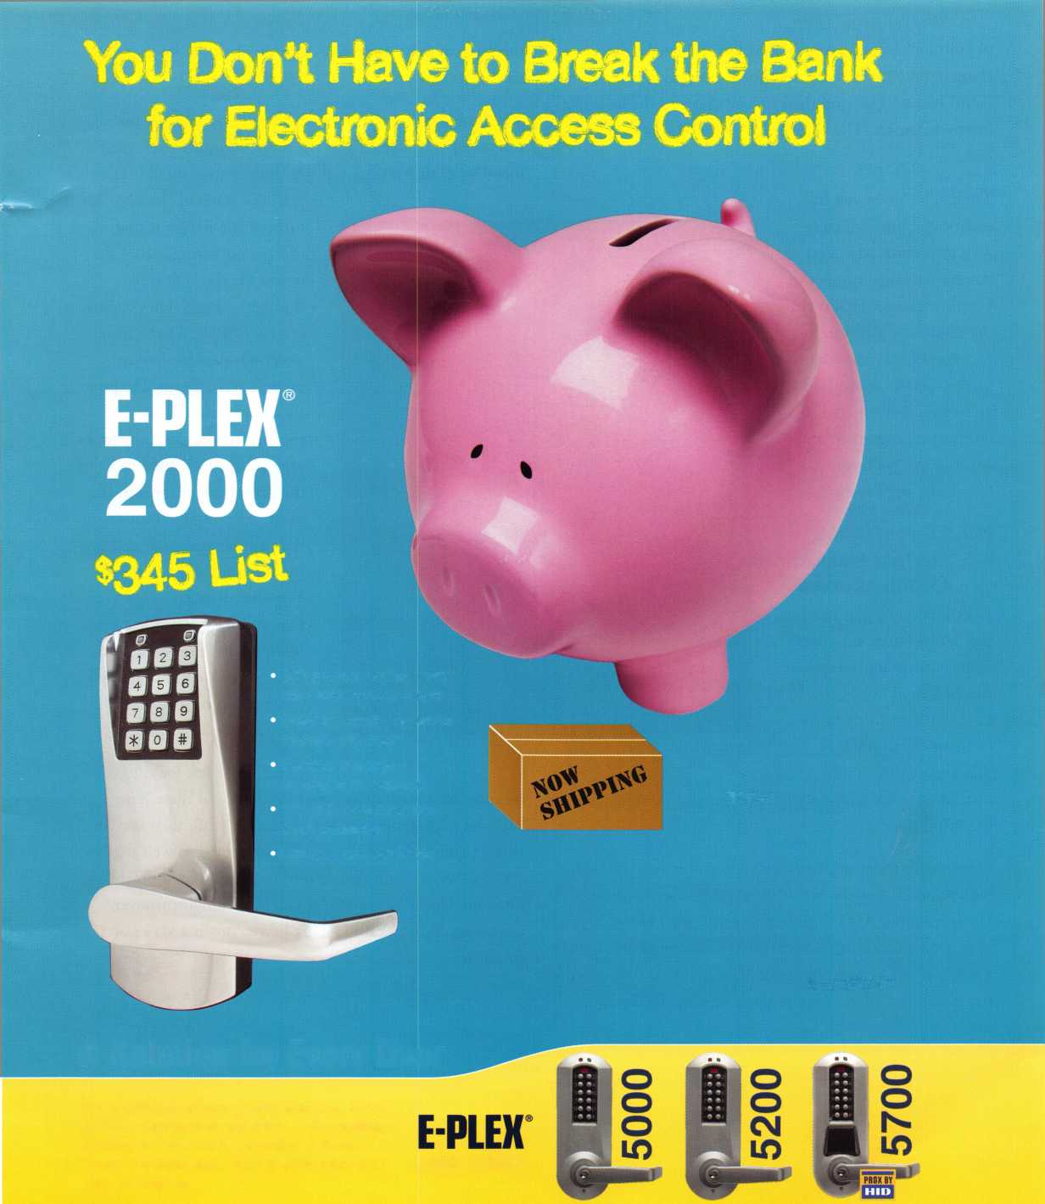

has all the right features.

Plus, it is a very durable  
lock,” concludes Erickson.

“It is ANSI/BHMA Grade  
1 certified, and can handle  
the temperature extremes  
of an outside application.

But best of all for Fort  
Lewis, it is the only fully-  
featured electronic lock  
that lets you use knobs

instead of levers without paying a premium or replacing  
the spindle.

“Most locks today are built with levers, because of ADA  
requirements. For the majority of the barracks at Fort  
Lewis, though, ADA requirements just don’t apply. If you  
have a disability that prevents you from using a door with  
a knob, it will also prevent you from going to Iraq. As the  
name implies, a lever applies more leverage to the lock

“The initial test locks have

been in use for about 4-5 months now, and there have been no management, maintenance, durability, or service issues”, concluded Erickson. “It performed so well that we ordered 58 more for installation in April. Based on this our experience, I’d say that if you have a high turnover, strenuous application like Fort Lewis, this is a very good solution.”

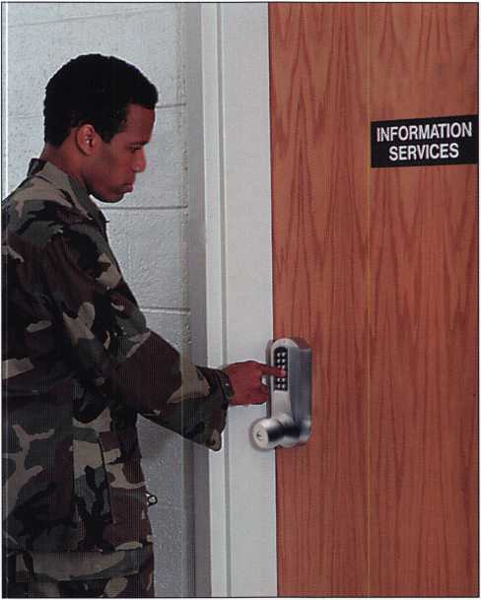

of your locks from a central location. You make the changes on your desktop computer, download them to a Palm® based PDA, and then upload them to the locks via infrared transfer. The whole process only takes seconds per lock.

The E-Plex gives you full  
audit capability, which is  
very important whenever  
you have a large number of  
people sharing a facility. In  
the event of a problem,  
you know everyone who  
used a specific access point  
and when they entered. In  
terms of management and  
control, the E-Plex 5000

mechanism every time you open the door. A knob elimi­nates that problem.

We started with a test of 50 E-Plex 5000s, and the installa-  
tion went very well. It was a retrofit, so John’s staff used a  
metal wrap that reduced our drilling to four small holes

per door. One of the best fea-  
tures of the E-Plex is that  
there is no wiring. All of the  
power for the lock runs  
through a single screw, called  
the LectroBolt. That really  
simplifies the installation  
process and cuts out the pos-  
sibility of failure from  
pinched wires. Once the locks  
were in, they assigned most of  
the management tasks to the  
units, relieving the burden on  
the maintenance staff and giv-  
ing the units more control  
over their barracks. However,  
they still have override capa-  
bilities here at the base level,  
so they can step in as needed  
to keep everything running  
effectively.”

**2**

Keynotes • June 2006

pa c ific c )i :i

**CREATING MANUFACTURERS,  
ONE LOCKSMITH AT A TIME**

**Starting to lose your padlock business to the** big retailer **down the street? Realizing that special keys or keyways won’t prevent your customers from leaving you for low prices? Then stop selling padlocks made by a manufacturer who is now directly competing with you by selling through big retail chains! Sell your customers a product that they can only buy from you...a PACLOCK with** THEIR **logo.**

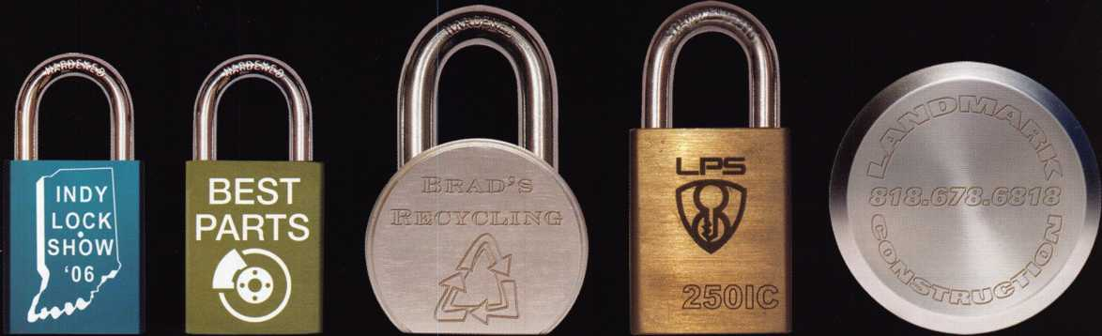

No *minimum orders*No *setup fees*\*

*Guaranteed 10-business day shipping  
on ALL orders*

*Make money in ways you never could  
before by charging your customers for  
"your engraving service."*

**888.562.5565**

**[www.paclock.com](http://www.paclock.com)**

***“Your Logo, Your Locks™"*Pricing Example**

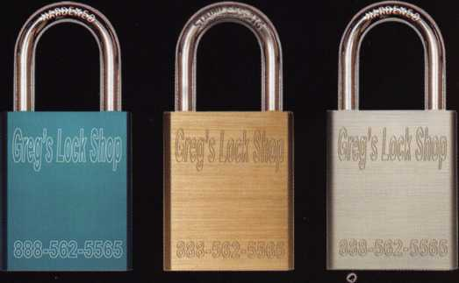

**Aluminum Brass Steel**

**$0.45 $0.75 $0.95**

Quick Change Artist, The Calvary Gun Safe

by Greg Perry, CML, CPS

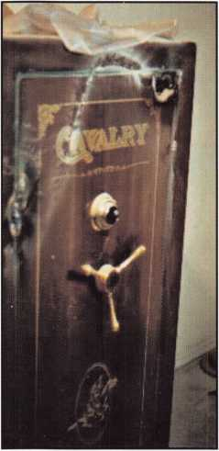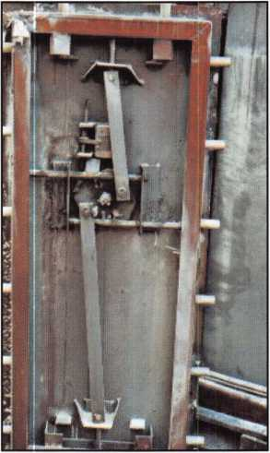

Just because the outside looks right doesn’t mean the inside is right. Sun Welding has redesigned their Calvary gun safes with minimal visible signs from the outside. We first looked at this safe model C34-FL in the February 2003 Keynotes.

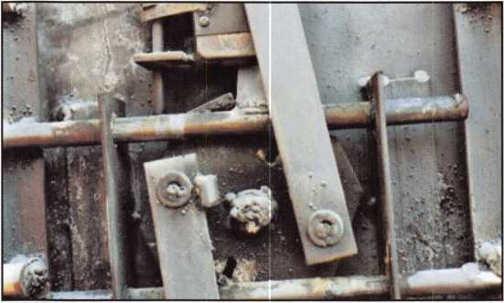

The gun safe in this article safe was the victim of an attempt­ed burglary with a cutting torch. We replaced the safe to the

customer the same day and stashed the other one in our yard to take back to the manufacturer for repair. Fast-forward a couple of years and we finally take the safe into the factory to get it repaired. They sent a replacement after choosing not to repair it. Looking inside the door we find a completely different safe.

This was discovered when the combination was changed to display on our showroom floor. The back must be removed to get at the safe lock. Keep this in mind if you want to side drill and scope the change keyhole. You must drill the verti­cal down mounted lock 2 3/8” back, 13 3/4” down, or 11” over from the open edge of the door to get between the lock

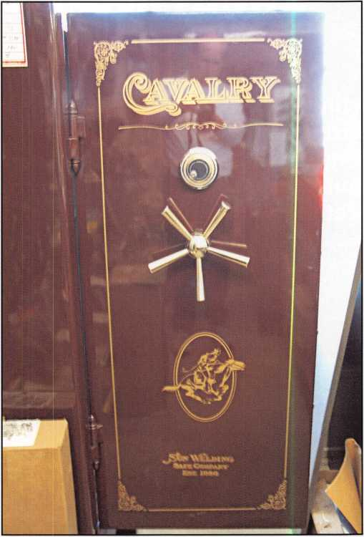

Keynotes • June 2006

**magnetic lock**

*•runs*

fustt Batten

% cm

**1504 with intercom**

going and Manufacturing a fuM Hn<

**Parking Control Gate Operator Telephone Entry**

Simple to use, install, and maintain. Basic digital entry as simple as a single stand alone digital keypad for economical applications - or programmable digital keypads with access for hundreds of users and multiple doors and/or gates.

Complete systems that can include electric locks and access control devices linked to weigand control boards - all manufactured by DKS.

* Durability - backed by more than 50 years of Made-in-the-USA manufacturing and expertise
* Outdoor use in all weather
* Easy to install magnetic locks for both doors and gates - a full line available from 300 - 1200 lbs holding force
* Vandal resistant - DKS

keypads feature: stainless steel u

faceplates, galvanized We use DoorKing because they have a

cuh-nlatoQ ar»H full line of products which provides us with rugged steel cabinets one-stop shopping and they have a great aa customer service department. ’’

Scott Brose, Bejan Souferian

Co-Owners, Scotland Entry Systems, Inc.

Van Nuys, California

ACCESS CONTROL SOLUTIONS

for over fifty years

**Locking and Entry**

**single and multi-door access control**

**flush mount**

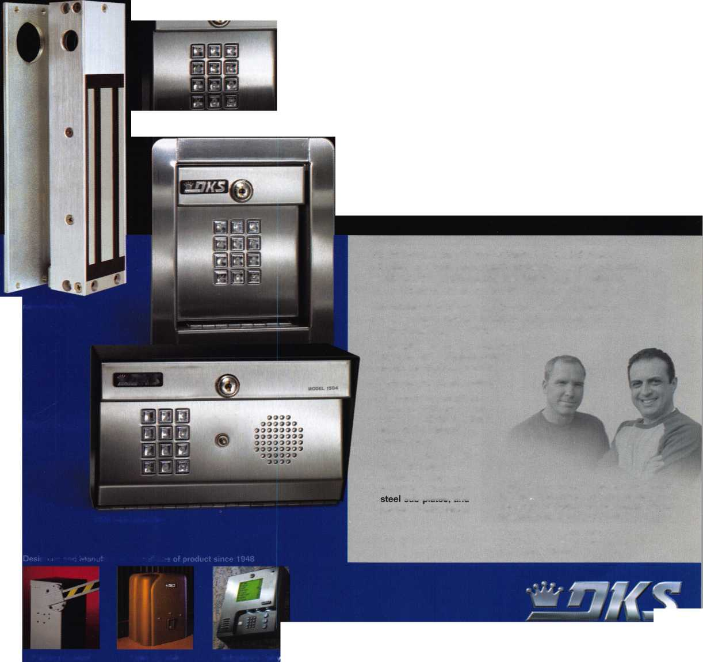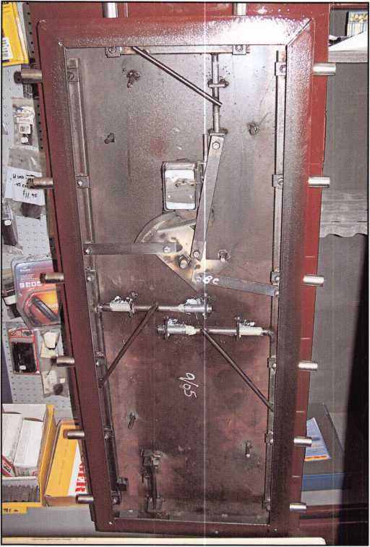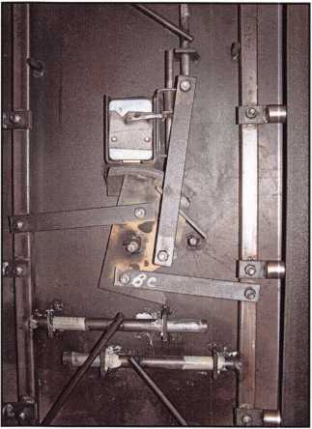

body and the door  
back cover. The older  
safe needed to be  
drilled 13 1/8” down  
so although I did not  
have both doors to  
compare at the same  
time, it appears the  
lock and handle loca-  
tion have moved  
down on the safe  
door by 5/8”. This  
may be the best hint  
to distinguish  
between the old and  
new style door. Dial  
center is 14 3/16”  
from the top of the

door on the new style and 13 9/16” on the old style. The  
old style pictured had a 3-spoke handle. They offered a 5-  
spoke handle upgrade so even though the new style has a 5-  
spoke handle this may not be a reliable indicator.

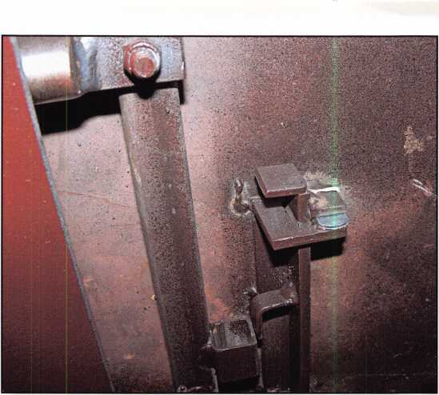

The inside of the door is constructed completely different. The old style used a flat strap on each side of the safe and across the top with the door locking bolts welded to them. A single bottom bolt is driven off the handle cam. The bolts are unevenly spaced alternating between 8 3/4” then 8 1/2” between them. From the top the are spaced at 5 1/2”, 14 1/4”, 22 3/4”, 31 1/2”, 40”, and 48 3/4”. The top bolts are located at 6 5/8” and 17 1/8” the bottom bolt is centered. The relock is located 2 1/2” to the right of the dial center.

The new style side bolts are bolted to square tubing with a different style handle cam. They are evenly spaced 8 1/2” apart starting at 5 3/8’, 13 7/8”, 22 3/8”, 30 7/8”, 39 3/8”, and 47 7/8”. The top bolts are placed at 6 7/8” and 16 1/2”. The new style does not have a bottom bolt. Instead a bolt- work detent is at the bottom of the door. This particular safe needed a slight modification to make it work properly. The detent trip is simply a 45-degree bevel cut on the bottom of the strap. It grabs a piece of the square tube welded to the vertical bolt bar to prevent bolt extension. This strap was hit­ting the body on the flat just at the start of the bevel causing the door to not always close smoothly. We glued a 1/8” thick cam from a cam lock with epoxy that prevents the bolt from dropping and keeps the detent on the bevel. Another differ­ence is that the relock on the new style is mounted 2 1/8” to the left of the safe lock.

What is the same? The doors are both 53 3/4” tall by 23 1/4” wide. The bodies are constructed the same, 1/4” steel with a layer of drywall inside. The locks are located 1 1/8” from the face, 3/8” mild steel and 3/4” of hardplate. The bolts are all 1” diameters. Both styles use external hinges. Both handles turn CCW to open. Both use spring loaded pins for relocks but again they are on opposite sides of the

1

**6**

Keynotes • June 2006

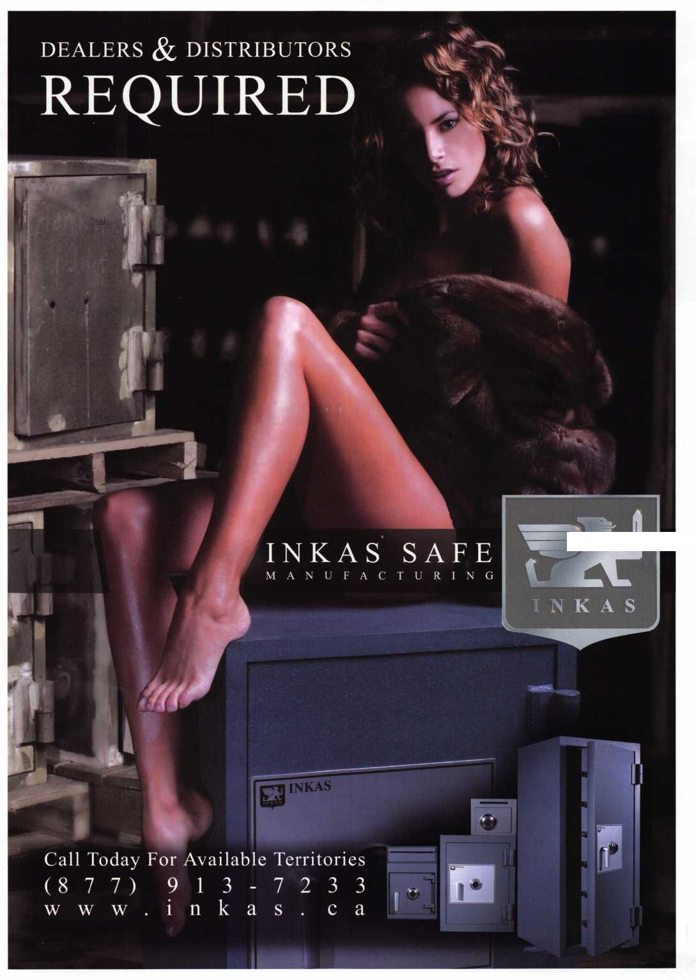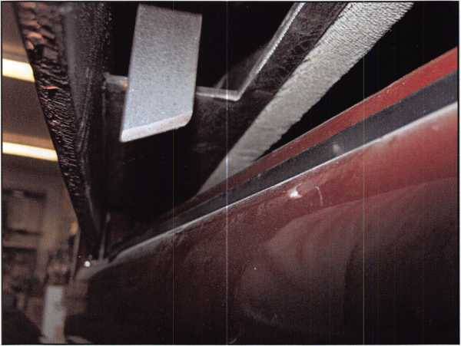

combination locks. They are both 30” wide and 24”  
deep, the old style is 60” tall, and I measured the new  
style at 60 3/4” tall. I’m not sure if this is a good  
indication or if I didn’t measure the old one exact.

Normally the outside of the safe is a good indictor of  
what it looks like inside. Sometimes the cover is not a  
good indictor like in the case of this gun safe.  
Encountering this safe in field might not be a prob-  
lem if it’s a lost combo or lock malfunction. Boltwork  
problems, burglary attempts or relock problem may  
cause you to think twice if you don’t know the  
differences.

ALOA OPEN GOLF TOURNAMENT

Wednesday, July 12, 2006

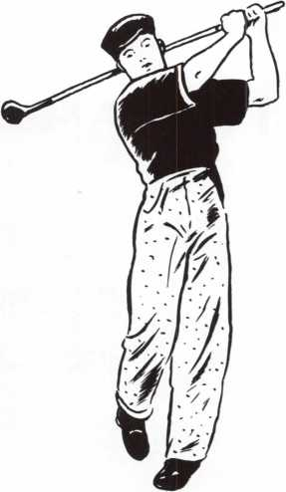

Registration fee is $150. This includes  
transportation, lunch, golf cart, beverages  
throughout the course and prizes for every-  
one. Proceeds benefit the ALOA  
Scholarship Foundation, and all  
registration is tax deductible.

Hole In One Contest - Win a $25,000 Van!!

fi

**8**

Keynotes • June 2006

This year we’re back in LEXINGTON for the 150th Anniversary of Sargent & Greenleaf.

**Keeping up with the latest the industry has to offer has never been this important - or this FUN! When it comes to learning about the latest in safes and vaults, time is of the essence. SAFETECH 2007 fea­tures an all-new menu of classes, covering every safe topic on the globe.**

***OUR SAFETECH 2007 SPONSORS!!***



**SARGENTANDGREENLEAF**



*THE RACE STARTS HERE.*

**SAFETECH**

**LEXINGTON’S**

**READY.**

**ARE YOU?**

**MARCH 5th thru MARCH 10th, 2007**

**LEXINGTON**

**KENTUCKY**

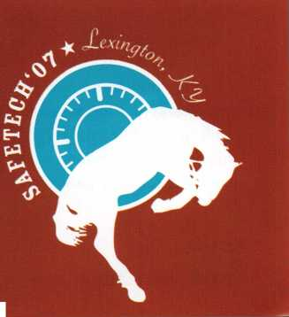

A Bad Decision

by Thomas Stern

I made keys at one of my local car dealerships this afternoon; a two year old Ford F-150 off road pick up truck. It seems that the driver over extended his abilities and rolled it. Once that hap­pened he decided that it wasn't worth what he'd agreed to pay for it so he quit paying the monthly notes and just left: it at the bone yard.

While I was waiting for the keys to be programmed I couldn't help but notice the car parked next to it; the one with the bullet holes in it. It had signs taped to all the windows, "Do Not Touch - U. S. Marshall's Investigation". There was a familiar foul stench emanating from within. All the windows had bullet holes while the driver's side window was shot out completely. I could see the blood stains and was told that the driver had been killed. He'd stolen the vehicle and, upon being pursued by the police in Louisiana, had shot it out rather than give up. I counted close to 40 bullet holes; wondering how many had hit the mark. I wish I had my digital camera with me; the first thing that came to mind was the last scene from Bonnie and Clyde.

When I was a very young police officer working evening shift patrol downtown one of the more demented patrolmen, I think that would cover his personality, would take his fancy 35mm camera around to all the crime scenes. He would take pictures on slide film so that he could slip them in with his vacation pictures when friends and family came over. "This one is the kids jump­ing in the pool at the Holiday Inn, this next one is a drug dealer with his half his head shot offfloating in Buffalo Bayou." He eventually got removed from the force for some rather serious infractions, imagine that.

I made keys for a wholesale car dealer several years ago; an old Suburban that he'd bought at a police auction. All the carpet, headliner fabric and even the seats had been removed leaving the inside down to bare metal. Even with all that removed my nose could pick up on the smell, a particularly unpleasant odor left when the human body starts to decompose. I bet he had a hard time selling it, even with a box of Citrus Glade to cover the lin­gering odors.

The first time I ever ran across a DOA in a car was back in 1972 when I was a rookie police officer. It was a Monday afternoon on evening shift around 3 or 4pm; about this time of year because it was already starting to get pretty warm. We got dispatched to the parking lot of a large grocery store off the Gulf Freeway and were met by the store manager. The manager was upset because there was an ambulance parked with its flashing lights; not good for

bringing customers in; that and the fact that there was a dead woman in one of the cars, a former customer at that.

We talked to one of the sackers who explained that he thought it a little strange that the car had been parked in the same place all weekend. He remembered having loaded the old woman's gro­ceries on Friday evening and never gave it another thought. The car windows were rolled up; even so, the smell was enough to gag a vulture. When the medical examiner gave permission for the body to be removed we were asked to help load the body into the bag. I wasn't too keen on the idea; but my senior partner had volunteered my services.

It had been an especially warm weekend and the heat had cooked the woman. I put the disposable gloves on and began to lift the woman's arm. I learned an important lesson that day; over cooked meat does not stick to the bones. It took quite a bit of effort to complete that assignment and when we left the odor had permeated my police uniform. It took several times going through the wash to make that shirt useable again; but when you only have 4 city issued shirts, well, you make do.

I suppose I need to bring this to a close, eventually. Jim Reed, the fellow who taught me how to be a locksmith, would show me the art of impressioning a trunk key. He'd prepare the key, wiggle it in the lock to collect some marks, file those marks and repeat the process until the key turned in the lock. He'd turn the key enough to make sure that the lock would work, letting the truck deck spring up half an inch or so before slamming it shut. He didn't like to let the truck lid open up all the way, "Never know what you might find in there, a dead Mexican named Jose shot full of holes or a bunch of marijuana; no, you never know what you might find."

I made keys for a Firebird that had been towed to a storage lot after being abandoned on the side of a freeway. Six months later the storage lot owner filed for a lien title so he could sell it when the original owner abandoned it. When I'd made the ignition key he wanted to hear the motor run. It turned over strong but never would start. I popped the hood for him, pulling the release under the dash board so he could see if it was getting any gas. He lifted the hood and had me crank it over again while taking the cover off the air intake.

"You're not gonna' believe this! The air filter has been packed with drugs in plastic bags; it's not getting any air!" The car start­ed right up as soon as the drugs were removed from on top of the carburetor. At least it wasn't a dead Mexican named Juan.

**20**

Keynotes • June 2006



You’ve come a long way, Bobby!

illations, Bob  
afe & Lock. We  
ilishments - fro

of service at your many ancfpresent!

LaVerne, Joe, Linda, Matt, Valerie Kyle, Kevin and Beth



**repair**

TAG

..nnaOOPQUU.: DQnOOOOQl'OOtl'*

^DODDilli**

' C°o^Nv

V. STATe^l

**key&lock**

CLAIM CHECK

VOUR FIRM NAME **HERE**

123 Main Street

VOUR TOWN. STATE AND ZIP

Phone 123-4567

0004115

'"VOICE

|  |  |  |
| --- | --- | --- |
| Professional Busi | | ness Products |
| Invoices | Tags | Call for a free |
| Checks | Key Fobs | brochure and samples |
| Business | Magnets | 1-800-355-6322 |
| Cards | Labels | [www.pbp2000.com](http://www.pbp2000.com) |

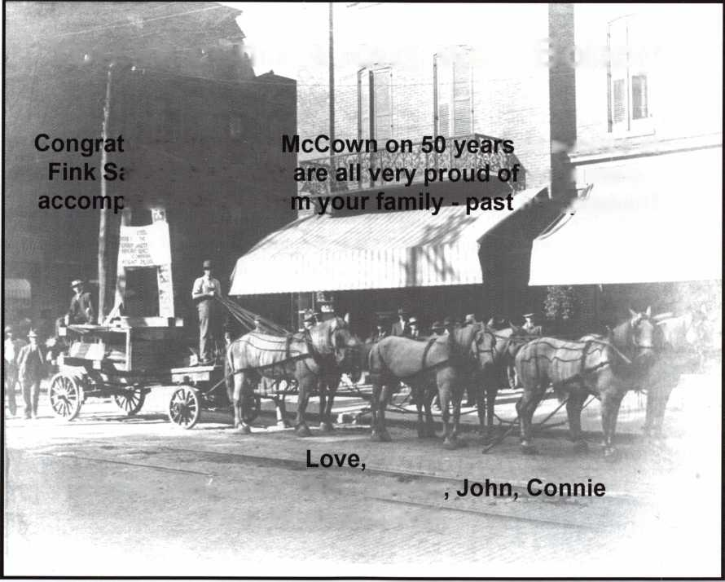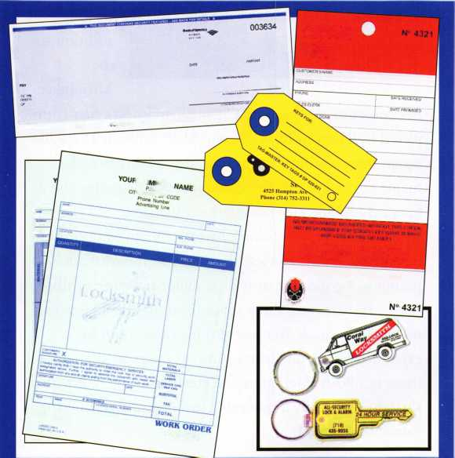

Style and Security Meet at Milwaukee Art Museum

The visual impact of the new Milwaukee Art Museums addition is stunning in every dimension, with vaulting sky­lights, a giant moveable sunscreen, and compound curves everywhere. In this aesthetic climate, everyday working components such as doors and their hardware must com­plement the overall design concept of the facility, yet also provide the required combination of security and life safety protection. Here’s how these components fill their mission at this spectacular structure.

The Quadracci Pavillion joins the existing Milwaukee County War Memorial, built in 1957 and designed by Eero Saarinen. Its first major addition, in 1975, was designed by David Kahler, who was also architect of record for the new addition. Design architect Santiago Calatrava says his design for the addition is transparent and light, which contrasts with the massive, compact Saarinen build­ing. He explains, “Instead of adding something more to the Saarinen building, I proposed to add something to the lakefront.”

A Dramatic Addition

The Santiago  
Calatrava-  
designed  
Quadracci  
Pavillion is a  
striking  
addition to  
the

Milwaukee

Art Museum. As the noted Spanish architect’s first com-  
pleted building in the U.S., the $120 million, 142,050-  
square-foot addition forms both the centerpiece of a  
major expansion for the Milwaukee Art Museum and a  
forward-looking city landmark on the shore of Lake  
Michigan. The expansion provides enhanced opportuni-  
ties for the public to view the works in the Museum’s  
permanent collection as well as major traveling exhibi-  
tions. It increases gallery space from 90,000 square feet  
to 117,000 square feet but also provides room for  
expanded visitor amenities. Among the most dramatic of  
these is a 90-ft. high glass and steel reception hall with a  
skylight shaded by a moveable, winged sunscreen—the  
Burke Brise Soliel.

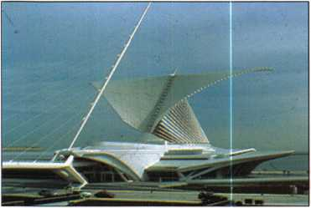

In addition to the landmark Quadracci Pavillion, the com­plete $120 million expansion project also encompassed renovated and reinstalled permanent collection galleries in

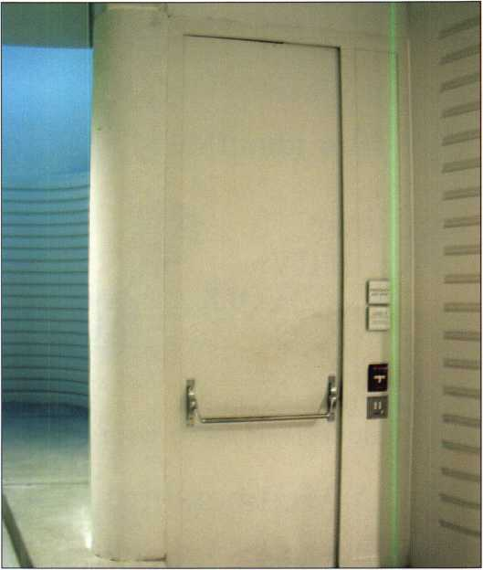

Keynotes • June 2006

Celebrating 50 years of the ALOA Convention and Security Expo

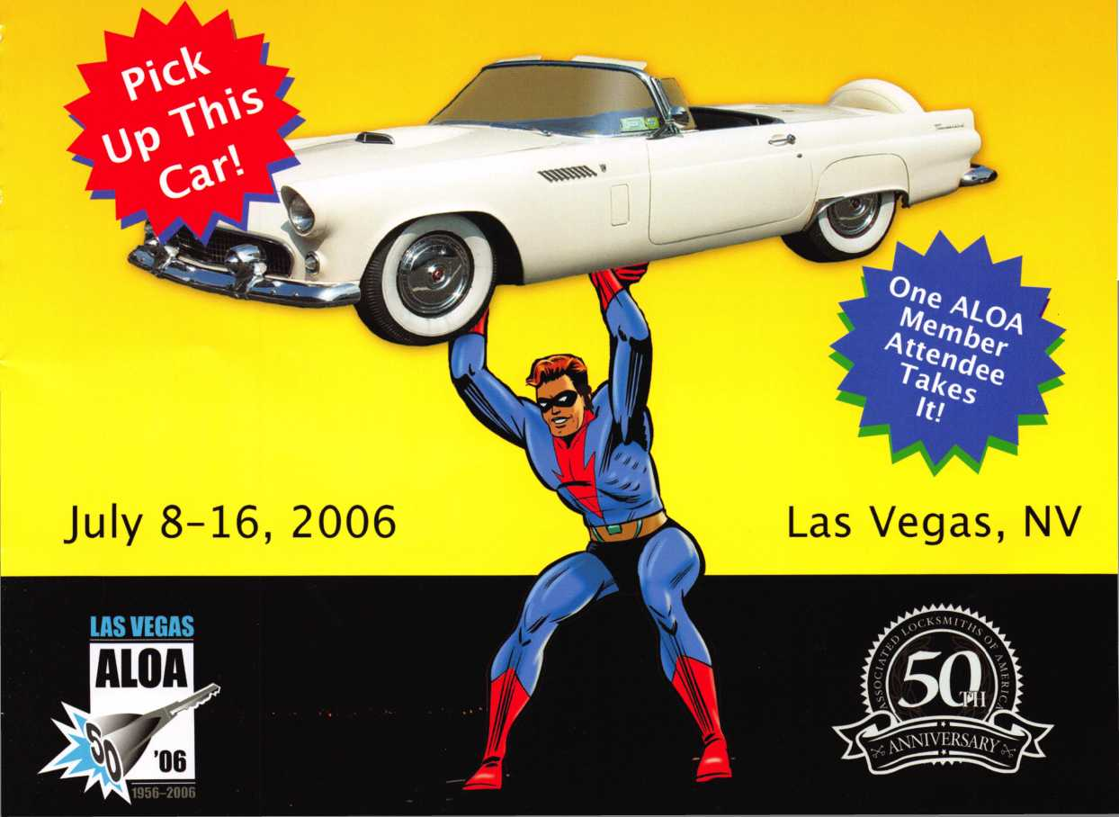

***iet\**** .. ***1/e^ Sty/e!***

Reserve your spot now for the hottest show in the industry! This year we’re doing it up Vegas style, with a great location and a schedule full of exciting classes and events, we are pulling out all the stops to celebrate the 50th Anniversary of the ALOA Convention and Security Expo in fabulous Las Vegas, Nevada. With sparkling shows, gam­bling, and nightlife, along with world- class accommodations, Vegas provides the perfect backdrop for a business vacation for any security professional. This special ALOA 2006 convention fea­tures an exceptional educational menu that will provide 86 full-day ACE classes and 43 half-day ACE classes and semi­nars - some familiar, some brand new but all containing info on the latest tech­nology available in the industry. Add to that the hundreds of exhibitors showing off the latest and greatest at the world- renowned Security Expo, (this interna­tionally renowned show will be held at the famed Las Vegas Convention Center just a short stroll away from the Las Vegas Hilton) and you have a show that covers all the bases. Come out and cel­ebrate ALOA’s 50th Anniversary Convention and Security Expo and enjoy yourself while taking home new ideas and products that will assure your busi­ness will thrive in the coming years. This year’s convention is not one to be missed!

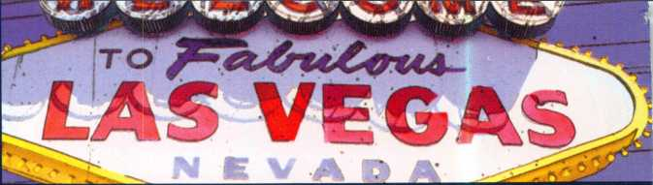

**Contents _ ,**

GENERAL INFORMATION 2

ALOA 2006 Security Expo ALOA Open Golf Tournament ALOA Kickoff Party and Scholarship Foundation Auction ALOA Membership Meeting Legislative Action Network Breakfast/

State of the States Roundtable ALOA 50th Anniversary Dinner Banquet

GETTING AROUND LAS VEGAS 10

Transportation

Accommodations

Parking

Help/ Questions

Daily Schedule of Events 3

Bonus Sunday 4

Classes and Seminars

Registration Instructions

Registration Policies

Convention Registration Form

Class & Seminar Registration

PRP/ STPRP Registration Form

WHB Hotel Reservation Request Form

Air Travel & Car Rental Information

Ju ALOA Membership Application

0HKA, f Dress Code

ALOA 2006 Exhibitors

ALOA 2006 Sponsors

bk cover

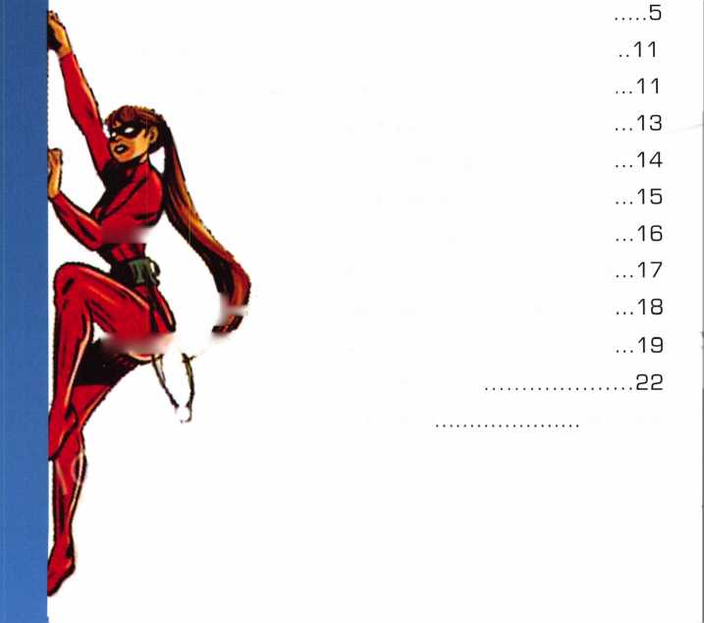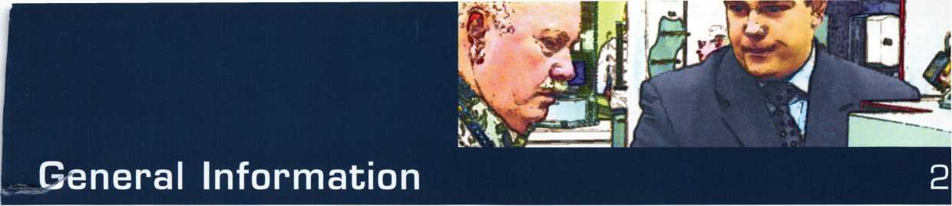

**DAY TOUR:**

**DESERT TO DIAMOND Tuesday, July 11, 2006**

FIRST..Red Rock Canyon National Conservation Area - Guests will travel by deluxe motor coach to scenic Red Rock Canyon - less than an hour’s drive west of Las Vegas. Red Rock Canyon features many geologic features. The tour will include a stop at the Visitor’s Center. Guests will also enjoy a drive along the scenic 13-mile loop, which offers sightseeing, vistas and overlooks.

THEN...The Fabulous Liberace Museum - Liberace was one of the foremost showmen of his time and his museum reflects all the glitz and glamour that was his life. The museum features “Mr. Showmanship’s” dazzling jewelry, rare antiques, unsurpassed wardrobe, unique and historical pianos and his custom car collec­tion.

LASTLY...Ethel M. Chocolate Factory - The Botanical Cactus Garden is adjacent to Ethel M. Chocolate Factory. Covering 2.5 acres, you’ll discover an arid land­scape rich with over 350 species of cactus, succulents and desert plants from the Southwest and other deserts of the world.

• Pick up and drop-off at Hilton. Tour Length:8am-3pm.

**ALOA OPEN GOLF TOURNAMENT Wednesday, July 12, 2006 6:30am-3pm**

The ever-popular ALOA Open Golf Tournament will be held at the Silverstone Golf Club in Las Vegas,

NV. Transportation will depart from the Hilton at 6:30am and return at 3pm. The registration fee is $150 (tax deductible) includes transporta­tion, green fees, golf cart, and bev­erages throughout the course,

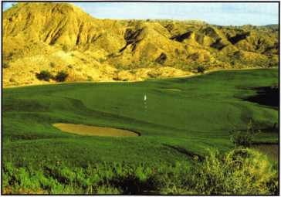

lunch and prizes for all players.

**KICK-OFF PARTY/**

**ASF LIVE AUCTION Wednesday, July 12, 2006 Party: 7-8pm, Auction 8-1 Opm**

ALOA’s Annual Kick-Off Party followed by the ALOA Scholarship Foundation Live Fund Raising Auction at the Las Vegas Hilton. All registrants are encouraged to attend and enjoy fabu­lous food and fun. Great items will be offered for your bidding pleasure at ASF’s 8th Annual live auction.

This is a great place to meet old and new friends while enjoying the oppor­tunity to purchase fantastic items and outstanding bargains - with the pro­ceeds going to the ALOA Scholarship Foundation.

**STATE OF THE STATES ROUNDTABLE Friday, July 14, 2006 3:00pm**

This meeting is designed as a forum for ALOA chapters and local/state/regional locksmith

associations to meet and share information and ideas about the state of locksmithing in their region and a dynamic way to share ideas. Primarily for the Chairman, President and Legislative Representative from each organiza­tion, all locksmiths are encouraged to participate. These discussions will provide the perfect opportunity to learn what’s going on the indus­try across the nation.

**ALOA 50TH ANNIVERSARY DINNER BANQUET/**

**“RAT PACK REVUE”** Saturday, July 15, 2006 7-11pm

This phenomenal group, featuring Sebastian Anzalado as “Frank”,

Andy DiMino as “Dean”, and Lambus Dean as “Sammy”, will cer­tainly astound your group as they bring back to life the music, come­dy, and camaraderie of the real “Rat Pack”! (more info on pg 20)

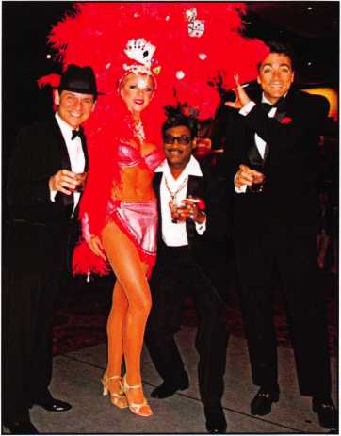

**CLASSES**

|  |  |  |  |
| --- | --- | --- | --- |
| SATURDAY | MONDAY | TUESDAY | WEDNESDAY |
| July 8, 2006  REGISTRATION  1-5pm • CONV. CENTER  FULL-DAY  EDUCATIONAL CLASSES CONV. CENTER | July 10, 2006  REGISTRATION  7:30am-5:30pm  CONV. CENTER  FULL-DAY  EDUCATIONAL CLASSES 8am-5pm • CONV. CENTER | July 11, 2006  REGISTRATION  7:30am-5:30pm  CONV. CENTER  FULL-DAY  EDUCATIONAL CLASSES 8am-5pm • CONV. CENTER | July 12, 2006  REGISTRATION & EXHIBITOR REGISTRATION 7:30am-5:30pm CONVENTION CENTER  FULL-DAY  EDUCATIONAL CLASSES 8am-5pm • CONV. CENTER |
| 001: Instructor Training | 201: Instructor Training | 301: Instructor Training | 401: NKL Certification |
| 002: Fundamentals of Locksmithing 1 | 202: Fundamentals of Locksmithing III | 302: Fundamentals of Locksmithing IV | 402: Fundamentals of Locksmithing V |
|  | 203: Exit Devices and Exit Alarms | 303: Keyless Mechanical Lock Servicing | 403: Hollow Metal Door & Frame Servicing |
|  | 204: Door Hardware 101 | 304: Basic Electric Locks & Wiring | 404: Advanced Automotive Lock Service |
| SUNDAY | 205: Investigative Locksmithing | 305: Investigative Locksmithing | 405: Forensic Locksmithing |
| (Day 2 of 3) | (Day 3 of 3) | 406: S&G Group 1 Mechanical Safe Locks |
| July 9, 2006  RFfZISTRATIONI | 206: Safe Deposit Lock Servicing | 306: Safe Deposit Lock Servicing | 407: GM Steering Column & Repair (Day 2 of 2) |
| (Day 2 of 3) | (Day 3 of 3) | 408: Defense Against Methods of Entry DAMES |
| KCVU1 RMf IW/li  7____ . rnMI/ rCIUTCD | 207: Intermediate Automotive Lock Service | 307: GM Steering Column & Repair (Day 1 of 2) | (Day 2 of 2) |
| /am-opm • lu/vv. ctnick | 208: Mechanical Push Button Lock Manipulation | 308: Defense Against Methods of Entry DAMES | 409: Alarm Design and Development |
| FULL-DAY | 209: Life Safety Codes and ADA | (Day 1 of 2) | 410: Basic Electricity & Electric Locks |
| EDUCATIONAL CLASSES | 210: Comprehensive Access Control 1 | 309: Alarm Design and Development | 411: Simplex Unican Certification |
| 8am-5pm • CONV. CENTER | 211: Electronic Safe Locks: Batteries not included | 310: Comprehensive Access Control II | 412: Professional Impressioning Methods |
|  | (Day 2 of 2) | 311: Medeco3 Certification | 413: AMSEC Certification Class |
| 101: Instructor Training | 212: Stand Alone Access Control | 312: Professional Lock Picking | 414: Schlage Cylindrical Lock Servicing |
| 102: Fundamentals of Locksmithing II | 213: Combination Lock Manipulation | 313: Combination Lock Manipulation (Day 2 of 2) | 415: Time Lock Servicing Day |
| 103: Servicing Aluminum Storefront Doors | (Day 1 of 2) | (Day 4 of 4) |
| 104: Wiring Techniques for the Electronic Locksmith | 214: Electrified Closers and Door Controls | 314: Basic Exit Device Servicing | 416: High Security Cylinders |
| 105: Investigative Locksmithing | 215: Time Lock Servicing Day (Day 2 of 4) | 315: Time Lock Servicing Day (Day 3 of 4) | 417: Business Planning |
| (Day 1 of 3) | 418: Large Format Interchangeable Core |
| 106: Safe Deposit Lock Servicing | 216: Fundamentals of Master Keying II | 316: Advanced Topics in Master Keying | 419: Access Control - Perimeter to Door |
| (Day 1 of 3) | 217: Financial Management for Locksmiths | 317: Financial Management for Locksmiths |  |
| 107: Basic Automotive Lock Service | (Day 1 of 2) | (Day 2 of 2) |  |
| 108: Safe Work for Dummies | 218: Interchangeable Core Fundamentals | 318: Small Format Interchangeable Core | ' |
| 109: Advanced Shop Management | 219: Master Lock Certification | 319: American Lock Certification | NOTE: |
| 110: Thinking Outside the Box | Evening Seminars | Evening Seminars | IJIffTiniC n AV |
| 111: Electronic Safe Locks: Batteries not included | 222: Business Strategy & Development | 321: Introduction to Access Control with Cyberlock | M ULTIPLE-DAY |
| (Day 1 of 2) | 223: Cates are Another Door to Opportunity | 322: Replacing Lost Keyless Entry Remotes - an | CLASSES ARE |
| 112: Basic Electricity & Electric Locks | 224: Introduction to Cargo Security - Protecting the | Untapped Market for Automotive Locksmiths |  |
| 113: Comprehensive Safe | Supply Chain | 323: Introduction to CompX eLock | HIGHLIGHTED |
| Servicing/Opening/Defeat Methods |  | 324: Key Control Policies - |  |
| 114: Mechanical Closers & Door Controls |  | Design & Implementation | IN COLOR |
| 115: Time Lock Servicing Day |  |  |  |

(Day 1 of 4)

116: Fundamentals of Master Keying I

*7-9pm*

*EVENING SEMINARS  
Hilton*

*7-9pm*

*EVENING SEMINARS  
Hilton*

*8am-3pm*

*DESERT TO DIAMOND TOUR*

*6:30am-3pm  
ALOA OPEN  
GOLF TOURNAMENT  
SILVERSTONE GOLF CLUB*

*7-11pm*

*KICK OFF PARTY/  
LIVE AUCTION  
Hilton*

**4**



**THURSDAY**

**July 13, 2006**

***REGISTRATION & EXHIBITOR  
REGISTRATION  
9am-5:30pm  
CONVENTION CENTER***

***NOON-5pm  
SECURITY EXPO  
CONVENTION CENTER***

***NOTE:***

***NO CLASSES  
ON THIS***

*DAY*

|  |  |  |
| --- | --- | --- |
| FRIDAY | SATURDAY | BONUS |
| July 14/ 2006  REGISTRATION & EXHIBITOR REGISTRATION 7:30am-Spm CONVENTION CENTER  HALF-DAY EDU. CLASSES  8-1 lam • CONV. CENTER  NOON-5pm  SECURITY EXPO CONVENTION CENTER | July 15, 2006  REGISTRATION & EXHIBITOR REGISTRATION 7:30am-2pm CONVENTION CENTER  HALF-DAY EDU. CLASSES  8-1 lam • CONV. CENTER  NOON-4pm  SECURITY EXPO CONVENTION CENTER | SUNDAY  July 16, 2006  REGISTRATION  7:30am  CONVENTION CENTER  FULL DAY CLASSES CONVENTION CENTER |
| 601: Alarm Lock Trilogy Certification | 701: BiLock High Security Cylinders | 801: ACE Instructor Refresher |
| 602: l-Que Elec. Access Control Certification | 702: Videx Cyberlock Advanced Training | 802: Gate Hardware for the Locksmith |
| 603: Mul-T-Lock Certification | 703: Mul-T-Lock Advanced Master Keying Certification | 803: The Complete Door & Door Closers |
| 604: Medeco Keymark Certification | 704: Arrow Factory Certification | 804: Motorcycle Locksmithing |
| 605: Primus/ Everest Update | 705: Pivots & Floor Closers | 805: CCTV for Locksmiths |
| 606: Kaba E-Plex Access Control | 706: Peaks Classic &  Peaks Global Certification | 806: S&G 6120/23/Z02 & Biometric Keypad Factory Training |
| 607: ASSA CUQ C4 Systems | 707: ABLOY PROTEC High Security Locks | 807: Automotive Transponder Systems |
| 608: Omnilock Access Control Systems | 708: Kaba Mechanical Safe Locks | 808: Safe Work for Dummies |
| 609: Corbin Russwin Pyramid Certification | 709: Unlocking the Mystery of Electrified Hardware | 809: Life Safety Code Instructor Refresher Course |
| 610: KABA llco Transponder Update 2006 | 710: Key Machine Technology & Maintenance | 810: Installing & Servicing Access Control Systems |
| 611: Automotive Servicing Techniques | 711: Scorpion CX-5 High Security Lock Certification | 811: Auto Theft, Arson & Forensic Examinations |
| 612: Professional Tools for the Professional | 712: Software for the Professional Lockshop |  |
| Locksmith |  |
| 613: Keyless Remote Certification | 713: Remotes 101 - No Computer Required |  |
| 614: STRATTEC Automotive Security Update & | 714: Hands-On MAXCESS, the Simple Mechanical |  |
| Transponders | Card System |  |
| 615: S&G Biometric Keypad Fundamentals | 715: Complete Guide to Electric Strikes |  |
| 616: Electronic Security Hardware Wiring | 716: How to Grow Your Business in the Ever |  |
| 617: Detex Access Control Systems | Changing Marketplace |  |
| 618: Fundamentals of Key Cutting & Machines | 717: Low Energy Power Operators Workshop |  |
|  | 718: Electric Lock Site Survey & Design |  |
|  |  |  |

***10-11:30am  
MEMBERSHIP MEETING  
Convention Center***

***6:30-10pm  
EVENING PRP EXAM  
Hilton***

***NOON-5pm  
SECURITY EXPO  
CONVENTION CENTER***

***3:00pm***

***STATE OF THE STATE  
ROUNDTABLE  
Hilton***

***7-11pm***

***ALOA SOTH ANNIVERSARY  
DINNER BANQUET  
Hilton***

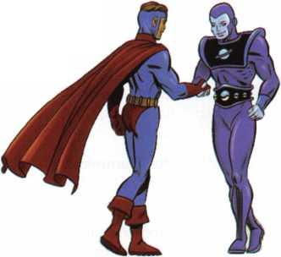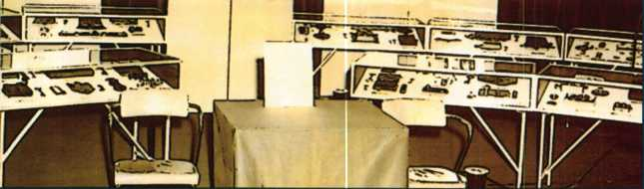

**Classes & Seminars**

The symbol to the left indicates that a class has been PRP Certified. Students may elect to take the exam for the PRP elective designated at the end of the class for an additional fee. PRP-Certified class exams will take place immediately following the end of class from 5-5:30 pm with 30 minutes of actual exam time allowed. The single elective exam option is avail­able to pre-registered ALOA members only.

**FOR COMPLETE CLASS DESCRIPTIONS VISIT ONLINE AT iAiww.aloa.org/2006Convention/education OR FAX ON DEMAND 310-575-5027.**

**SATURDAY, JULY 8, 2006 * 8am-5pm**

1. Instructor Training (Day 1 of 4)

Instructor: Monte Salway, CML Peter Field, RL

Gordon Malczewski (Four-day class)

1. Fundamentals of Locksmithing (Day 1 of 5)

Instructor: James Hancock, CRL, CPL J. Casey Camper, CML,CPS

**SUNDAY, JULY 9, 2006 • 8am-5pm**

1. **Instructor Training (2 of 4)**
2. **Fundamentals of Locksmithing (Day 2 of 5)**
3. **Servicing Aluminum Storefront Doors**

Instructor: Dave Thielen, CML

**104 Wiring Techniques for the Electronic Locksmith**

Instructor: Tom Foxwell

**105 Investigative Locksmithing (Day 1 of 3)**

Instructor: Keith Whiting, CML,CFL Tom Seroogy, CFL Lab fee: $100

**106**

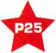

**Safe Deposit Lock Service, Repair and Key-Fitting (P-25)**

Instructors: Michael McMannis, CPL Curtis Robison, CML, CPS Lab fee: $250

**107 Basic Automotive Lock Service**

Instructor: Ed Woods, CML, CPS

**108 Safe Work for Dummies**

Instructor: Harry Sher, CML, CPS

**109 Advanced Shop Management**

Instructor: Thomas Demont, CML, AHC

**110 Thinking Outside the Box**

Instructor: Bill Neff, CML, CPP

**111 Electronic Safe Locks: Batteries not included (Day 1 of 2)**

Instructor: Michael Yarberry, CML, CPS Lab fee: $25

112

**Basic Electricity & Access Control (P-13)  
(Day 1 of 2)**

Instructor: Adam Black, CRL

■a

1. **Comprehensive Safe Servicing, Opening &**

**Defeat Methods**

Instructor: Dennis Watanabe, CML, CMST Frances Watanabe Lab fee: $100

1. **Mechanical Closers 6 Door Controls**

Instructor: Chuck Barth

**115**

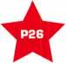

**Timelock Technology (P-26) (Day 1 of 4)**

Instructor: Dan Graffeo, CMST, CRL  
Matt McManis  
Lab fee: $300

**116 Master Keying Methods & Formats (Day 1 of 2)**

(Two-day class)

Instructor: Lloyd Seliber, CML

Clyde Roberson, CML, CPP

**MONDAY, JULY 10, 2006 • 8am-5pm**

1. **Instructor Training (Day 3 of 4)**
2. **Fundamentals of Locksmithing (Day 3 of 5)**

**203**

★

**Exit Devices & Exit Alarms (P-16)**

Instructor: Dave Thielen, CML

**6**

**204 Door Hardware 101**

Instructor: Carl Rollison

1. **Investigative Locksmithing II (Day 2 of 3)**

Lab fee: $100

1. **Comprehensive Safe Deposit Lock Servicing (Day 2 of 3)**

Lab fee: $250

1. **Intermediate Automotive Lock Service**

Instructor: Ed Woods, CML, CPS

1. **Mechanical Push Button Lock Manipulation**

Instructor: Harry Sher, CML, CPS

20S



**Life Safety Codes w/ADA (P-07)**

Instructor: Thomas Demont, CML, AHC  
Lab fee: $40

210

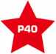

**Comprehensive Access Control (P - 40)**

Instructor: Bill Neff, CML, CPP

**211 Electronic Safe Locks (batteries not included) (Day 2 of 2)**

**212 Basic Electricity & Access Control (Day 2 of 2)**

Instructor: Greg Perry, CML, CPS Adam Black, CRL

**213: Combination Lock Manipulation (Day 1 of 2)**

Instructor: Dennis Watanabe, CML, CMST Frances Watanabe

1. **Electrified Closers and Door Controls**

Instructor: Carl Dean

1. **Time Lock Servicing (Day 2 of 4)**

Lab fee: $300

1. **Master Keying Methods & Formats (Day 2 of 2)**
2. Financial Management for Locksmiths  
   (Day 1 of 2)

Instructor: Virl Mullins

1. Interchangeable Core Fundamentals

Instructor: William M. Lynk, CRL

21S Master Lock Factory Certification

Instructor: Billy B. Edwards, CML

**Monday Evening, July 10, 2006; 7:00-9:00PM**

1. Business Strategy and Development

Instructor: Brad Smith - Medeco Business Development Program Manager

1. Gates are Another Door to Opportunity

Instructor: Brian Sweet - D & D Technologies

1. Introduction to Cargo Security - Protecting the Supply Chain

Instructor: Dennis Congdon - Kaba Mas

**Tuesday, July 11, 2006 • 8am - 5pm**

**301 Instructor Training (Day 4 of 4)**

**302 Fundamentals of Locksmithing (Day 4 of 5)**

**303**

★

Keyless Mechanical Lock Servicing (P-20)

Instructor: David Thielen, CML

1. The Basics in Electric Locking 6 Wiring

Instructor: Cecil Thornton

1. **Investigative Locksmithing III**

Lab fee: $100

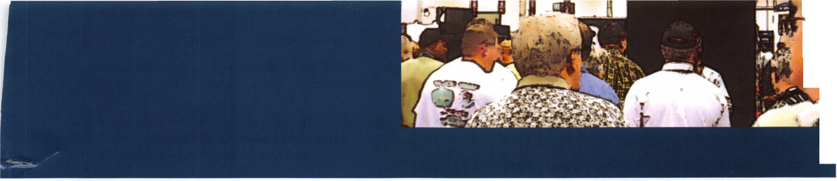

1. Comprehensive Safe Deposit Lock Servicing (Day 3 of 3)

Lab fee: $250

1. Steering Column Service & Repair (Day 1 of 2)

Instructor: Ed Woods, CIVIL, CPS Lab fee: $30

1. Defense Against Methods of Entry (Day 1 of 2)

Instructor: Harry Sher, CIVIL, CPS Lab fee: $50

**309**

Alarm Design & Development (P-42)  
(Day 1 of 2)

Instructor: Ed Streski, CML  
Lab fee: $190

**310**



**Comprehensive Access Control (P-40)  
(Day 2 of 2)**

1. Medeco3™ Factory Certification

Instructor: Sam Wilson

1. Professional Lock Picking

Instructor: Jim Watt, CML, CPS

1. Combination Lock Manipulation (Day 2 of 2)
2. Basic Exit Device Servicing

Instructor: George Nimee

1. **Time Lock Servicing (Day 3 of 4)**

Lab fee: $300

**316**

i4r

Advanced Topics in Master Keying (P-31)

Instructor: Lloyd Seliber, CML

Clyde Roberson, CML.CPP

**317 Financial Management for Locksmiths (Day 2 of 2)**

**318**

ilr

Small Format Interchangeable Core (P-38)

Instructor: William M. Lynk, CRL

319 American Lock Factory Certification

Instructor: Billy B. Edwards, CML

**Tuesday Evening, July 11, 2006 • 7:00-9:00PM**

1. Cyberlock Introduction to Access Control

Instructor: Barb Newton - Videx

1. Replacing Lost Keyless Entry Remotes - An Untapped Market for Automotive Locksmiths

Instructor: Michael Laranang - Keyless Ride

1. Introduction to the CompX eLock

Instructor: Mitch Mlynarczyk - CompX

1. Key Control Policies - Design 6 Implementation

Instructor: Gordon Malczewski

**WEDNESDAY, JULY 12, 2006 * 8am-5pm**

1. NKL Safe Certification Class

Instructor: Lance Ponder

1. Fundamentals of Locksmithing (Day 5 of 5)
2. Hollow Metal Door & Frame Servicing

Instructor: Dave Thielen, CML

**404:**



Advanced Automotive Lock Service (P-03)

Instructor: Ray D’Adamo, CML

405 Forensic Locksmithing

Instructors: Hans Mejlshede, CML

406 Sargent 6 Greenleaf Group 1 Mechanical Safe Locks

Instructor: Brian Costley, CML, CMST

1. **Steering Column Service 6 Repair (Day 2 of 2)**

Lab fee: $30

1. **Defense Against Methods of Entry Day 2**

Lab fee: $50

**409**

**Alarm Design 6 Development (P-42) (Day 2 of 2)**

Lab fee: $190

**410**

★

Basic Electricity & Electric Locks (P-13)

Instructor: Adam Black, CRL

411 Simplex Unican Certification

Instructor: Roger Bergstrom Lab fee: $40

**7**

1. Professional Impressioning Methods

Instructor: Jim Watt, CML, CPS Lab fee: $70

1. AMSEC Factory Certification

Instructor: Tony Maniaci

1. Schlage Cylindrical Lock Servicing

Instructor: Bruce Eagan, CML

1. Time Lock Servicing (Day 4 of 4)

Lab fee: $300

**416**



High Security Cylinder Servicing (P-08)

Instructor: Clyde Roberson, CML, CPS

417 Business Planning

Instructor: Virl Mullins

**418**

lir

Large Format Interchangeable Core (P-39)

Instructor: William M. Lynk, CRL

419 Access Control—Perimeter to Door

Instructor: Robert F. Stosse

**HALF-DAY CLASSES**

**FRIDAY, JULY 14, 2006 • 8am-11am**

1. Alarm Lock Trilogy Certification

Instructor: Bob Swoope

1. l-Que Elec. Access Control Certification

Instructor: Ray Krispin

1. Mul-T-Lock Certification

Instructor: Sean McNorton

1. Medeco Keymark Factory Certification

Instructor: Sam Wilson

1. Primus 6 Everest Update

Instructor: Roger Yost, CML, CPS

1. Kaba E-Plex Access Control

Instructor: Roger Bergstrom Lab fee: $125

1. ASSA CLIO C4 Systems

Instructor: Scott Paulhus, Lance Berger

1. Omnilock Access Control Systems

Instructor: Rick Rasmussen

1. Corbin Russwin Pyramid Certification

Instructor: Lee Garver

|  |  |  |
| --- | --- | --- |
| 610 | Kaba llco Transponder Update 2006  Instructor: Mike Kirkpatrick, Marco Machi |  |
| 611 | Automotive Servicing Techniques  Instructor: Rodney McClung |  |
| 612 | Professional Tools For the Professional Locksmith  Instructor: Marty Jalove |  |
| 613 | Keyless Remote Certification  Instructor: Michael Laranang |  |
| 614 | STRATTEC Automotive Security Update 6 Transponders  Instructor: Jeff Baker |  |
| 615 | S&G Biometric Keypad Fundamentals  Instructor: Brian Costley, CML, CMST |  |
| 616 | Electronic Security Hardware Wiring  Instructor: John L. Schum |  |
| 617 | Detex Access Control Systems  Instructor: Jim Handschuh |  |
| 618 | Fundamentals of Key Cutting 6 Machines  Instructor: Joy Skowron |  |
| SATURDAY, JULY 15, 2006 • 8am-1 lam | |  |
| 701 | BiLock High Security Cylinders  Instructor: Jack Hobin |  |
| 702 | CyberLock Videx Advanced Training  Instructor: Barb Newton |  |
| 703 | Mul-T-Lock Advanced Master Keying Certification  Instructor: Sean McNorton |  |
| 704 | Arrow Factory Certification  Instructor: Gordon Malczewski |  |
| 705 | Pivots & Floor Closers - a better way to hand 6 control doors  Instructor: Lynn A. Kaiser, AHC | |
| 706 | Peaks Classic and Peaks Global Certification  Instructor: Roger Bergstrom | |
| 707 | ABLOY PROTEC High Security Locks  Instructor: Martin Day |  |
| 708 | Kaba Mechanical Safe Locks  Instructor: Bruce Robertson |  |
| 709 | Unlocking the Mystery of Electrified Hardware  Instructor: Claude Hollyfield, AHC |  |
| 710 | Key Machine Technology & Maintenance  Instructor: Mike Turner, Mike Kirkpatrick |  |
| 711 | Scorpion CX-5 High Security Lock Certification  Instructor: Scorpion High Security - Limit 25 |  |
| 712 | Software for the Professional Lockshop  Instructor: Marty Jalove | 8 |

1. Remotes 101 - No Computer Required

Instructor: Walton Guerrero

1. Hands-On MAXCESS, the Simple Mechanical Card System

Instructor: Bruce Sedley

1. Complete Guide to Electric Strikes

Instructor: HES - George Algeria

1. How to Grow your Business in the Ever Changing Marketplace

Instructor: Michael Masten

1. Low Energy Power Operators Workshop

Instructor: Dawn Orem

1. Electric Lock Site Survey & Design

Instructor: Mark McBroom

**BONUS Sunday, July 16, 2006; 8am-5pm**

1. ACE Instructor Refresher

Instructor: Monte Salway, CML

1. Gate Hardware for the Locksmith

Instructor: Brian Sweet

**803**



**Complete Door & Door Closers (P-05)**

Instructor: Dave Thielen, CML

**804**

**Motorcycle Lock Servicing (P-22)**

Instructor: Ray D’Adamo, CML

1. CCTV for Locksmiths

Instructor: Keith Whiting, CML

1. **Safe Work for Dummies**

Instructor: Harry Sher, CML, CPS

1. **Life Safety Code Instructor Certification Course**

Instructor: Tom Demont, CML, AHC

1. **Installing and Servicing Electronic Access Control Systems**

Instructor: Greg Perry, CML, CPS

1. **Auto Theft/Fire 6 Forensic Examinations**

Instructor: Herb Miller, CFL Tom Seroogy, CFL

**FOR COMPLETE CLASS DESCRIPTIONS VISIT ONLINE AT [www.aloa.org/2006Convention/education](http://www.aloa.org/2006Convention/education) OR FAX ON DEMAND 310-575-5027.**

**All ALOA classes are approved for the following number of points towards the ALOA PRP Recertification requirements. Full Day = 1 point, Half-day 1/4 point; Evening Seminars 1/2 point.**

1. S&G 6120/23/Z02 6 Biometric Keypad Factory Training

Instructor: Brian Costley, CML, CMST

1. Automotive Transponder Systems

Instructor: Ed Woods, CML, CPS

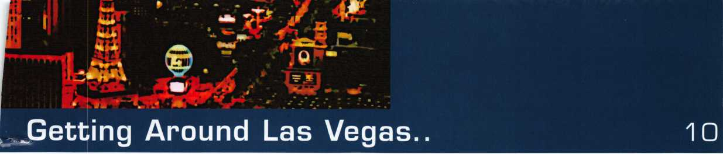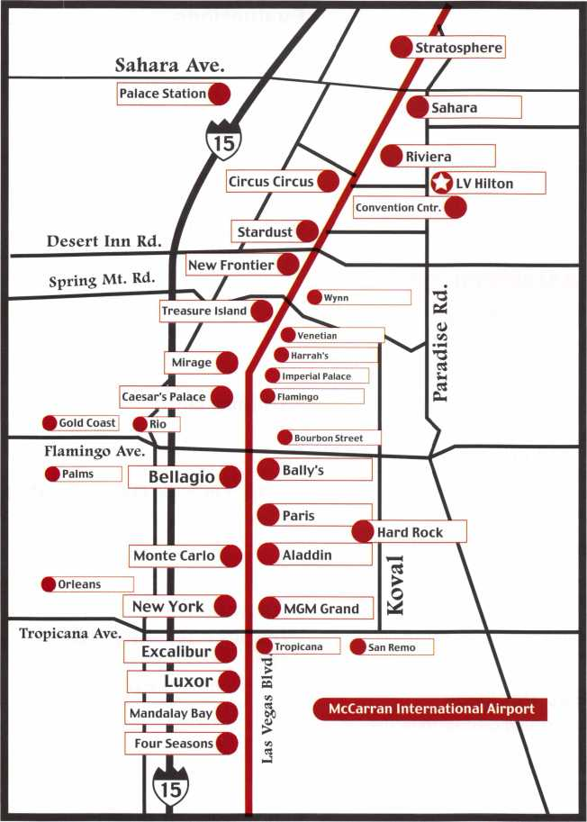

**AIRPORT INFORMATION**

Las Vegas and the surrounding area is serviced by  
McCarran International Airport. The Las Vegas  
Hilton is 3.5 miles from the airport. There are more  
than 1,200 taxi cabs and a dozen limousine compa-  
nies serving Las Vegas. There are also several shut-  
tle services that operate from McCarren. Taxi is a  
minimum of $12 (typical cost]. Bell Transportation  
(Shuttle) is $4.75 one way.

**AVIS CAR RENTAL**

ALOA 2006 attendees receive special discounted  
rates from Avis for this convention by calling Avis at  
800.331.1600 or visit the ALOA website  
[www.aloa.org/convention](http://www.aloa.org/convention) & Click on the AVIS  
Discount Link. Don’t forget the ALOA Discount Code  
B466699 to receive your discount.

**ACCOMMODATIONS**

Guest room blocks with discounted guaranteed  
rates have been reserved at the Las Vegas Hilton  
as the official host hotel for ALOA 2006 attendees.  
Reservations can be made by calling the Las Vegas  
Housing Service at: 1-888-892-5822, or at 1-702-  
386-7813, or you can fax the form in this brochure  
to the housing service at 702-386-7818 or make  
reservations online at [www.aloa.org](http://www.aloa.org).

**PARKING**

Las Vegas Hilton - Complimentary Valet Parking and  
Self Parking are available at the Hilton for all regis-  
tered guests. Non hotel guests may be charged a  
daily parking fee if space is limiited.

Las Vegas Convention Center - Parking is available  
at the main entrance and the cost is currently at $5  
per day. There are no in and out privileges.



The Las Vegas Hilton in compliance with the Public Accomadation provision of the Americans with Disabilities Act (ADA), has 50 guest rooms for mobility impaired guests. All areas of the hotel are easliy accessed from the hotel entrances, lobbies and elevators. Public restrooms throughout the hotel are ADA accessible. Direct access for mobiliity impaired guests is available in all hotel restaurants. Then entire main floor of the Hilton Theatre is wheelchair accessible. ADA access to the Convention Center Skywalk is located at the South Paviilion “B” Doors. TDD telecommunica­tions devices are available for hearing impaired guests. Guide animals are welcome in all guest areas and rooms. A limited number of wheelchairs are available.

The Las Vegas Convention Center has mobility impaired parking spaces at the main entrance and side entrances of the facility. Automatic doors are at all entrances. Wheelchairs are available for emergency use only. For Wheelchair rental information, contact the Las Vegas Visitors Information Center for a list of wheelchair rental companies. TDDs (Telecommunications Device for the Dead) are permanently installed at various pay phones throughout the facility. Volume control pay phones are also available at the permanent pay phones. Auxilary Aids - Assistive Listening System and Portable Wheelchair Lifts are also available upon request.

**Registration Instructions**

**& Policies**

**REGISTRATION**

**CHECKLIST**

* Complete Form 1.
* Complete Form 2 if you are attending classes
* Complete Form 3 if you are taking the PRP or STPRP evaluations.
* Send registration Forms 1,2, and 3 with a check to:

RO. Box 972143 Dallas, TX 75397-2143

or if paying by credit card, fax to 214-819- 9736 or mail to 3500 Easy St., Dallas, TX 75247

* If you are making hotel reservations com­plete Form 4 and submit by mail or fax to:

ALOA 2006

Las Vegas Convention & Visitors Authority

* 3150 Paradise Rd. S.,

Las Vegas, NV 89109-9096

or you can make reservations online at our website at:[www.aloa.org/convention](http://www.aloa.org/convention)

Be sure to mention ALOA 2006 when mak­ing your travel plans.

**REGISTRATION**

**INFORMATION**

Each individual locksmith, member or non­member, must fill out a separate registra­tion form. No phone registrations will be accepted. Complete all applicable portions, including selection of classes and semi­nars.

Return to:

ALOA

P.O. Box 972143 Dallas, TX 75397-2143

* Applications for any classes for which a government/institutional purchase order is submitted must provide a $50 deposit at the time of registration.
* A check made payable to ALOA or credit card information MUST accompany this registration. Credit card registrations ONLY: FAX (214) 819-9736, or mail to 3500 Easy Street, Dallas, TX 75247.
* Registrations will not be processed with­out payment. Your name will appear on your badge exactly as printed on your regis­tration form. Copy this form for additional

individuals who wish to register for conven­tion activities.

* Be sure to select first, second and third choice of classes for each day. Number choices in the spaces provided on the next page.
* CANCELLATION POLICY: Full credit will be given to cancellations received prior to June 10, and an 80 percent credit from June 10-30, 2006. No credit given after June 30, 2006.

All cancellations and requests for refunds must be in writing.

**EXPLANATION OF**

**REGISTRATION**

**PACKAGES**

Full Deal Package

Includes four full-day classes, breaks and lunches on full-day class days, two half-day classes, three days of the Security Expo, evening seminars, the Kick-Off party and the Dinner Banquet discount.

High Roller Package

Includes two full-day classes, breaks and lunches on full-day class days, two half-day classes, three days of the Security Expo, evening seminars, the Kick-Off party and the Dinner Banquet discount.

Sure Bet Package

Includes two half-day classes, three days of the Security Expo, evening seminars, the Kick-Off Party and the Dinner Banquet dis­count.

Full-day Classes

Includes one class with lunch and break on class day, and Expo. Select the class you want to attend.

Half-day Classes

Classes start at 8am and go until 11am. There are no breaks during these sessions, and no lunch is supplied.

PRP and STPRP Evaluations

The PRP exam will be administered on Thursday night, July 13. The test is NOT a part of any convention package, so if you wish to take the PRP exam at the conven­tion, you MUST sign up and pay the exam fee. (Fees are listed on page 22, and the PRP exam schedule can be found on page 8.) You must also fill out Form 3 on page 24.

BONUS SUNDAY

A fulll day of classes will be held on Sunday, July 16 bringing the grand total of ALOA’s full-day class schedule to five. The bonus Sunday classes are ideal for the locksmith who can’t get away during the week or for anyone who is trying to squeeze the most value out of their registration fee.

Exhibits Only

Admission to all three days of the ALOA 2006 Security Expo.

ALOA Dinner Banquet Only

Admission for 1 individual to the ALOA Dinner Banquet on Saturday, July 15.

ALOA Open Golf Tournament Wednesday, July 12,

2006

Registration fee is $150. This includes transportation, lunch, golf cart, beverages throughout the course and prizes for every­one. Proceeds benefit the ALOA Scholarship Foundation, and all registration is tax deductible.

Cancellation of Classes

ALOA reserves the right to cancel any class that does not have a minimum of 10 participants registered. Classes may not be attended without registration.

ALOA Member Discounts

In order to qualify for the ALOA member discounted registration fee, current mem­bership dues must be paid and you must have a valid ALOA membership number.

<

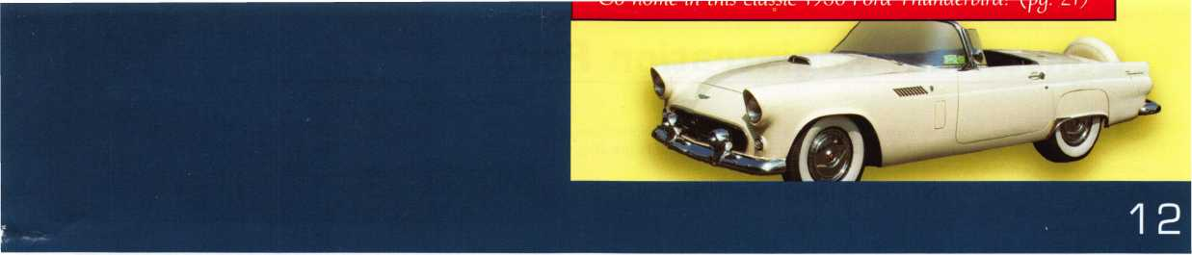

Neuu Membership

All applicants for ALOA membership may take the ALOA member discounted registra­tion fee if their application is received at or before time of registration with full payment and a membership number assigned.

Complete All Forms

All forms must be filled out completely and legibly. Please print or type all information. If the forms are not legible, there may be a considerable delay in processing your regis­tration. Be sure to list:

* ALOA membership number, if you are a member
* Zip Code and complete address on all forms
* Phone number; including area code

You must complete the appropriate sections of the registration form in order to register for classes. Please be sure you have filled this information out completely, including your alternate choices to ensure placement in the class of your choice.

Mail Delays

ALOA cannot be responsible for postal delays, so mail your registration forms early!

Payment

All payments to ALOA must be in U.S.

Funds. Payments may be made by check or money order or charged to your MasterCard, VISA, American Express or Discover Card. Any charge received with an invalid card number or an amount over the credit limit will result in a delay in process­ing the registration. There is a $25 mini­mum on all credit card purchases. Upon receiving a check returned to ALOA for insufficient funds, registration will automati­cally be cancelled and will not be reinstated until a money order or cashier’s check is received as replacement. This may result in the loss of original registration choices. There will be a $25 service charge on all returned checks.

ALL PRE-REGISTRATIONS MUST BE PRE-PAID.

Government/Institutional

Payment

Government/Institutional purchase orders are acceptable. However, any classes for which a government/institutional purchase order is submitted the applicant must pro­vide a $50 deposit at the time of registra­tion. This amount will be refunded to the individual if:

* Cancellation is received prior to June 21, 2006 or
* If the individual attends classes covered on the government/institutional purchase order.

The amount of $50 is not refundable if the individual cancels his/her registration after June 21, 2006.

Age Requirement

All applicants for classes must be at least 16 years old for ALOA members and 18 years old for non-members. Persons under age 16 may be permitted to attend class only if approved by the Education Manager and the instructor. Admittance to the Security Expo for children under five years old is free. The fee for children ages 6-15 to the Security Expo is $5 before June 21 or $10 after June 21, 2006. An adult must accompany anyone under the age of 16.

Certificates

Certificates will be issued to all participants who complete full day classes. The certifi­cate will be printed from the information that appears on the participant’s registra­tion form. Be sure to complete the form leg­ibly. PLEASE PRINT OR TYPE.

Tools Needed

Students may be required to bring tools and materials to class. Be sure to read the class description for the requirements of each class. Lab fees may apply to certain classes.

Proficiency Registration Program

The Proficiency Registration Program Evaluation will be given on Thursday, July 13, from 6pm - 10pm. Pre-registration is required for the evaluation. June 21, 2006 is the deadline for receipt of PRP registra­tion. Due to time constraints in developing the test packets, no exceptions will be made for late requests. The ALOA PRP evaluation will be held for three levels of locksmith cer­tifications: CRL (Certified Registered Locksmith), CPL (Certified Professional Locksmith) and CML (Certified Master Locksmith).

The SafeTech PRP evaluation will be avail­able at ALOA 2006. There are two levels to the STPRP To achieve the first level certifi­cation, you must pass a written examination consisting of 17 mandatory categories on safe and vault technology. To achieve the next level you must pass the first level mandatory test along with a second advanced test. To take either evaluation, you must submit the PRP registration form included with this brochure, in addition to completing the ALOA 2006 registration form.

Note: The deadline for all PRP registration is June 21, 2006.

ALOA Education Units

Students attending ALOA classes will earn ALOA Education Units (AEUs) based on the length of the class. Eight hour classes earn the student 1.0 AEU, and 16-hour classes earn 2.0 AEUs. The primary purpose of the AEU is to provide a permanent record of the educational accomplishments of an individ­ual. Any AEUs earned after Jan. 1, 1993 can be applied toward Registered Locksmith (RL) status. Twelve AEUs are required for the RL designation.

Prerequisites

It is the student’s responsibility to make sure that he or she is prepared to take a class by having fulfilled all prerequisites as stated in the class description. If an instruc­tor determines that a student is not pre­pared, s/he may request that the student leave the class and the student will not be reimbursed for the class or any other expenses.

**Convention Registration Form**

**FORM**

**1**

□ Yes!

I want to advance my career. Please process my ALOA 2006 Registration Form.

I understand that ALOA 2006 is a public event and that I may be photographed while attending  
classes, the Security Expo, and related events.

PLEASE TYPE OR PRINT YOUR INFORMATION

* ALOA Member #
* Non-Member

PRP/STPRP Status: □ RL □ CRL □ CPL □ CML □ CPS □ CMST Is this your first ALOA Convention? □ Yes □ No

REGISTRANT:

First Name

Ml

Last Name Name for Badge Company Name Street or PO Box

City

State or Providence

Zip/Postal Code

Country

Work Number

Home Number Fax Number E-mail

Is this an address change? □ Yes □ No

NON-LOCKSMITH GUESTS (complete only if attending)

First/Last Name:

First/Last Name:

Would you like information on sharing hotel room costs? □ Yes □ No

FORM OF PAYMENT:

* Check Number
* Charge: □ Check □ MasterCard □ Visa □ Discover □ American Express

Card Account Number:

Card Expiration Date:

Print Name:

Signature:

PACKAGES/INDIVIDUAL CLASSES

Before June 17 After June 17

Full Deal Package (PKG1)

* Member $695 $795 =
* Nonmember $1065 $1095 =

High Roller Package (PKG2)

* Member
* Nonmember

Sure Bef Package (PKG3)

* Member
* Nonmember

Full-Day Classes (INDF)

* Member
* Nonmember

Half Day Classes (HALF)

* Member
* Nonmember

Bonus Sunday Class (BONS)

* Member

|  |  |
| --- | --- |
| $495  $720 | $595 =  $820 = |
| $180  $290 | $210 =  $340 = |
| $225  x | $265 =  X |
| $335  x | $395  X |
| $85  X | $100 x = |
| $125 $150  X X  with package  $125 $150  X X | |
| $120 | $140 |

X X =

IF PAYING BY CHECK Send registration  
forms 1, 2, and 3 with your check to: ALOA  
P.O. Box 972143 • Dallas, TX 75397-2143

IF PAYING BY CREDIT CARD Send registration forms 1, 2, and 3 with your credit  
card information to: ALOA • 3500 Easy Street • Dallas, TX 75247 -or- FAX registration  
forms 1,2, and 3 with your credit card information to: ALOA 214.819.9736

EXPO, MEETINGS, EVALUATIONS AND EVENTS

|  |  |  |
| --- | --- | --- |
|  | Before 6/17 | After 6/17 |
| EXHIBITS ONLY |  |  |
| □ Member (EXH) | FREE | $15 |
| □ Nonmember (EXH) | $15 | $25 |
| □ Non-Locksmith/Guest (EXG) | $5 | $10 |
| PRP AFTER CLASS ELECTIVE TEST- | -MEMBERS ONLY | |
| Check a box for each day that you will be taking a PRP elective test after the class: | | |
| □ Monday (PCT2) | $10 | $15 |
| □ Tuesday (PCT3) | $10 | $15 |
| □ Wednesday (PCT4) | $10 | $15 |
| □ Sunday (PCT5) | $10 | $15 |
| PRP EVALUATION (PRP1) |  |  |
| THURSDAY, JULY 13, 2006 • 6-10PM | |  |
| □ Member | $35 | N/A |
| □ Nonmember | $190 | N/A |
| STPRP Evaluation, CPS (SCPS) |  |  |
| □ ALOA/SAVTA Member | $80 | N/A |
| □ Nonmember | $235 | N/A |
| STPRP Evaluation, CMST (SCMS) |  |  |
| □ ALOA/SAVTA Member | $125 | N/A |
| □ Nonmember | $280 | N/A |

Dinner Banquet Only

* With package (BANP) $25 x
* Member/Nonmember (BANQ) $50 x
* Child under 12 (BANC) $30 x

ALOA Open Golf Tournament (GOLF)

* Member/Nonmember $150 x
* Shirt Size

Tour (all prices are Per-person) (TOU1)

|  |  |  |
| --- | --- | --- |
| □ Desert to Diamond | $60 x | = |
| Fees and Materials |  |  |
| Lab Fees |  |  |
| □ 105 | $100 X | = |
| □ 106 | $250 x | = |
| □ 111 | $25 x | = |
| □ 113 | $100 x | = |
| □ 115 | $300 x | = |
| □ 209 | $40 x | = |
| □ 307 | $30 x | = |
| □ 308 | $50 x | = |
| □ 309 | $190 x | = |
| □ 411 | $40 x | = |
| □ 412 | $70 x | = |
| □ 606 | $125 x | = |
| PRP Resource Guide (PRG) |  |  |
| □ Member | $20 x | = |
| □ Nonmember | $25 x | = |

Safe Technicians Reference Manual (STRM)

* Member $135
* Nonmember $155

Membership RENEWAL If applying for NEW membership, please complete the application (Form 5)

Annual Dues

* Active/Allied Member (US&usTemtones)/Prob. Mem (MEM1 )$ 155
* Int'l Member (MEM2) $130
* Retired Member (MEMR) $40
* Canadian Air Mail (AIR1) $20
* Overseas Air Mail (AIR2) $50

Application Fee (APPL) $50 **(waived)**

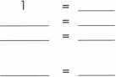

□ Nonmember

TOTAL AMOUNT:

PAYABLE IN U.S. FUNDS ONLY!

**FORM**

**2**

**Class and Seminar Registration Form**

|  |  |
| --- | --- |
| SUBMIT THIS FORM WITH REGISTRATION FORM 1 |  |
|  | Due to class limits, mark your first, second and third choices.  Multi-day classes are charged as separate classes unless purchased with a package. These classes are highlighted on pages 5- 8.  Be sure to include your lab and/or PRP fees on Registration Form 1. |
| -Name | ALOA Member Number: |
| Phone Number: | |
| Fax Number: | |



Date

Saturday, July 8, 2006  
Sunday, July 9, 2006  
Monday, July 10, 2006  
Monday Seminar  
Tuesday, July 11, 2006  
Tuesday seminar  
ednesday, July 12, 2006  
Friday, July 14, 2006  
Saturday, July 15, 2006  
Sunday, July 16, 2006

First Choice

(Indicate Class Number)

PRP

After

Class

Lab

Fee

Second Choice  
(Indicate Class Number)

PRP

After

Class

Lab

Fee

Third Choice  
(Indicate Class Number)

PRP

After

Class

|  |  |  |  |  |
| --- | --- | --- | --- | --- |
|  | □ □ |  | □ □ |  |
|  | □ a |  | □ □ |  |
|  | □ □ |  | □ □ |  |
|  |  |  |  |  |
|  | □ □ |  | □ □ |  |
|  |  |  |  |  |
|  | □ □ |  | □ a |  |
|  |  |  |  |  |
|  |  |  |  |  |
|  |  |  |  |  |

□

□

□

□

□



★

This symbol indicates a class that offers a PRP elective exam at the end of class for an additional fee. PRP Certified class exams  
will take place immediately following the end of class from 5 - 5:30pm with 30 minutes a exam time allowed. The single  
elective exam option is available to ALOA members only. A single elective after class PRP exam is approved  
for 1/4 point towards the ALOA PRP Recertification requirements.

**Proficiency Registration Program**

**SUBMIT THIS FORM WITH REGISTRATION FORM 1**

**FORM**

**3**

Proof of the PRP certification assures your customer that he/she is dealing with a professional that has the  
education and technical competence to provide safe and efficient service. The PRP separates you from those  
who claim to be professionals but do not have your knowledge or training.

Sitting for a PRP exam that includes the Mandatory categories or includes at least 8 electives is approved for  
point towards the ALOA PRP Recertification requirements.

If you plan to participate in the PRP, include the proper PRP fee on the convention registration form, com-  
plete the PRP registration form.

Note: The PRP Resource Guide and the Safe Technician's Reference Manual can be ordered on page 20.

CANDIDATE (please type or print):

|  |  |  |  |
| --- | --- | --- | --- |
| Last Name: | First Name: |  | Ml: |
| Address: | | | |
| City: | State: | Zip Code: |  |
| Work Phone: | Home Phone: |  |  |
| Social Security Number: | | | |

Have you ever taken the PRP/STPRP before? □ Yes □ No

MEMBERSHIP STATUS:

Application will not be accepted at the member rate without valid current membership number.

* ALOA Member Number
* SAVTA Member Number
* Non-member

EVALUATION ALOA 2006 CONVENTION

Level Testing For:

□ CRL □ CPL □ CML □ CPS □ CMST

In the listings at right, place a check mark to the left of your choices. Below are descriptions of  
each level and its requirements.

CRL Level: L 00 + two (2) Electives. Choose the Mandatory and two (2) Electives.

CPL Level: CRL + twelve (12) Electives. If you pass the CRL in one try choose any twelve (12)  
Electives. Otherwise, choose any nine (9) Electives. Do not choose any Electives you have pre-  
viously passed.

CML Level: CPL + nine (9) Electives. Choose any nine (9) Electives. Do not choose any  
Electives passed previously for CRL or CPL.

Re-Take CRL Level: If you did not pass the Mandatory, you must choose the Mandatory.  
You may also take one (1) or two (2) Electives if you did not pass one (1) or two (2) Electives,  
but you may not take extras.

Re-Take Other Level: If you passed the Mandatory, choose any nine (9) Electives.

CPS Level (S-00): Because of the time required this cannot be taken with any other selec-  
tion.

CMST Level (S-01): The first level (S-00) of the STPRP (CPS) must be passed before taking  
the second level (S-01) of the STPRP. Because of the time required this cannot be taken with  
any other selection.

**IMPORTANT: PHOTO ID REQUIRED  
FOR ADMITTANCE TO EXAM ROOM.**

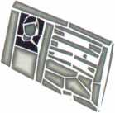

**□ Thursday, July 13, 2006 • 6pm-10pm**

|  |
| --- |
| Note: Application will be returned if choices are not indicated. |
| Select/CAT#/Elective Name  □ L-00: Mandatory Categories |
| □ L-03: Domestic Auto |
| □ L-04: Foreign Auto |
| □ L-05: Door Closers |
| □ L-07: Life Safety Codes |
| □ L-08: Cylinder Servicing, High Security |
| □ L-l 1: Cylinder Servicing,Special Application |
| □ L-l 2: Cylinder Servicing, Tubular Key |
| □ L-l3: Basic Electricity |
| □ L-l 6: Exit Hardware & Alarms |
| □ L-20: Locks, Keyless Mechanical |
| □ L-21: Locks, Lever Other Than Safe Deposit |
| □ L-22: Locks, Motorcycle |
| □ L-24: Locks, Safe Combination Type |
| □ L-25: Locks, Safe Deposit |
| □ L-26: Locks, Time |
| □ L-28: Lockset, Installation |
| □ L-31: Master Keying, Advanced |
| □ L-32: Safe Installation |
| □ L-33: Safe Opening and Servicing |
| □ L-34: Vault Installation and Service |
| O L-38: Interchangeable Core, Small Format |
| □ L-39: Interchangeable Core, Large Format |
| □ L-40: Electro-mechanical Access Control |
| □ L-41: Hardware, Door-Related |
| □ L-42: Alarms |
| □ L-43: Locks, Detention |
| □ STPRP Exams |
| □ S-00: CPS |
| □ S-01: CMST |

**WARNING:**

**This PRP Registration must be received at ALOA no later than June 13, 2006.**

**FORM**

**4**

**Hilton Hotel Reservation Form**

**Mail this FORM with your CHECK or credit card number to:**

**ALOA Housing Center • Las Vegas Convention & Visitors Authority 3150 Paradise Rd. S. • Las Vegas, NV 89109-9096 CALL 1-888-892-5822 • FAX 702-386-7818**

GUEST (please type or print):

Last Name: First Name: Ml:

|  |  |  |
| --- | --- | --- |
| Address: | | |
| City: | State: | Zip Code: |
| Phone: | Fax: |  |
| E-mail address: | | |
| HOTEL INFORMATION |  |  |
| Name of Persons sharing accommodations: |  |  |

Arrival Date Departure Date # of nights: Room Type:

Q 1st available/No preference Q Non-smoking room Q Smoking Q Accessible Room

PAYMENT METHOD

* Check Number

I authorize the Las Vegas Hilton to charge my account for one night's deposit and all applicable taxes.

* Charge: □ Check □ MasterCard □ Visa □ Discover □ American Express  
  Card Account Number:

Card Expiration Date:

Print Name:

**ALOA 2006**

**Annual Security Expo  
and Convention  
Las Vegas, Nevada  
July 8-16, 2006**

**To make reservations,**

we request that you either:

Make your reservations on the internet at  
<http://www.aloa.org>

**ROOM RATES (109.00 for Double/Single)  
• TAXES (9%)**

In order to take advantage of the special  
ALOA 2006 Convention rates, be sure to  
book your reservation by June 13, 2006.

After that date, the official ALOA 2006  
blocks will be released and the hotels  
may charge significantly higher rates.

All rates are per room night and are subject to a  
9% tax (subject to change). The rates at the  
Hilton are for Single/Double occupancy.

The hotel may charge for additional occupants.

**DEPOSITS**

The Hilton hotel requires a credit card guarantee or  
check deposit for one nights room and tax with  
each reservation request. Requests received without  
a credit card guarantee or check deposit will be  
returned. Please fill out the credit card information  
entirely or mail a check payable to the

Signature:

CUT OFF DATE: JUNE 13, 2006

Reservations requested after the cut off date and/or after the  
room block is filled are subject to availability and may not be  
available at the group rate.

**ALOA Housing Center  
Las Vegas Convention & Visitors Authority  
3150 Paradise Rd. S.**

**Las Vegas, NV 89109-9096**

**DO NOT SEND THIS  
FORM TO ALOA or HILTON.**

PLEASE USE ONE FORM PER ROOM.

MAKE COPIES AS NEEDED.

FORMS MUST BE COMPLETELY FILLED OUT.

**FOR HOTEL USE ONLY**

Please Fax Confirmation Number back to Guest.

*Confirmation Number*

**FORM**

5

**Airline/ Car Rental Reservation**

**CORPORATE TRAVEL, INC.**

The official travel agency of ALOA 2006, and has negotiated discounted air fares for all attendees. Book early to ensure the lowest possible airfare. Certain restrictions may apply.

CORPORATE TRAVEL, INC.

5205 North O’Connor Suite 110 Irving, TX 75039

For assistance with travel needs 1.877.752.0391

The annual Security Expo is the icing on the cake for ALOA 2006. Each year, newly refreshed and educated students take to the show floor, where hundreds of exhibitors are showing off their latest products. Pick them up, kick the tires and ask questions of the exhibitors about their products. It’s the perfect chance for you to learn about new products. It’s the perfect chance for you to learn about new products that you may sell to your own customers as a value-added service - and you can even take advantage of show discounts in the process! Keep in mind all the freebies going around, on the show floor each year. It’s truly shaping up to be a Vegas-Style "show” for all our participants.

The future is unfolding right before your eyes. Don’t gamble it away by passing up the industry’s biggest and best show. Come to Vegas this year for ALOA’s annual Convention and Security Expo. You won’t regret it.

ALOA 2006 SECURITY EXPO will be located in Hall C5 on:

Thursday, July 13 • Noon-5pm Friday, July 14 • Noon-5pm

Saturday, July 15 • Noon-4pm - **WIN A ‘56 T-BIRD AT 3:30pm!!!! - Must be present to win.**

Travel Fast & Easy  
with Avis.

Avis takes care of you for business or pleasure. Our special meeting rates and discounts makes it easy for you to incorporate leisure fun into your plans.

Your special low Avis rates are good from one week before to one week after your meeting so you can take in the sights and explore. "We try harder" to help you enjoy your meeting with great rates and time saving services.

Call 1-800-331-1600 and resen/e your Avis car for this meeting.

Be sure to mention this special meeting Avis Worldwide Discount (AWD) number: B466699

Associated Locksmiths of America  
Convention and Security Expo  
July 8-16, 2006  
AWD# B466699

Am

Weury

harder.

Avis features GM cars.

c 2000 Avis Rent A Car System, Inc.

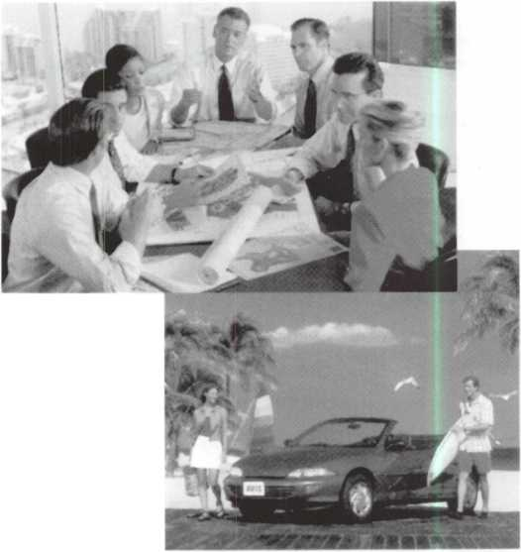

**MEMBERSHIP APPLICATION**



Welcome to the Associated Locksmiths of America, Inc., an association for persons involved in the locksmith/access control industry as locksmiths, security consultants, educators, manufacturers and distributors.

To apply for membership, please complete this application and submit it with the dues for the current year, and your business card, company letterhead, or other suitable proof of employment.

All of the following questions MUST be answered before this application may be processed. Please type or print.

TYPE OF MEMBERSHIP

Please check only one.

* ACTIVE MEMBERSHIP Persons actively engaged in the locksmith/access control industry for a minimum of two years and have acheived one of ALOA's recognized program designations.
* PROBATIONARY MEMBERSHIP Persons undergoing training to qualify as an Active member, and have not received one of ALOA's recognized program designa­tions. No person shall be a Probationary member for more than three years.
* ALLIED MEMBERSHIP Persons whose position in the locksmith/access control industry relates to locksmiths, and cannot qualify for any other class of membership.

APPLICATION AND FEES

A $50 application fee, appropriate annual dues, and your business card, company letterhead, or suit­able proof of employment must accompany this application. Your second year's dues will be prorated based on the date your application was received by ALOA.

FINAL CHECKLIST us

Dollars

* Application Fee 50.00

ANNUAL DUES STRUCTURE

* Active/Probationary/

Allied Member 155.00

U.S. + U.S. Territories (PR, VI, Guam)

(DUES: 130.00 +

LEGISLATIVE ASSESSMENT FEE:25.00)

* Active/Probationary/

Allied Member 1 30.00

Non U.S. Resident or Non U.S. Territories

OTHER FEES

* Canadian Air Mail 20.00
* Overseas Air Mail 50.00

Total Enclosed

CANDIDATE (PLEASE TYPE OR PRINT)

|  |  |  |  |
| --- | --- | --- | --- |
| Name □ Mr. □ Mrs. □ Ms. | First Name | Last Name Ml | Designation |
| Business Name | | | |
| Mailing Address | | | |
| City | State | Zip Code Country | US County |
| Work Phone | Home Phone | Fax |  |
| Email Address | Website | n |  |
| Date of Birth (Required) | Social Security Number | Do Not List in the Directory |  |
| Directory Address (if different than mailing address) | | | |
| City | State | Zip Code Country |  |

Are you licensed to perform locksmithing/access control in your state? □ Yes □ No If "yes",

license number

PROFESSIONAL INFORMATION

1. Are you a...

* Sole Owner □ Corporate Officer
* Partner □ Employee □ Student

1. Are you currently employed in the locksmith/access control industry?

* no □ yes, years

1. How did you learn locksmithing or locksmith/access control work?

4. ALOA Sponsor (not required)

Sponsor's ALOA Number

Please note, your application will be processed with a 90 day waiting period.

5. Names and Phone #'s of two industry-relat­ed references (required):

*Name*

*Phone* #

*Name*

*Phone* #

6. IMPORTANT: Have you ever been convicted of a crime? □ No □ Yes

If yes, please give details on a separate sheet. All crimes are reported to the Membership Department for review.

METHOD OF PAYMENT

□ Check □ MasterCard □ Visa □ Discover □ American Express

|  |  |
| --- | --- |
| Card Number | Expiration Date |
| Please print name as it appears on card |  |

Cardholders Signature

I understand and consent that in the course of reviewing this application ALOA may review publicly available information for the purpose of verifying the information submitted and do a background check.

I certify that all statements are true and, if accepted as a member, I agree to abide by the rules, regulations, and Bylaws of ALOA, and further agree to adopt the Code of Ethics of ALOA as my own, and adhere to it to the best of my ability. Should my membership be discontinued, I agree to return my mem­bership card, and cease use of all ALOA insignia.

**Return to**

**ALOA • 3500 Easy Street  
Dallas, TX 75247  
Fax: (214)819-9736**

Revised 1 2/05

**Tuxedo and suit sendees:**

(for Banquet)

**The ALOA Board of Directors requires that people attending the ALOA Security Expo dress appropriately. No one who is dressed improperly will be admit­ted to any of the convention events. "Events" include, but may not be limited to, classes, par­ties, receptions and the Trade Show. Everyone is expected to be clean and neat. Shirts with col­lars are required. T-shirts are not allowed. No clothing that has printing can have profanity or offensive messages. Help raise the image of the profession of locksmithing by complying with this requirement.**



Men’s Wearhouse 1159 E. Twain Ave.

Suite 104-107 (Parkplace S.C.]

Las Vegas, NV 89109 Store ID #2401

Open:

M-F, 10am-9pm SAT, 9:30am-6pm SUN, 11am-5pm

**PRE-ORDER YOURS TODAY!!**

Preorder at home and pick up at the convention in Vegas. Be sure to mention store #2401.

**OPEN SUNDAY FOR RETURNS**

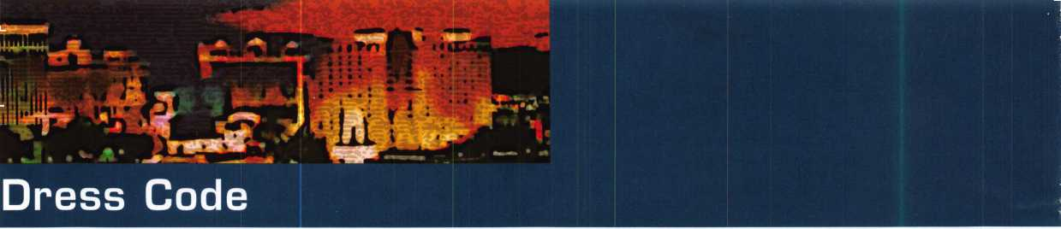

*56tk dtitiw&iiti l&iHtiefy 7£fiJituct*

Saturday, July 15, 2006 • 7pm-11pm

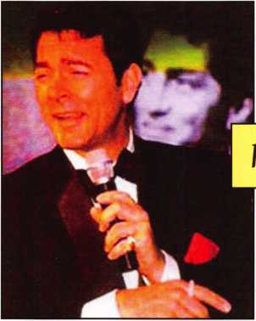

Relive the 1950's!

*Sr Sftfntrw*

This phenomenal group, featuring Sebastian  
Anzalado as “Frank”, Andy DiMino as “Dean”,  
and Lambus Dean as “Sammy”, will certainly  
astound your group as they bring back to life  
the music, comedy, and camaraderie of the  
real “Rat Pack”!

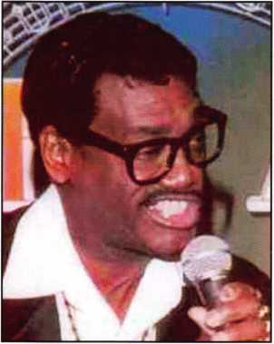

Enjoy a fabulous dinner, entertainment, show-  
girls, all while mingling with charter members.

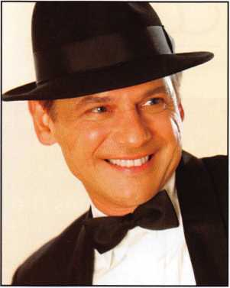

**The ALOA 50th Anniversary Dinner Banquet  
is a formal event. Black-tie is preferred. A  
dark suit or dark sport coat and pants are  
acceptable for men. Formal evening attire is  
acceptable for ladies..**

20



sponsored by:

**FKI**

SECURITY GROUP

*(@>*

Security & Safety

Proven Source. Proven Solutions^



SECURITY PRODUCTS

**One Lucky Member Attendee at ALOA 2006 is going home with  
this gorgeous mint-condition 1956 Ford Thunderbird.**

**A ticket will be given to each ALOA Member who registers and attends the  
show. Someone has to win it, and it might as well be YOU!**

**(Must be present to win. Board Members, Exhibitors, Employees,  
Family Members of Employees, and nonmembers are not eligible**

**for this door prize.)**

**2006 Exhibitors**

(List current as of 4/3/06)

1-800-LOCKSMITH 1-800-UNLOCKS, INC 1st In Hardware, Inc. Aable Locksmith A & B Safe Corporation- A-1 Security Mfg. Corp Abloy Ooor Security Abus Lock Company Access Hardware Supply Accredited Lock Supply Adams Rite Mfg.

Company Adel Fingerprint Technologies ADI, Inc.

Adrian Steel Company Advanced Diagnostics Alarm Controls Corp. Alarm Lock Systems Allstate Insurance Company All 5 Lock Altronix

American Eagle Lock Co. American Safe Technologies American Lock American Security Products

Arco Industrial Corp. Arrow Lock ASR Inc.

ASSA Inc.

Auto Tech Security Systems Bad Dog Tools Bianchi USA, Inc. BiLock/Login Lock Biogate, Inc.

Blackhawk Products

BMG Door Hardware,

Inc.

Boyle & Chase CAL Security Enterprises Camden Door Controls CCL Security Products CPFilms, Inc.

Clark Security Products Clearstar CODELOCKS, LLC Commercial Van Interiors Compx Security Products Corporate Safe Specialists Corbin Russwin C.R. Laurence Cross Country Automotive D & D Technologies Dida Locks DKG Doorking Defiant Safe DETEX Corporation Don-Jo Manufacturing Inc.

Dorma Architectural Hardware

Dugmore and Duncan, Inc.

Eclipse Industries ekey USA Systems Elock USA

ESP Lock Products Inc. FKI Security Group H.L.Flake

Framon Mfg. Company, Inc.

FUKI, Co. Ltd Gardall Safe Corporation GE Supra Products. Inc.

GMS Industries Guardian Safe Hammerhead Industries HES, Inc.

High Tech Tools Homeowners Marketing Services Howard Keys HPC, Inc.

Hurd Corporation IDN Corporation Inkas Safe Mfg. Intermountain Lock & Security

Ingersoll Rand Sec.

Technologies Jet Hardware Mfg.co. JMA USA Kaba llco Corp.

Kaba Mas Corp.

Keedex Manufacturing

Keri Systems, Inc.

Key-Bak

Keyless Ride

KSP

Kustom Key

Kwikset (formerly BDHHI) La Gard Inc.

LAB Security Lectro-Truck/IMS, Inc. Lockmasters, Inc.

LSI

LS Group Locksmith Ledger International Locksmithing Unlimited Lucky Line Products, Inc. M.A.G. Manufacturing Main's Lock Supply Major Manufacturing,

Inc.

Markar (Div. of Adams Rite)

MARKS, U.S.A.

Master Lock Company Maxess Card Systems MBA-USA, Inc.

MDS Incorporated MTS International Medeco

Midwest Wholesale Hardware

Mil-Comm Products Mul-T-Lock USA, Inc Mustang Company Norton (Div of Assa Abloy Amer)

Olympus Lock Company OSI Security Devices Pacific Lock Company Pacific Security Products PDQ Manufacturing Perma-Vault Safe Co. Peterson Manufacturing Phoenix Safe International Pop-A-Lock

Positive Identity Solutions Powermate/LP International PRO-LOK

Professional Business Products Promet Safe Protex Safe Co Rodman & Co ROFU International Corp Rutherford Controls Inc. - RCI

Salesgenie.com

Sargent & Greenleaf, Inc. SARGENT Manufacturing Company Schwab Corp.

Scorpion Locks of America, Inc. SecuriFort

Securitech Group, Inc. Securitron Magnalock Corp.

Security Distributors Inc. Security Door Controls Security Lock Distributors Select Hinges Simon Voss Technologies Southwest Specialty Products

STRATTEC Security Corp. Streetwise Security Products

Strong Arm Security, Inc. The Determinator The Locksmith Store The National Locksmith TimeMaster, Inc. Townsteel Incorporated U.S. Lock Corp.

Ultra Lift Victor e-lok Videx

Wilson Safe Company Yale (Div of Assa Abloy Amer)

Zipf Lock Co.

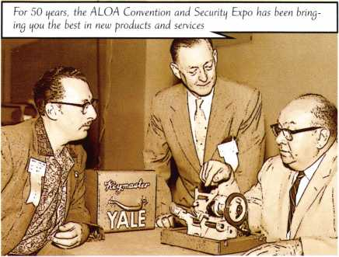

**Don’t miss the Security Expo, which will fea-  
ture the latest and greatest products and  
services on the market. This internationally  
renowned show will be held at the famed Las  
Vegas Convention Center, just a short stroll  
away from the Las Vegas Hilton. The show  
schedule is July 13-15, 2006.**

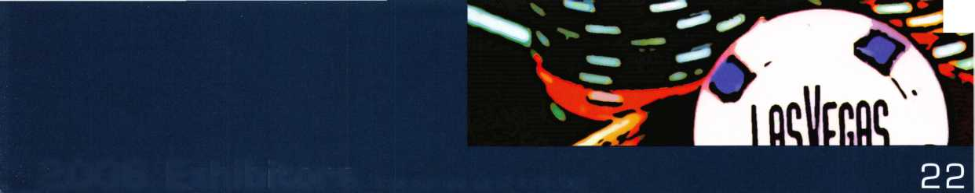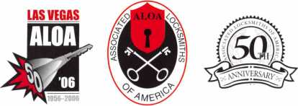

Associated Locksmiths of America, Inc.  
ALOA 2006

International Convention  
and Security Expo

3500 Easy Street  
Dallas, Texas 75247  
(800) 532-2562 phone  
(214) 819-9733 fax

[www.aloa.org/convention](http://www.aloa.org/convention)

**SPONSORS:**

(as of 3/19/06)

AMSEC

ASSA

ARROW

ClearStar Security Network  
IR Security & Safety  
KABA, KABA ILCO, KABA MAS  
Lucky Line Products  
Medeco

ASSA Retrofit Security Solutions  
STRATTEC, INC.

Videx

PRSRT. STD.

US POSTAGE  
PAID

DALLAS, TX  
PERMIT NO. 7274

Real Security Is When Do-Overs  
Take Place Only On Your Personal Time

When you instali Schlage® locks, you know you've done the job right. After all, our products are among the most durable and dependable on the market today. They're also easy to install, repair and maintain, so they generate fewer callbacks. Which means you're free to concentrate on other things. Like learning how to pick up the 7-10 split.

Real Security Sets You Free™

[www.schlage.com](http://www.schlage.com)

**CHLAG**

a

*mm*

**>06 SngersoiS Rar<ri Company Limit**

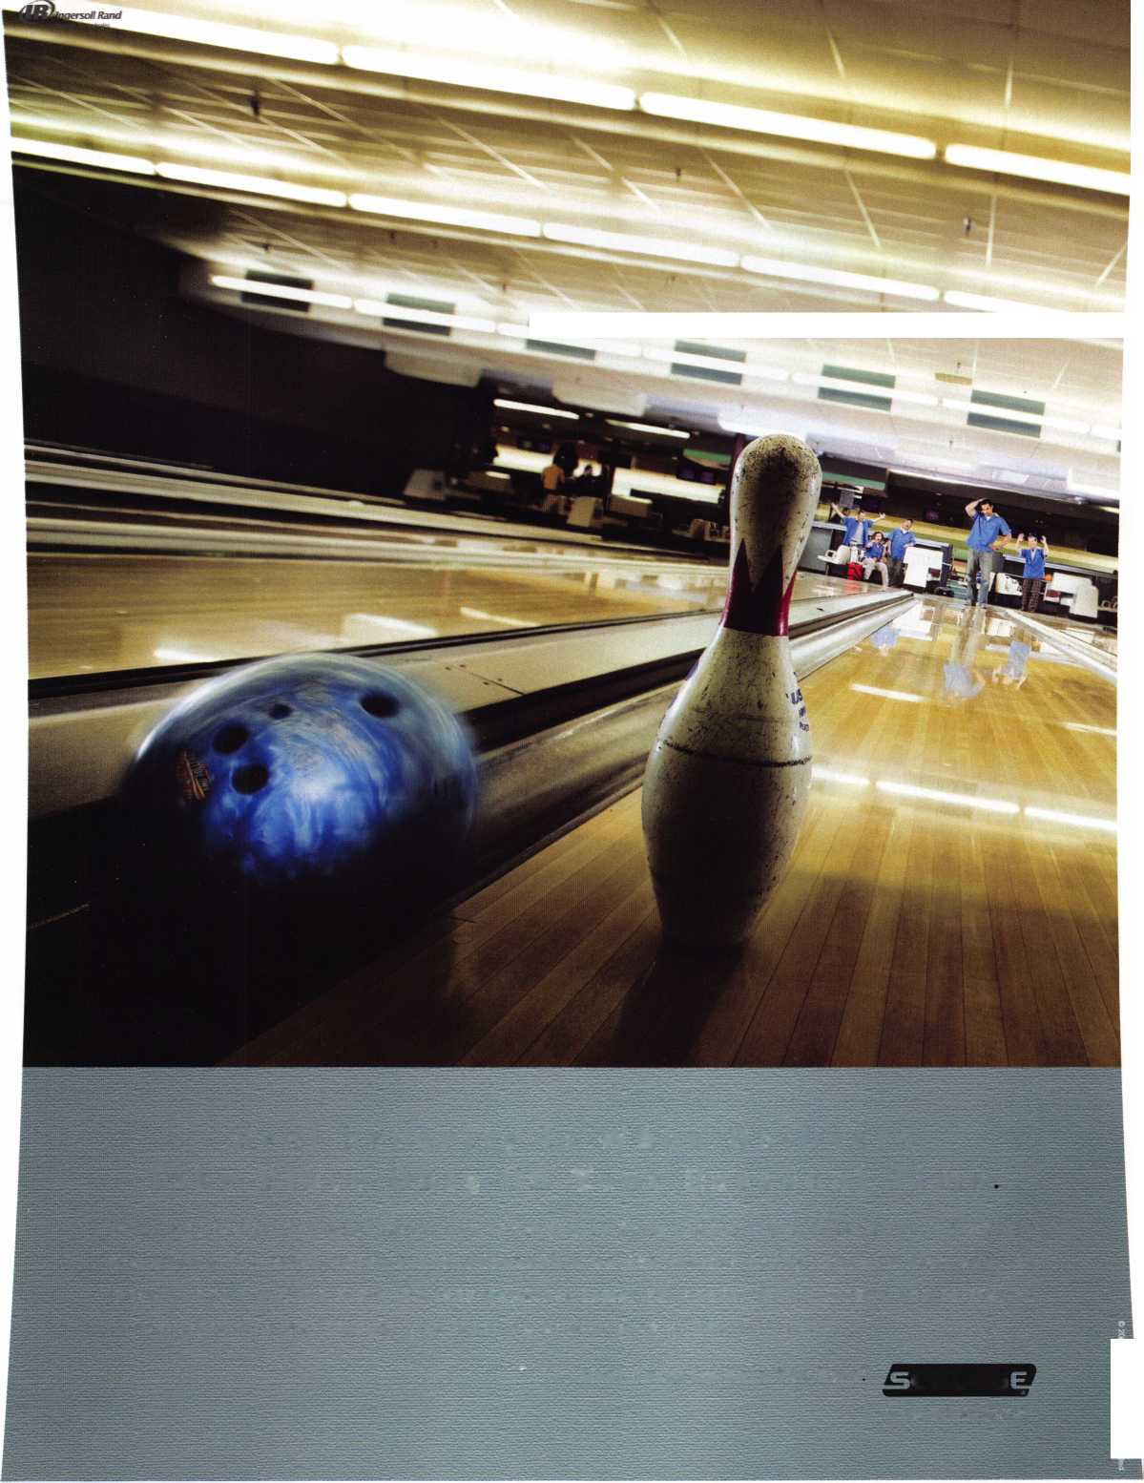

the existing museum buildings, and The Cudahy Gardens,  
designed by noted landscape architect Dan Kiley.

Door Hardware Maintains Security and Safety

In a building with this  
breathtaking a design,

hardware details are easy to  
overlook, but sometimes  
they provide a counter-  
point of simplicity to a far-  
reaching structure. For  
example, the architect used  
Von Duprin 55 Series exit  
devices on egress path  
doors in the new addition.

Unlike the latest touch bar  
designs that typically are  
integrated into building  
systems, these simple push  
bar devices often are select-  
ed by architects for their  
clean, functional lines.

To maintain the building’s  
design simplicity, LCN  
2010 heavy-duty single-  
arm concealed closers help

preserve the facility’s architectural integrity while providing  
highly dependable operation to ensure that doors close  
properly. Other doors are equipped with LCN 4010,  
4110 and 5020 series closers.

As one means of differentiating between the original and  
new structures, doors in transitional areas between the two  
areas are equipped with Von Duprin 99 Series exit devices.  
Glynn Johnson overhead stops protect the doors from  
abrupt opening. Throughout the building, Schlage Primus  
interchangeable core lock cylinders provide a higher level  
of security and key control. Other applications include  
Locknetics delayed egress systems, used with the exit  
devices on fire exits that remain locked from the outside.

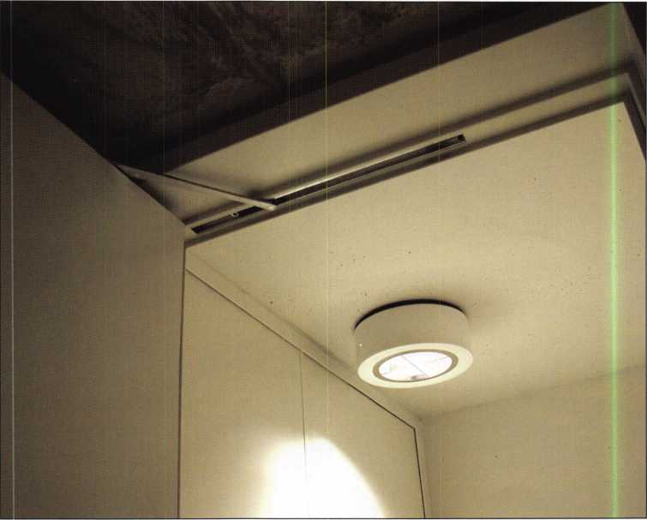

Keynotes • June 2006

Raymond, 4 years Accounting

We represent the 500 employees  
of CompX Security Products.

Hardworking. Reliable. Dedicated,

And it shows in the products we make.

Is it any surprise that, year after year, you the locksmith  
community, choose to partner with us?

Made in America does matter to you, and it matters to us. Through our four US facilities, we will continue to provide you with the high quality products you have come to expect from CompX Security Products.

*Comfit.*

SECURITY PRODUCTS

lary, 8 years

Customer Service d

Alberto, 11 years Machine Operator

*Comfit*

***Comfit***

NATIONAL

FORT

*mm*

Shirley, 23 yea Lock Assembly

***Comfit***

***Comfit,***

TIMBERLINE

CHICAGO



I Can’t Afford to Go to Class

Recently the Pacific Locksmith Association hosted the Pacific Locksmith Conference Locksmith Trade Show and Convention. We offered a wide variety of classes that were designed to accommodate every level of locksmith, from the “newbie” to the old pro who remembers when Linus Yale invented the pin tumbler lock.

I was contacting people to advertise the PLC one common excuse I heard was “I can’t afford to go. I have too much work to do.” My response was “you can’t afford NOT to go.” Why? If you don’t advance yourself through educa­tion, your competition will eventually put you out of busi­ness. That is a fact of life in this profession.

As we all know locksmithing is an ever-changing profes­sion. Yes, the basic pin tumbler lock is pretty much the same today as was when designed by Linus Yale in the 1870’s. However, there have been many improvements such as high security locks, locks with sidebars, locks with multiple cuts on multiple surfaces on the key and inter­changeable core locks. Luckily for some locksmiths the old standard pin tumbler locks will never go away, as there are too many already out in the field. They are sold in an

ever-increasing volume in discount hardware stores to the  
public. (I didn’t say they were high security, grade I or even  
grade II quality)

What happens though when a customer wants a lot of pin  
tumbler locks keyed so they become part of a large master

key system? How many  
locksmiths really KNOW  
how to set up a large sys-  
tem without cross keying  
somewhere in the sys-  
tem? How many lock-  
smiths KNOW how to  
analyze and add to an  
existing system, which  
they did not create, with-  
out causing problems  
further down the line?  
What about the system  
where the customer  
wants multiple cross key-  
ing so a lot of keys, each  
under a different master  
will operate a single lock;  
or a system using several  
different key sections, yet

there can only be one top master key?

The locksmith who has never taken any classes in mas-  
terkeying may or may not know the proper way to set up  
such a complex system. If the person who taught them  
locksmithing didn’t do it correctly, chances are the student  
will not do it correctly either. The result is a dissatisfied  
customer with a “key box” master key system. The one  
who takes an ALOA or LIST Council certified masterkey-  
ing course will know the CORRECT way to set up such  
complex systems. Mess up a single job for a large company  
and you will never get another one from them. You just  
lost a customer, and your competition just picked up a  
new customer. It will be the trained people who will  
invariably get the job.

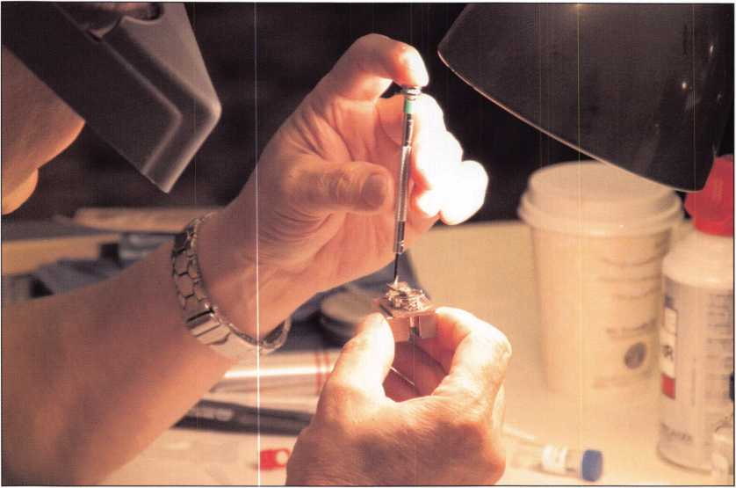

Keynotes • June 2006

Locking mechanisms are also progressing at a  
fast pace. Lock companies are taking advantage  
of new innovations in electronics and comput-  
ers. Electronic access is becoming the wave of  
the future. Just look at the hotel industry.  
Fifteen or twenty years ago all you would ever  
find for door locks on hotels and motels is a  
pin tumbler lock. Today it is hard to find any  
hotel or motel that does not have some form  
of electronic access lock on the doors.

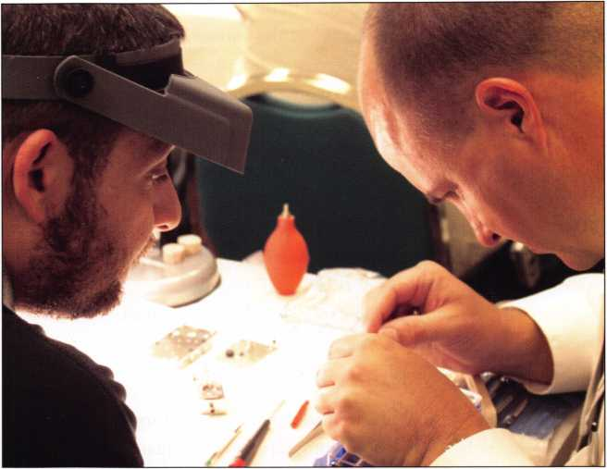

In todays competitive world there is a vast  
array of “corporate secrets” and “prototypes”  
that companies want to keep secret from the  
competition. Industrial espionage is at an all  
time high, especially in the computer industry.

What happens when you have a good cus-  
tomer who decides to go from a pin tumbler

lock to an electronic access locking device. He wants one  
with an audit trail, where entry can be limited to certain  
people, and access of even these chosen few can be limited  
to certain days and certain times. Do you know the differ-  
ent products available on the market that can fill these  
requirements? Are you familiar with installation procedures  
for these devices? Do you know how to trouble shoot these  
devices when something is not working like it is supposed  
to? Do you know the various products available well  
enough you can recommend the exact product for your cus-  
tomer s needs? Do you know this product well enough that  
you can train the customer and his people in the correct use  
and maintenance of the product? If you don’t keep on top  
of these developments in the trade, eventually you will loose  
that customer and your competition will gain another cus-  
tomer. Your competition has taken classes to educate him-  
self on various electronic devices and can meet the demands  
of your FORMER customer.

The same applies to the safe industry. Most of the locks today on the higher security safes being produced are of the electronic type. A good example is the GSA containers used by the U.S. Government. Twenty years ago they were al group 1R combination locks. Now they are all XO-7, XO-8 or XO-9 locks....ELECTRONIC LOCKS! There are also innovations in safe design that were not in place even ten years ago. These include things like glass barriers, random relockers, ceramic barriers and improved hard- plate. The locksmith and safesmith who does not attend

training classes to keep up on the latest innovations will be left behind and left to work on the small, simple Sentry type safes.

Automotive locksmithing is another area that has pro­gressed by leaps and bounds in the past fifteen years.

Fifteen years ago most foreign cars had a simple wafer type

3

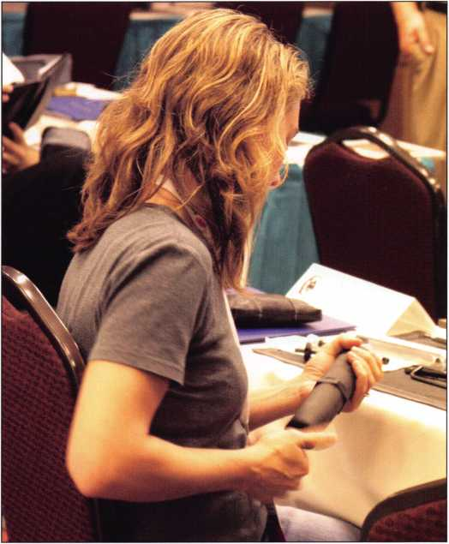

Keynotes • June 2006

**2**

lock. The Chrysler and Ford had a pin tumbler type lock and the General Motors products had the famous GM sidebar lock. The doors were pretty simple and straightfor­ward and most could be opened with a simple slim-jim. Not today.

Cars today are equipped with VATS resistor keys, transponder keys and complex computers that read elec­tronic codes from a special high security key, before the car can be started. This is now giving away to keyless entry systems. The inside of car doors has been upgraded mechanically so it now requires special tools to open them. The locksmith who fails to keep up with this modern tech­nology will be left behind.

The bottom line is this: The locksmith who keeps on top of the industry by attending training classes will ultimately take most of the business away from the one who doesn’t think he/she needs any additional training. The more areas of locksmithing your competition becomes proficient at because of current training, the more business your compe­tition will take away from you.

If a customer calls and asks you to do a complex job for which you are planning to “wing it” because you haven’t received any training in that area, the chances are you will probably mess it up. If not on this job then on another, but it WILL happen, it is just a question of when.

If your competition has been trained in a specific area and can do the job in a professional and competent manner because of training classes he/she has taken, he/she will be able to do a much better job than you can without train­

ing. When the customer realizes this, whom do you think he will call again to do the next job? Who do you think that customer will be praising and whom do you think he will be badmouthing?

Another area that the locksmith today needs to consider is that of certification. Everyday more and more states are passing laws that will limit and/or control the locksmith industry in those states. More and more the trend is toward licensing of locksmiths.

There are many jobs that require that a locksmith have some sort of VERIFIABLE certification before their bid will even be considered. These are generally jobs with large corporations or governmental agencies.

Often I hear fellow locksmiths complain that there is no training available locally. To get training in a specific area one has to fly to Southern California, or the east coast, or attend the ALOA show once a year. My reply is to get involved with your local association. If you don’t have an association in your area, form one. Your association can con­tact ALOA, SAVTA, IAIL or some other national organiza­tion to arrange training. You can even use your own in- house instructors to teach other members specific skills in specific areas. There is nothing saying you can’t contact a specific instructor to come to your association to teach in a specific subject area. Why not take advantage of it?

Remember, if you fail to take classes and upgrade your skills, the only looser is YOU. So again I will ask, HOW CAN YOU AFFORD NOT TO TAKE CLASSES TFfAT UPGRADE YOUR SKILLS?

**28**

Keynotes • June 2006

**Financing**

**Available**

PowerMate

jtmSs&Mm

♦ PowerMate® does 100% of the lifting and is ergonomically designed to reduce physical effort used to move heavy loads by 87%.

♦ Increases job efficiency and productivity.

♦ Significantly lowers labor costs.

♦ Create referrals and repeat business.

♦ Best in Class post sales support and on-site training.

To learn how PowerMate® is the “SOLUTION” for you, call.

**1**-**800**-**697-6283**

[www.powermate.info](http://www.powermate.info)

**PowerMate® is a Registered Trademark of**

L P INTERNATIONAL INC.

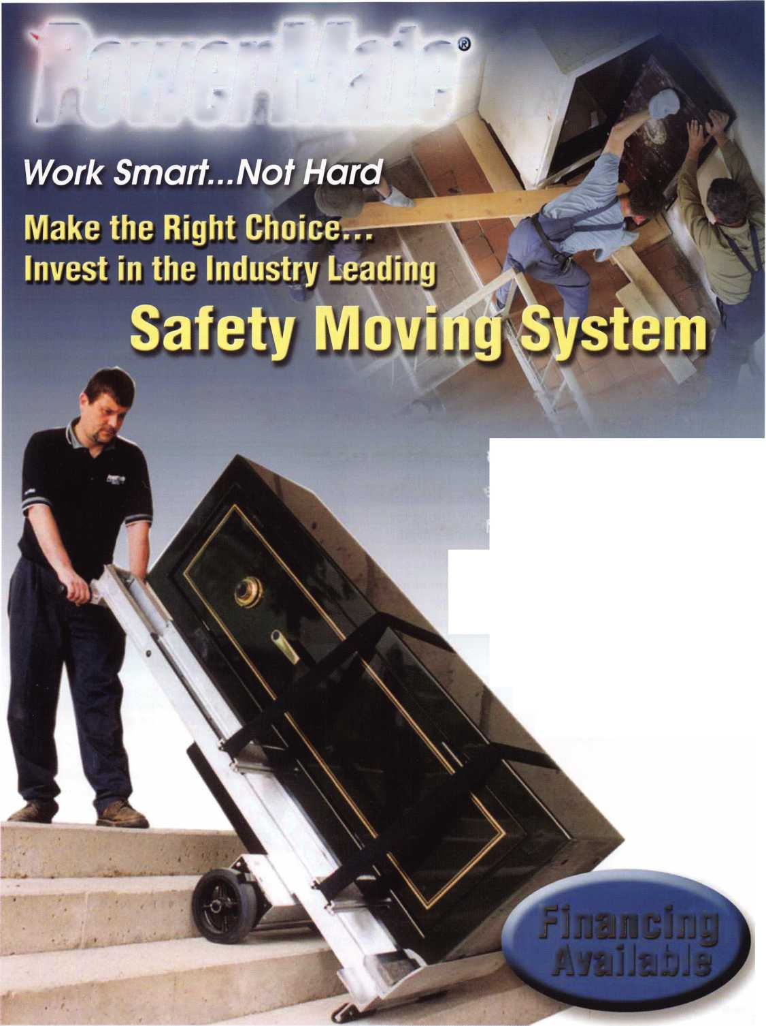

Medeco Does it Again,

A Look At The Medeco M3

by Dan Cunningham, JD, CRL, CFL, CFATE

Medeco sidebar locks have been around for years. First there was the original 10 Series. Just before the patent ran out on the 10 Series Medeco came out with the BiAxial Series. The difference between the original and the BiAxial was substan­tial. The BiAxial introduced a new series of keys, a new style of pin with different locator tabs and a different chisel point and fore and aft cuts. The two systems did not interchange.

The original series uses pins that have a difference of .030 between each depth and have only one position for the cut and that is on the centerline of the space designated for that cut. Each cut has an angle in it; left, right or center. The MACS is a set MACS of four. The BiAxial has a depth of .025 between each depth and, while still using one of the left, right and center angles in every cut, the cuts are either fore or aft. Cuts positioned in the centerline of the cut space were no longer used. Because of this fore and aft cutting the MACS for the BiAxial is variable and depends on the depth of the two adjacent cuts and their location, fore or aft.

Now Medeco has introduced another updated version of its ever, popular side bar lock. The latest addition to the Medeco family of high security sidebar lock is the new M3 locks.

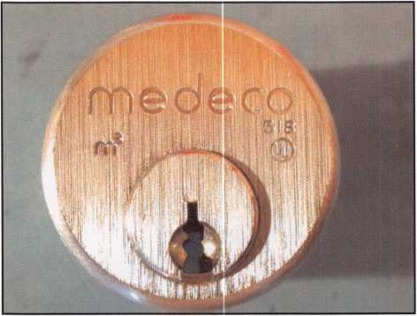

#1 Face of the new M3 lock. On the exterior it looks like any other MEDECO lock, except for the M3 mark on the face.

The M3 system follows in the tradition of the two previous Medeco series of locks. It is a very well made lock with very close tolerances. From the exterior it looks the same as the earlier Medeco locks. (#1) For those of you who still have the parts and pin kits from the original 10 series locks you can dig them out and dust them off. The new M3 series of locks is available in both original and the newer BiAxial for­mats. The major change is the introduction of a “Slider” in the keyway. It is operated in conjunction with the sidebar, and increases security and the number of possible key com­binations available.

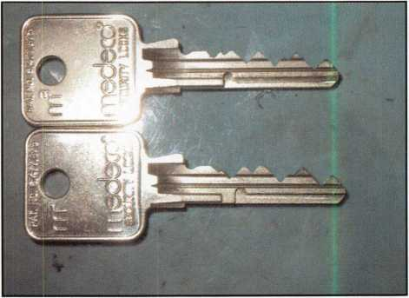

#2 Side view of the new M3 keys. The top key is a “Master” key and the bottom key is a “change” key. Note the location of the notch in the side of the bottom of the key blade.

The first noticeable difference in the new M3 locks is the key. The keys are available in all the Medeco keyways and levels of key control. The difference is the bottom edge of the key blade is partly milled away from the tip back towards the bow. There is a “notch” cut in the land. This is the por­tion of the key that contacts and operates the “slider” in the keyway of the lock. There are six possible locations for the “slider notch”. There is also a “master notch” for master key systems. These notch locations would be comparable to dif­ferent key sections in a standard key system.

Keynotes • June 2006

VISIT US AT ALOA BOOTH 1420

***ALARM CONTROLS CORPORATION***

WALITY SECURITY EQUIPMENT SINCE 1971

**19 BRANDYWINE DRIVE P.O. BOX 280 DEER PARK, NY 11729 PH: 800 645-5538 FAX: 631 586-6500**

**EMAIL: [INFO@ALARMCONTROLS.COM](mailto:INFO@ALARMCONTROLS.COM)  
WEB: ALARMCONTROLS.COM**

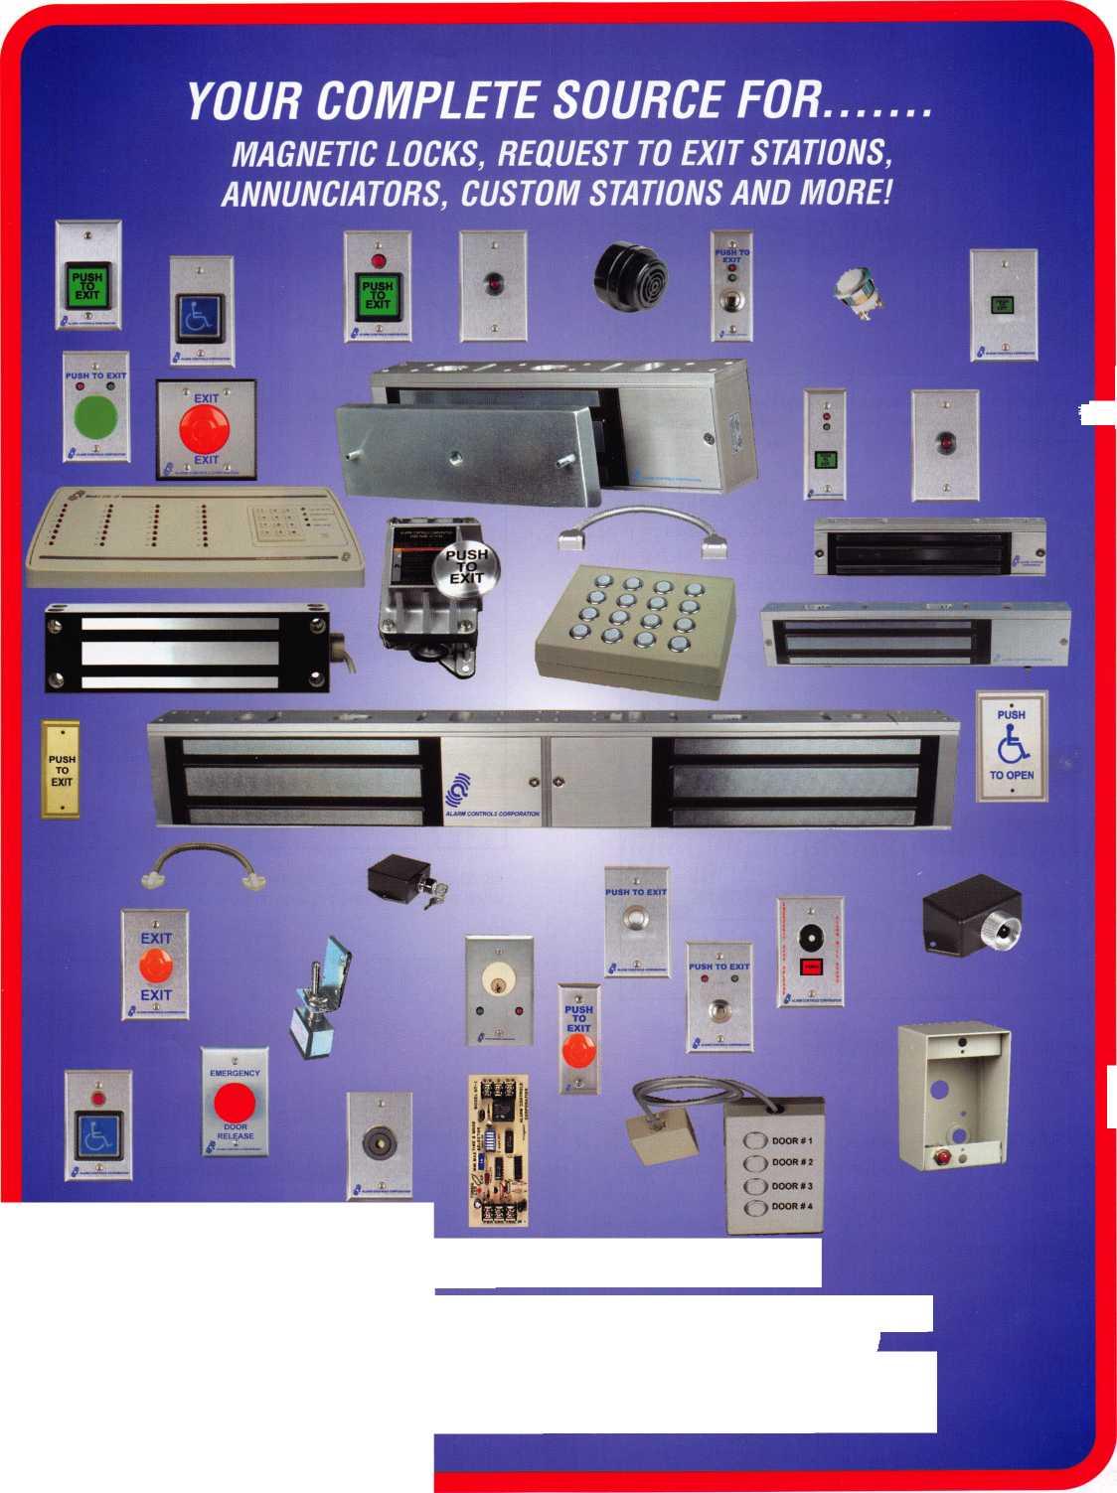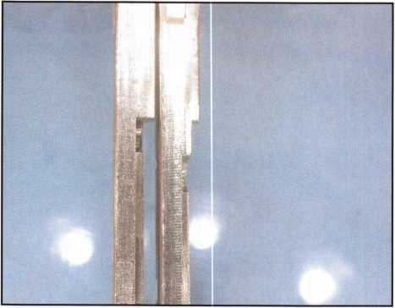

#3 Bottom view of the new keys for the new M3 lock. Note the location of the notches. The key on the left is a “master” key and the key on the right is a “change” key.

#5 The newer style M3 sidebar and the “slider” showing the relationship between the notches of the sidebar and the legs of the slider.

The next noticeable difference with the M3 is the design of the sidebar. The new style sidebar has two notches in it near the front of the bar. These two notches in the sidebar must be aligned with the two legs of the slider before the sidebar can be withdrawn and allow the plug to turn.

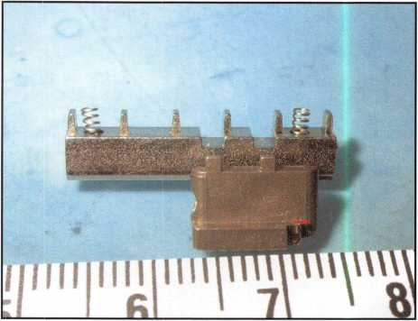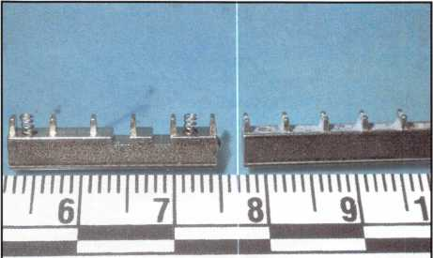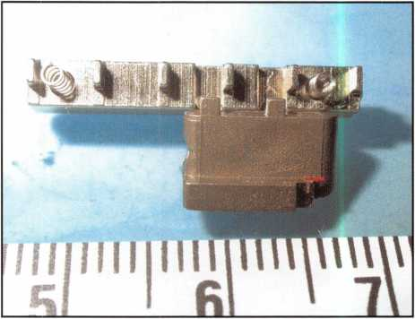

#6 Shows the relationship between the slider and the sidebar when the notches and the legs of the slider are aligned.

#4 The new type sidebar from the M3 lock on the left com­pared with the conventional style of sidebar used by the Original and the BiAxial Medeco locks on the right.

The slider is an entirely new addition to the Medeco lock. It is the heart of the new modification to the Medeco lock.

The slider is moved to the rear of the lock when the key is inserted into the keyway. When it is moved predetermined distance to the rear the two legs on the slider align with the notches in the sidebar align and allow the sidebar to be with­drawn into the lock plug and allow the plug to turn.

#7 Lock plug with sidebar in place and slider removed.

Notice two small notches in sidebar where legs of slider inter­act with the sidebar.

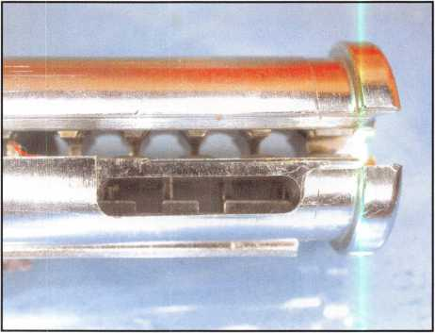

Keynotes • June 2006

TrueCenter

the Harry C. Miller story

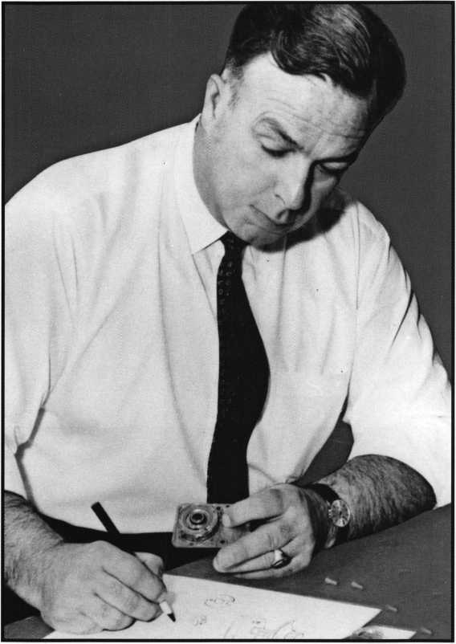

This is a must have book for any  
locksmith/safe technician’s library!

This book chronicles the life of Harry C. Miller  
who was one of a handful of individuals who  
dominated and defined the physical security  
community in the 20th century. The book is  
laced with history and anecdotes from his early  
life when he would travel to watch his father  
erect bank vaults to his apprenticeship with  
Diebold, the formation of his own company in  
1941, the invention of the first manipulation  
proof combination lock and 29 other patents,  
through his presidency of Sargent & Greenleaf  
which spanned three decades and the creation of  
Lockmasters. The book contains 119 rare pho-  
tos many of which are selected items from the  
Harry C. Miller Lock Collection.

AVAILABLE NOW AT THE  
ALOA BOOKSTORE!  
PURCHASE YOURS ONLINE TODAY!

[www.aloa.org/](http://www.aloa.org/) store

#8 View of slider with a change key inserted into lock plug.

#9 View of slider with Master key inserted into lock plug.

When the key is inserted into the keyway the notch on the bottom of the key blade makes contact with the slider in the bottom of the keyway. This moves the slider towards the rear of the lock a prescribed distance. Once moved to the rear two small bars on the side of the slider align with two notches in the side of the sidebar.

The other features of the M3 are the same features as in the earlier versions. All three locks have the standard half moon hard plates in the face of the lock and the plug still contains the hardened steel rods.

For further information contact your local Medeco distribu­tor or the Medeco customer service at 1-800-839-315.

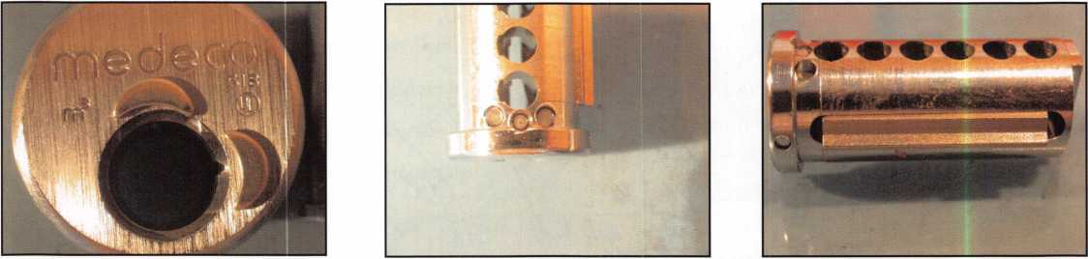

Keynotes • June 2006



KEY CODE SERWICE

With proper ID and security clearance

we can get codes for most cars.

Fax us at 1 -800-695-6810  
or call 1-800-741-4764  
for more information.

Hello, I'm Doug Jameson of Jameson Code Services. We would like to try and make your  
business just a little easier when you make a key. We can furnish a key code to you for almost  
all cars. There is no charge should the code we provide not work. We can have most codes  
back to you within 30 minutes. Some codes are even quicker such as Ford and Toyota. We  
furnish a pin number for Chryslers, also brake codes and immobolizer codes  
for Hondas and Acuras. We have been in the key code business since 1995 and learn a little  
more everyday. We are open Monday thru Friday 8:30 a.m. to 6:00 p.m. All codes are  
$15.00. This includes a vat number if needed. The $15.00 also includes the pin number,  
brake code and immobolizer code. Corvettes are a special category as the vat numbers are  
not often available. We would appreciate your input and welcome suggestions for improving  
our service. Give us a call at 214-630-0477 to set up your account or to have any questions  
answered. Looking forward to servicing all locksmiths. Fords and Chryslers within 15 minutes!

FYI: We are now open on Saturdays 9:00 a.m. to 1:00 p.m.

All codes are $15.00 on Saturday

We are accepting applications from ALOA Members only.

Fax **US** at 1-800-695-6810  
or call 1-800-741-4764

**Classifieds**

EMPLOYMENT

LOCKSMITH WANTED

Commercial, Residential, Auto Work for a Licensed contractor. Salary & commission. 24 Hour Shop. Fax or mail resume to: J&J Locksmiths, 3201 Fulton Avenue, Sacramento, CA 95821. Fax: 916-485- 9385, Ph: 916-482-4213

LOCKSMITH TECH WANTED

Sanders Lock & Key, San Dimas, CA. High volume shop. Residental, automotive, com- merical, Commission based pay. Contact Chris at 909-599-3178.

LOCKSMITH WANTED

Locksmiths wanted at Liberty Lock & Safe! All Positions. Fast Paced. Performance Pay, Great Benefits. Beautiful weather. 29th Year in Business. Over 50 Employees and growing. Professional skilled locksmiths only. Call James at 702-284-5404.

INVENTORY CONTROLLER WANTED

Inventory Controller Wanted at Liberty Lock and Safe! Inventory experience and hard­ware knowledge are required. Call James at 702-284-5404.

SEEKING A NO BUY-IN PARTNER, TEAM PLAYER, LOCKSMITH

South Florida (Broward) Locksmith Company seeks an honest, dependable, and reliable outside service person to serv­ice mostly commerical accounts. Excellent opportunity for an individual dedicated to the Trade and Customer service and to share in the benefits and profits of this 19 year old company. Most of the benefits of being a partner without the headaches. Health Insurance, Retirement, Vacation, Profit Sharing, Vehicle, Tools and Uniform.

Contact Art at [ASLinc2@earthlink.net](mailto:ASLinc2@earthlink.net) with resume and requirements and more infor­mation. 954-989-4848.

WANTED TO BUY/SELL

KEY BLANK CATALOG WANTED

Looking for copy of llco Key Blank Catalog #19. Contact Roger Weitzenkamp at 970- 882-7191 or by mail at 2591 3 Road T.5, Dolores, Colorado 81323.

FOR SALE

Key Machine KD55 Unican. Contact Albemarle Lock and Safe b email at: [snow- derrow@aol.com](mailto:snow-derrow@aol.com) or call 1-434-977-5397 and ask for Linda or Scott Johnson. Asking $450.00 plus shipping.

FOR SALE

Mobile Locksmith Business for Sale.

Central New Jersey. Established 15 years, only locksmith in town. Hitop conversion van, key machines, tools. Offers consid­ered. For more information please email: [isl245@comcast.net](mailto:isl245@comcast.net)

ELECTROPICK FOR SAFE

Brand new surplus HPC Electropick No. EPG-1. Factory fresh, unopened. List price $141. Sell for $60 plus $8 shipping to anywhere in the US. Check, money order or credit card. Please send email to George at [selectlocks@aol.com](mailto:selectlocks@aol.com) or fax to 925- 820-6698.

BUSINESS FOR SALE

Well established Lock and Security busi­ness for sale, located in sunny southern Colorado, serving the entire San Luis Valley and surrounding area, a population of approximately 50,000 and growing rapidly. We have 300 plus security accounts, locksmiths has limited competi­tion, gross income in the six figure range.

Great hunting, fishing, sand dunes national monument, surrounded by mountains, ski­ing only an hour away. We have four long term employees, medical, retirement and bonuses are some of the benefits we offer. Sale includes four service vehicles, entire inventory and equipment, building sale includes two rentals presently occupied.

For more information, please contact Bob or Ivan. Valley Lock & Security, Inc. 500 Main Street, Alamosa, CO 81 101. Tel. 719-589-5895. Fax 719-589-4299. [Valleyloc@fone.net](mailto:Valleyloc@fone.net)

BUSINESS FOR SALE

Started in 1973, same location since 1978. Well over 50,000 blanks, 9 key machines, 2 Curtis # 15s with a lot of cams and carriages, plus all tools, inventory and accounts. Low rent, excellent landlord. Owner must retire due to health, will help with transition. $100,000 firrm. 609-646- 9065 Monday-Friday 9a.m. - 1pm 609- 652-6073 Evenings and weekends.

BUSINESS FOR SALE

Well established locksmith business since the 1 950's for sale due to health reasons. Serious inquiries only to Advanced Lock Service, 18 N. Van Brunt St. Englewood,

NJ 07631.

BUSINESS FOR SALE

Mom and Pop Locksmith and Screen Business for Sale in Golden Valley,

Arizona. Located between Kingman, AZ and Laughlin, AZ in fast growing Mohave County. Health and age are our reasons for selling. Our Dodge Ram Van and Business have more than $75,000.00 in equipment and inventory. All is included. Three bedroom, two bath 24x24 detached garage (which now houses the business) on 1.7 acre lot with all utilities and no assessments owed. Make an offer that is reasonable for this area. 928-565-2294 or email at [lmburks@citlink.net](mailto:lmburks@citlink.net)

Classified Advertising Policy

Classified advertising space is provided free of charge to ALOA members and for a fee of $2.00 per word, $40.00 minimum for non members. Classified ads may be used to advertise used merchandise and overstocked items for sale, "wanted to buy" items, business opportunities, employment opportunities/positions wanted and the like. Members or non members wishing to advertise services or new merchandise for sale may purchase a "Commercial Classified Ad" for a fee of $4.00 per word with a minimum of $ 100.00. Each ad will run for two issues. For blind boxes there is a $10.00 charge for members and non members. All ads must be submitted in writing to the Advertising Sales Department via fax at 8 17-645-7599 or through an email to [adsales@aloa.org](mailto:adsales@aloa.org) by the fifteenth of the month two months prior to issue date. ALOA reserves the right to refuse any classified advertisement that it deems inappropriate according to the stated purpose of the classified advertising section.

Security Products

**A Division of The Eastern Company**

**301 West Hintz Road Wheeling, IL 60090 Telephone: 800.733.8588 Fax: 847.537.1881 vsrww.cclsecurity.com**

Features & Benefits

* Industrial Strength Combination Lock!
* Resists Hammer and Re-bar Attacks!
* Hardened Steel Full Metal Jacket!
* Hardened Steel Full Metal Jacket Shroud!
* Weather Resistant Black Electrocoating!
* 7/16” Chrome Plated Molybdenum Shackle!
* Inside Shackle Clearances: 1 ” and 2”!
* Shackle Pull Strength: 2,750 pounds!
* All Brass Inner Mechanism!
* Four All Brass Dials!
* 10,000 Changeable Combinations!
* Quick Delivery: Shipped from Stock!

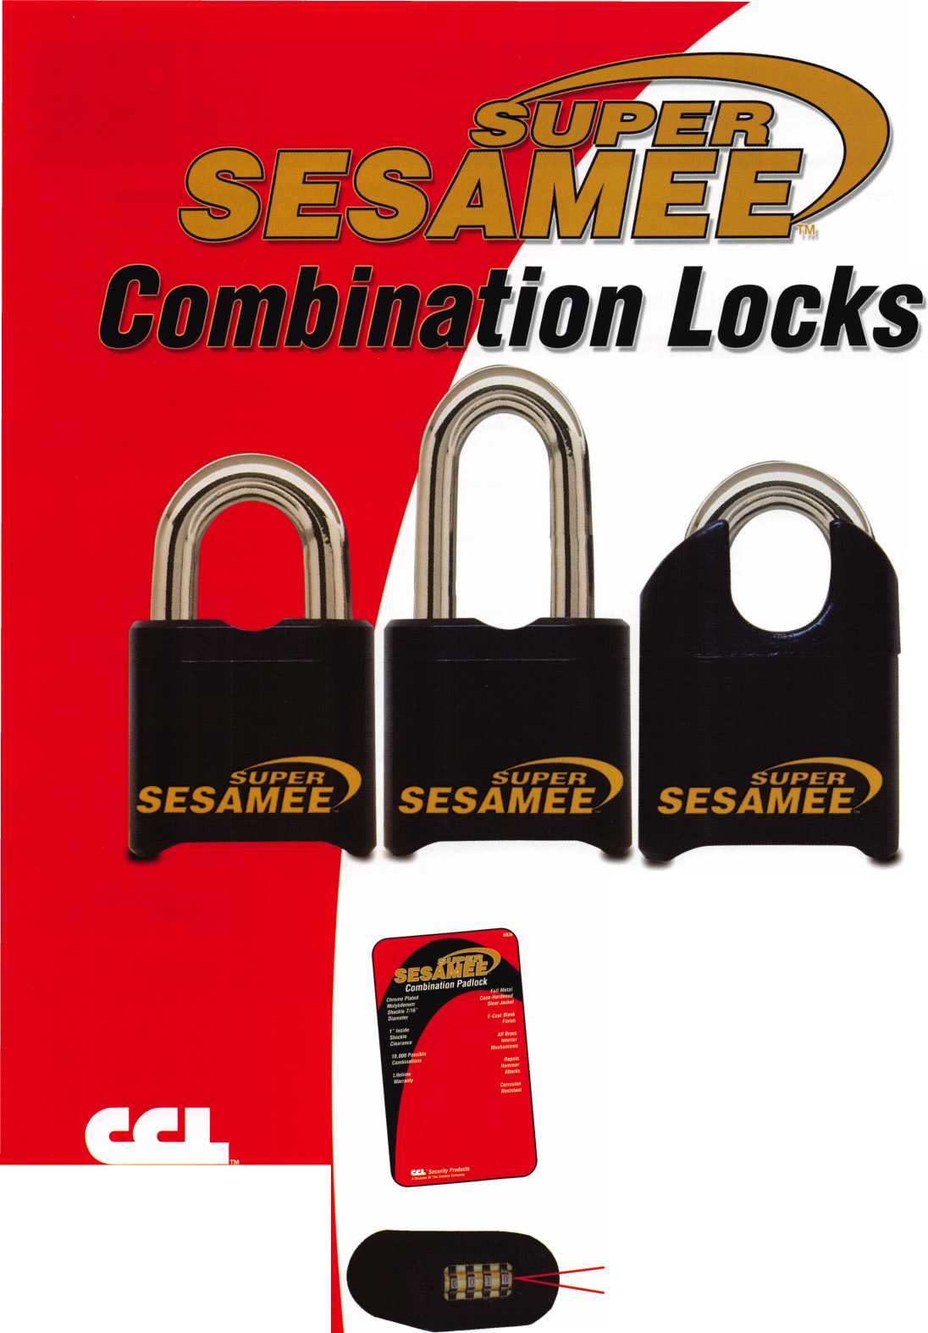

Distributor

**1st In Hardware, Inc.**

Phone: Phone: 410-646-9900 Fax: 410-646-0045 www. 1 stinhardware.com

**ADEL Fingerprint Technology, LLC**

Phone: 909-595-1222 Fax: 909-595-1667

**Accredited Lock Supply Co.**

Phone: 800-652-2835 Fax: 201-865-2435 [www.acclock.com](http://www.acclock.com)

**Andrews Wholesale Lock Supply**

Phone: 717-272-7422 Fax: 717-274-8659 [www.andrewslock.com](http://www.andrewslock.com)

**Boyle & Chase Inc.**

Phone: 800-325-2530 Fax: 800-205-3500 [www.boyleandchase.com](http://www.boyleandchase.com)

**Clark Security Products**

Phone: 858-974-6740 Fax: 858-974-6720 [www.clarksecurity.com](http://www.clarksecurity.com)

**Cookrs Building Specialties**

Phone: 505-883-5701 Fax: 505-883-5704

**Dire's Lock & Key Company**

Phone: 303-294-0176 Fax: 303-294-0198

**Direct Security Supply, Inc.**

Phone: 800-252-5757 Fax: 800-452-8600

**Discount Key Machines.Com/Busch**

Phone: 800-332-8724 Fax: 407-363-4666

**Doyle Security Products**

Phone: 800-333-6953 Fax: 612-521-0166 [www.doylesecurity.com](http://www.doylesecurity.com)

**Dugmore and Duncan, Inc.**

Phone: 888-384-6673 Fax: 888-329-3846

**E. L. Reinhardt Co., Inc.**

Phone: 800-328-1311 Fax: 651-481-0166 [www.elreinhardt.com](http://www.elreinhardt.com)

**Ewert Wholesale Hardware**

Phone: 800-451-0200 Fax: 708-597-0881

**Foley-Belsaw Company**

Phone: 800-821-3452 Fax: 816-483-5010 [www.foley-belsaw.com](http://www.foley-belsaw.com)

**Fried Brothers Inc.**

Phone: 800-523-2924 Fax: 215-592-1255 [www.fbisecurity.com](http://www.fbisecurity.com)

**H.L. Flake Co.**

Phone: 800-231-4105 Fax: 713-926-3399 [www.hlflake.com](http://www.hlflake.com)

**Hans Johnsen Company**

Phone: 214-879-1550 Fax: 214-879-1530 [www.hjc.com](http://www.hjc.com)

**Hardware Agencies, Ltd.**

Phone: 416-462-1921 Fax: 416-462-1922 [www.hardwareagencies.com](http://www.hardwareagencies.com)

**IDN Incorporated**

Phone: 817-421-5470 Fax: 817-421-5468 [www.idn-inc.com](http://www.idn-inc.com)

**Instant Hardware Delivery, Inc**

Phone: 800-355-1 107 Fax: 800-663-8518

**Intermountain Lock & Supply**

Phone: 800-453-5386 Fax: 801-485-7205 [www.intermountainlock.com](http://www.intermountainlock.com)

**International Electronics, Inc**

Phone: 800-343-9502 Fax: 617-821-4443

**Jo Van Distributors**

Phone: 416-288-6306 Fax: 416-752-8371 [www.jovanlock.com](http://www.jovanlock.com)

**L V Sales Inc**

Phone: 323-661-4746 Fax: 323-661-1314 [www.lvsales.com](http://www.lvsales.com)

**Lockmasters, Inc.**

Phone: 859-885-6041 Fax: 859-885-7093 [www.lockmasters.com](http://www.lockmasters.com)

**Locks Company**

Phone: 800-288-0801 Fax: 305-949-3619

**Locksmith Ledger International**

Phone: 847-454-2700 Fax: 847-454-2759 [www.lledger.com](http://www.lledger.com)

**McDonald Dash Locksmith Supply**

Phone: 800-238-7541 Fax: 901-366-0005 [www.mcdonalddash.com](http://www.mcdonalddash.com)

**Monaco Lock Co.**

Phone: 800-526-6094 Fax: 800-845-5625 [www.monacolock.com](http://www.monacolock.com)

**NLS Lock Supply Dba Nevada Lock S**

Phone: 702-737-0500 Fax: 702-737-7134

**Omaha Wholesale Hardware**

Phone: 800-238-4566 Fax: 402-444-1664 [www.omahawh.com](http://www.omahawh.com)

**Phoenix Safe International LLC**

Phone: 765-483-0954 Fax: 765-483-0962 [www.phoenixsafeusa.com](http://www.phoenixsafeusa.com)

**Positive Identity Solutions**

Phone: 704-663-1175 Fax: 704-660-1301 [www.pids-usa.com](http://www.pids-usa.com)

**RA-Lock Company**

Phone: 972-775-6301 Fax: 972-775-6316 [www.ralock.com](http://www.ralock.com)

**Security Distributors Inc**

Phone: 800-333-6953 Fax: 612-524-0166

**Security House**

Phone: 905-669-5300 Fax: 905-660-6313 [www.securityhouselock.com](http://www.securityhouselock.com)

**Security Lock Distributors**

Phone: 800-847-5625

Fax: 800-878-6400

[www.securitylockdistributors.com](http://www.securitylockdistributors.com)

**Southern Lock and Supply Co.**

Phone: 727-541-5536 Fax: 727-544-8278 [www.southernlock.com](http://www.southernlock.com)

**Stone & Berg Wholesale**

Phone: 800-225-7405 Fax: 800-535-5625

**Streetwise Security Products**

Phone: 252-830-5577 Fax: 252-830-5542

**The Locksmith Store Inc.**

Phone: 847-364-5111 Fax: 847-364-5125 [www.locksmithstore.com](http://www.locksmithstore.com)

**Timemaster Inc.**

Phone: 859-259-1878 Fax: 859-255-0298 [www.time-master.com](http://www.time-master.com)

**Top Notch Distributors, Inc.**

Phone: 800-233-4210 Fax: 800-854-4146 [www.topnotch.bz](http://www.topnotch.bz)

**Turn 10 Wholesale**

Phone: 800-848-9790 Fax: 800-391-4553

**U.S. Lock Corp.**

Phone: 800-925-5000 Fax: 800-338-5625 [www.uslock.com](http://www.uslock.com)

**Wilson Safe Company**

Phone: 215-492-7100 Fax: 215-492-7104 [www.wilsonsafe.com](http://www.wilsonsafe.com)

Manufacturer

**A & B Safe Corporation**

Phone: 800-253-1267 Fax: 856-863-1208 [www.a-bsafecorp.com](http://www.a-bsafecorp.com)

**ABUS Lock Company**

Phone: 800-352-2287 Fax: 602-516-9934 [www.abus.com](http://www.abus.com)

**Access Security Products Ltd.**

Phone: 905-337-7874 Fax: 905-337-7873 [www.access-safe.com](http://www.access-safe.com)

**Adams Rite Mfg Company**

Phone: 800-872-3267 Fax: 800-232-7329 [www.adamsrite.com](http://www.adamsrite.com)

**Adesco Safe Mfg. Company**

Phone: 800-694-9340 Fax: 562-408-6427 [www.adesco.com](http://www.adesco.com)

**Adrian Steel Company**

Phone: 800-677-2726 Fax: 517-265-5834 [www.adriansteel.com](http://www.adriansteel.com)

**Advanced Diagnostics USA Inc**

Phone: 650-876-2020 Fax: 650-876-2022 [www.ad-mvp.com](http://www.ad-mvp.com)

**Alarm Controls Corporation**

Phone: 631-586-4220 Fax: 631-586-6500 [www.alarmcontrols.com](http://www.alarmcontrols.com)

**All Five Tool Company, Inc.**

Phone: 860-583-1691 Fax: 860-583-4516 [www.all5tool.com](http://www.all5tool.com)

**American Security Products**

Phone: 909-685-9680x2013 Fax: 909-685-9685 [www.amsecusa.com](http://www.amsecusa.com)

**BWD Lockcraft**

Phone: 973-728-3707 Fax: 973-728-3731 [www.bwdautomotive.com](http://www.bwdautomotive.com)

**Bianchi USA, Inc.**

Phone: 800-891-2118 Fax: 216-803-0202 [www.bianchi](http://www.bianchi) 1770usa.com

**Buddy Products**

Phone: 312-733-6400 Fax: 312-733-8356 [www.buddyproducts.com](http://www.buddyproducts.com)

**CCL Security Products**

Phone: 800-733-8588 Fax: 847-537-1800 [www.cclsecurity.com](http://www.cclsecurity.com)



Keynotes • June 2006

associate

**members**

**CompX Security Products**

Phone: 864-297-6655 Fax: 864-297-9987 [www.compxnet.com](http://www.compxnet.com)

**D&D Technologies (USA), Inc.**

Phone: 714-677-1300x292 Fax: 714-677-1299 [www.ddtechusa.com](http://www.ddtechusa.com)

**DETEX Corp.**

Phone: 800-729-3839 Fax: 830-620-6711 [www.detex.com](http://www.detex.com)

**Don-Jo Manufacturing, Inc.**

Phone: 978-422-3377 Fax: 978-422-3467 [www.don-jo.com](http://www.don-jo.com)

**Door Controls International**

Phone: 800-742-3634 Fax: 800-742-0410 [www.doorcontrols.com](http://www.doorcontrols.com)

**Door Jamb Armor/A&G Security**

Phone: 201-490-5381 Fax: 201-490-5389 [www.djarmor.com](http://www.djarmor.com)

**Doorking Inc.**

Phone: 800-826-7493 Fax: 310-641-1586 [www.doorki](http://www.doorki) ng .com

**E-Lock USA**

Phone: 434-589-5913 Fax: 434-589-3738 [www.e-lock-usa.com](http://www.e-lock-usa.com)

**FireKing Security Products**

Phone: 800-457-2424 Fax: 800-896-6606 [www.fkisecuritygroup.com](http://www.fkisecuritygroup.com)

**Framon Manufacturing Company Inc.**

Phone: 989-354-5623 Fax: 989-354-4238 [www.framon.com](http://www.framon.com)

**G-U Hardware Inc.**

Phone: 757-877-9020 Fax: 757-877-9720 [www.g-u.com](http://www.g-u.com)

**HPC, Inc.**

Phone: 847-671-6280 Fax: 847-671-6343 [www.hpcworld.com](http://www.hpcworld.com)

**HY-KO Products Co.**

Phone: 330-467-7446 Fax: 330-467-7442

**Hammerhead Industries, Inc.**

Phone: 805-658-9922 Fax: 805-658-8833 [www.gearkeeper.com](http://www.gearkeeper.com)

**Ingersoll Rand Security Technologies**

Phone: 317-805-5713 Fax: 317-805-5779 [www.schlagelock.com](http://www.schlagelock.com)

**Jackson Corporation**

Phone: 323-269-81 1 1 Fax: 800-888-6855 [www.jacksonexit.com](http://www.jacksonexit.com)

**Jet Hardware Mfg., Co.**

Phone: 718-257-9600 Fax: 71 8-257-0973 [www.jetkeys.com](http://www.jetkeys.com)

**KABA ILCO Corp.**

Phone: 252-446-3321 Fax: 252-446-4702 [www.kaba-ilco.com](http://www.kaba-ilco.com)

**KEY-BAK/West Coast Chain Mfg.**

Phone: 909-923-7800 Fax: 909-923-0024 [www.keybak.com](http://www.keybak.com)

**Kenstan Lock Company**

Phone: 516-576-9090x315 Fax: 516-576-0100 [www.kenstan.com](http://www.kenstan.com)

**Keri Systems Inc.**

Phone: 408-451-2520 Fax: 408-441-0309 [www.kerisys.com](http://www.kerisys.com)

**Knaack Manufacturing Co.**

Phone: 800-456-7865 Fax: 815-459-9097 [www.weatherguard.com](http://www.weatherguard.com)

**Kustom Key Inc.**

Phone: 800-537-5397 Fax: 800-235-4728 [www.kustomkey.com](http://www.kustomkey.com)

**LAB Security**

Phone: 800-243-8242 Fax: 860-583-7838 [www.labpins.com](http://www.labpins.com)

**La Gard Inc.**

Phone: 310-325-5670 Fax: 310-325-5615 [www.lagard.com](http://www.lagard.com)

**Lock America, Inc. dba L.A.I. Group**

Phone: 714-373-2993 Fax: 714-373-2998 [www.laigroup.com](http://www.laigroup.com)

**LockPicks.Com/Brockhage Tools**

Phone: 408-437-0505 Fax: 408-516-9642

**Lucky Line Products, Inc.**

Phone: 858-549-6699 Fax: 858-549-0949 [www.luckyline.com](http://www.luckyline.com)

**M.A.G. Manufacturing**

Phone: 714-891-5100 Fax: 714-892-6845 [www.magmanufacturing.com](http://www.magmanufacturing.com)

**MUL-T-LOCK USA, Inc.**

Phone: 800-562-351 1 Fax: 973-778-4007 [www.mul-t-lockusa.com](http://www.mul-t-lockusa.com)

**Major Mfg, Inc.**

Phone: 714-772-5202 Fax: 714-772-2302 [www.majormfg.com](http://www.majormfg.com)

**Maxcess Card Systems Ltd**

Phone: 949-492-5964 Fax: 949-492-0415 [www.maxcess-card.com](http://www.maxcess-card.com)

**Medeco Security Locks**

Phone: 540-380-5000 Fax: 540-380-5010 [www.medeco.com](http://www.medeco.com)

**Mil-Comm Products Co Inc**

Phone: 201-935-8561 Fax: 201-935-6059

**Promet Safe Inc.**

Phone: 859-373-8565 Fax: 877-690-9595

**Protex Safe Co., LLC**

Phone: 818-610-8030 Fax: 818-610-8004 [www.protexsafe.com](http://www.protexsafe.com)

**ROFU International Corp.**

Phone: 253-922-1828 Fax: 253-922-7272 [www.rofu.com](http://www.rofu.com)

**Rutherford Controls Int'l Co.**

Phone: 519-621-7651 Fax: 519-621-7939 [www.rutherfordcontrols.com](http://www.rutherfordcontrols.com)

**5TRATTEC Security Corp.**

Phone: 414-247-3333 Fax: 414-247-3564 [www.aftermarket.strattec.com](http://www.aftermarket.strattec.com)

**Sargent & Greenleaf, Inc.**

Phone: 859-885-941 1 Fax: 859-885-3063 [www.sargentandgreenleaf.com](http://www.sargentandgreenleaf.com)

**Sargent Manufacturing Co.**

Phone: 800-727-5477 Fax: 888-863-5054 [www.sargentlock.com](http://www.sargentlock.com)

**Schwab Corp.**

Phone: 765-447-9470 Fax: 765-447-8278 [www.schwabcorp.com](http://www.schwabcorp.com)

**Securifort Inc**

Phone: 819-359-2226 Fax: 819-359-2218 [www.securifort.com](http://www.securifort.com)

**Securitron Magnalock Corp.**

Phone: 775-355-5625 Fax: 775-355-5636 [www.securitron.com](http://www.securitron.com)

**Security Door Controls**

Phone: 805-494-0622 Fax: 805-494-8861 [www.sdcsecurity.com](http://www.sdcsecurity.com)

**Security Solutions**

Phone: 405-376-1600 Fax: 405-376-6870

[www.securitysolutions-usa.com](http://www.securitysolutions-usa.com)

**Select Engineered Systems**

Phone: 305-823-5410 Fax: 305-823-5215 [www.selectses.com](http://www.selectses.com)

**Townsteel, Inc.**

Phone: 626-858-5080 Fax: 626-858-3393 [www.townsteel.com](http://www.townsteel.com)

**UCA Inc**

Phone: 972-437-4696 Fax: 972-692-7056 [www.ibuttonlock.com](http://www.ibuttonlock.com)

**Videx Inc.**

Phone: 541-758-0521 Fax: 541-752-5285 [www.videx.com](http://www.videx.com)

**YSG Door Security Consultants, Inc.**

Phone: 800-438-1951 Fax: 800-338-0965

Service

Organization

**Allstate Insurance Company**

Phone: 847-551-2181 Fax: 847-551-2732 [www.allstate.com](http://www.allstate.com)

**Cardservice Mobile Solutions**

Phone: 561-210-8488 Fax: 561-953-6268 [www.cardservicems.com](http://www.cardservicems.com)

**Cross Country Automotive Services**

Phone: 800-541-2262 Fax: 781-393-0256 [www.argosi.com](http://www.argosi.com)

**Massglass & Door Service**

Phone: 888-742-8837 Fax: 805-497-2255 [www.massglass.com](http://www.massglass.com)

**SalesGenie.Com**

Phone: 402-593-4500 [www.salesgenie.com](http://www.salesgenie.com)

**The Mechanic Group, Inc.**

Phone: 845-735-0700 Fax: 845-735-8383 [www.mechanicgroup.com](http://www.mechanicgroup.com)

**Webster Safe & Lock Co., Inc.**

Phone: 901-332-2911 Fax: 901-332-2878 [www.webstersinc.com](http://www.webstersinc.com)

Keynotes • June 2006



NUMEROUS LEGISLATIVE ACTIVITIES WILL KEEP YOU INFORMED AT CONVENTION!!!

Find out what's the latest happening in your state capitol. Contact your state representative or senator about a certain bill. Let your Governor know exactly what you think about him/her. Get free popcorn. Come to the "State of the States Roundtable" This is just some of what you can expect this year from the Government Affairs department at the ALOA 2006 Convention and Security Expo in Las Vegas. Here are some of the highlights:

If you contribute $100 or more to the Legislative Action Fund you become a member of the prestigious Legislative Action Network (LAN) Council.

The Council is an important instrument in raising the stan­dards of our profession through the legislative process by making sure that locksmiths have the final say in how our industry will be run. As a Council member, you will receive:

• The quarterly Legislative Action Network Update alerting you to important legislation in your state and around the country (same as LAN members)

Thursday July 13, 2006 thru Saturday July 15, 2006

Noon to 5pm (Noon to 4pm Saturday)

GOVERNMENT AFFAIRS BOOTH AT SECURITY EXPO

Once again, well have the popcorn machine serving up fresh hot buttered popcorn but now we've added activities that you can participate in as well! On site we'll have infor­mation on all bills, and legislation in your state PLUS our UPDATED "Locksmith Lobbying for Licensing: A Guide for Influencing your State Legislature and Governor." Free Convention merchandise for Legislative Action Network Council ($+100 and up donation) members.

Friday, July 14, 2006 3pm to 4:30pm

STATE OF THE STATES ROUNDTABLE

This meeting is designed as a forum for ALOA chapters and local/state regional locksmith associations to share informa­tion about the state of locksmithing in their region and a dynamic way to share ideas. Primarily for the Chairman, President and Legislative representative from each organiza­tion, all locksmiths are encouraged to participate. This is the perfect opportunity to learn about what's going on in the industry across the nation.

Become a Legislative Action Network Council Member TODAY!

* A comprehensive guide to lobbying in your state capital, so you can be the "voice of ALOA" to legislators.
* A lapel pin designating you as a special ALOA LAN Council member,
* Recognition in Keynotes magazine.
* Invitation to exclusive functions at the annual ALOA con­vention for LAN Council members.
* Complimentary Legislative Convention merchandise.

It's simple to join the LAN Council:

* Log into the ALOA Store at <http://www.aloa.org/store>
* Click on Search and type in "Council"
* From there you can join at four different donor levels
* Add this to your basket and checkout!

Note: if this is the first time you have used the ALOA Store, you will need to set up a username and password.

The National Automotive Service Task Force (NASTF) Establishes Board of Directors; Accepts Management Proposal From the National Institute for Automotive Service Excellence

Keynotes • June 2006

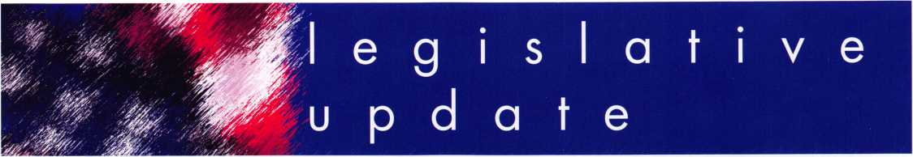

On April 1 1, 2006, the NASTF announced several signifi­cant organizational steps including the establishment of a Board of Directors to oversee the organization and develop its mission, vision, and structure and chose the National Institute for Automotive Service Excellence (ASE) to provide day-to-day management for NASTF.

One of the first orders of business for the NASTF Board was to elect officers for the first year. The following officers were elected:

Chair - Charlie Gorman (Equipment & Tool Institute);

Vice Chair - Charlie Elder (Automotive Service Association); and Secretary/Treasurer - Steven Douglas (Alliance of Automobile Manufacturers).

Along with Tim McMullen, ALOA's Legislative Manager, other Board members include: Scott Brown (International Automotive Service Technicians Network); John Cabaniss (Association of International Automobile Manufacturers); Douglas Greenhaus (National Automobile Dealers Association; Steve Handschuh (Motor Equipment Manufacturers Association); John Lypen (Motor Information Systems/ETI Service Management Group); Karen Miller (Automotive Training Managers Council); Shelly Nolder (Automotive Service Councils of California); Chuck Roberts (National Institute for Automotive Service Excellence).

The Board will be finalizing an agreement as soon as possi­ble with ASE for management of NASTF. Funding to support this program for the first year has been pledged by several organizations. Mary Hutchinson, former Executive Director of the National Automotive Technicians Education Foundation, will become the NASTF manager anreport to the NASTF Board.

The NASTF Board of Directors' first priorities are to develop voluntary program standards, a third party dispute resolu­tion (arbitration) process, and a sustainable funding model for NASTF.

The new NASTF Board of Directors and the new officers were introduced and recognized at the semi-annual NASTF general meeting on April 4, 2006. Mr. Gorman thanked everyone for their support and said "This is an exciting time for the automotive repair industry. Through commitment and mutual understanding we have accomplished a great deal in the last few months. Although there are still challenges ahead, we have assembled the building blocks that will assure NASTF's success."

Mr. Elder added "This is a major step toward assuring that service information, tools, and training are available today and in the future for the independent automotive service industry."

The National Automotive Service Task Force was estab­lished in 2000 to facilitate: (1) the identification and correc­tion of gaps in the availability and accessibility of OEM automotive service information; (2) technology training for technicians; (3) availability of both OEM and generic diag­nostic tools and equipment; (4) availability of vehicle securi­ty information (added in 2004), and (5) communication out­reach to automotive service professionals. Go to [www.nastf.org](http://www.nastf.org) for details.

The Board emphasized that the mainstay of the NASTF has and will continue to be the voluntary technical committees for Service Information, Training, Tools and Equipment, and Vehicle Security. The NASTF Communications Committee will be re-focused on publicizing and promoting the new NASTF to broaden industry awareness and participation.

Keynotes • June 2006



keynotes

Buyer's Marketpla



SERVICE MANAGER/DISPATCHER

John Koons Locksmiths is looking for a per­son experienced in all phases of the trade in order to manage and dispatch our outside service staff. This position requires 9 hours minimum daily and every other Satruday 9-2. John Koons Locksmiths provides health insur­ance and paid days off. Applicants must be non-smokers and physically be able to assist in moving safes within our warehouse prior to delivery. We are always interested in hiring experienced locksmiths for outside service or in-shop postions with housing available for qualified applicants. Please call or fax resume to George Klein. John Koons Locksmiths, 3635 Fowler Street, Fort Myers, Florida 33901. Tel. 1-800-282-8458. Fax 239-939-5869.



FROM A & B SAFE CORP.

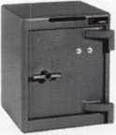

A & B Chest  
Model WS-0

Equipped with  
dual key,  
combination or  
electronic locking  
slot optional

A & B SAFE CORPORATION

114 S. Delsea Drive, Suite 3 Glassboro, NJ 08028-6237 856-863-1186 Fax 856-863-1208

IN-STOCK...MORE SAFES

***FREE Freight Program***

***(30 States)***

AMSEC FireKing

Gaidai **hayman**

MEIUNK ytCTOK

**TURfl tO**

**WHOLESALE SERVICE**

800-848-9790

Keynotes • June 2006

*mMom*

T.M.

*OPERATOR SAFETY*

Injuries can be virtually eliminated. Ultra Lift does the lift-  
ing so that operator effort required to complete a move is  
minimized. Heavy loads are broken back with ease. The  
operator stays in control by using a combination of motor  
power, balance and leverage in every phase of a move.

*REDUCE LABOR COSTS*

Fewer people are required for any move with Ultra Lift.  
Manpower can be scheduled more productively. Labor  
savings often pay for the Ultra Lift in one month.

*ELIMINATE DAMAGE*

Loads are broken back, set down and moved under power  
with maximum leverage and operator control. Gentle  
handling eliminates bumps, bounces and damage to the  
load and premises.

*INCREASE PROFITS*

Increased operator safety, reduced labor cost and elimina-  
tion of damage to the load and premises all contribute to  
significant increases in profits.

FOR LITERATURE, VIDEO OR ON-SITE  
DEMONSTRATION, WRITE OR CALL:

ULTRA LIFT CORPORATION

475 STOCKTON AVENUE, UNIT E  
SAN JOSE, CA 95126  
800-346-3057  
408-287-9400  
FAX 408-297-1199  
E-mail: [info@ultraIift.com](mailto:info@ultraIift.com)  
[www.ultralift.com](http://www.ultralift.com)

U.S. PATENT 4.570.953

ULTRA LIFT supplies the power — so you don't have  
to. One person can safely and easily handle loads  
that usually require 2 or 3 people, even up or down  
stairs. Two people can handle most safes to 1500  
pounds. If safety is your concern, ULTRA LIFT is the  
best move you'll ever make!

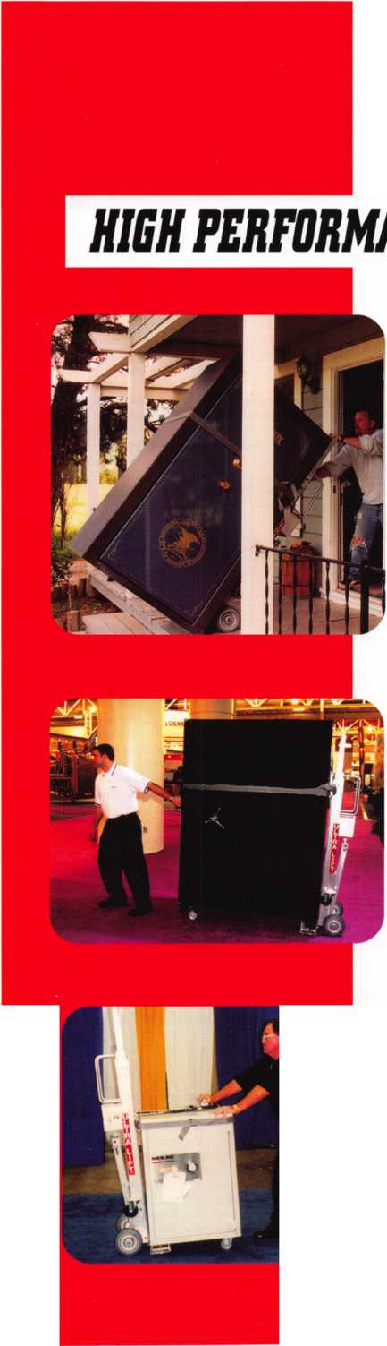

DRESS CODE COMMENTS

On the Road  
w i th th e Board

I wish to express my concern for many new policies that are beginning to trouble me. It appears as the board of directors has seen fit totake the position of knowing what is better or best for everyone. I amin regard to a "dress code" though I agree in theory. Just where does this begin and where does it end? I do not need to tell you that locksmiths in general are very independ­ent people. If we begin to tell people what to do, what is next? Shall we determine diet and exercise while also attending events? Most of us are rather large and also smoke. I do not smoke- however I find it VERY offensive to walk through clouds of smoke to get to the trade show or other events during ALOA at convention time. Maybe we need a non-smoking policy, too. This would also qualify as exercise because one always has to walk plenty to get to the events, so I think that is already covered. This is also going to be Las Vegas where is it hotter than Hell in July. SOme might appreciate wearing shorts and showing off their hairy legs, if that are also large (fat). Now let's go back to diet. Lets assume we have not consumed healthy food at the high priced concessions and now need to relieve ourselves. Shall ALOA also determine when and where we also take a crap too? Speaking of crap if we are no longer supposed to wear T-shirts shall we stop passing them out or rather selling them as a fundraiser for the opening auction for the ALOA Scholarships> We should lead by example. Instead maybe we should pass out Tuxedo shirts and cute little ties instead. And do not forget lets ban all T-shirts like Mede- co, Kaba, and the like along with the hundreds on display at the nostalgia booth. After all it might make us look like some of the sloppy pigs that we are. What about all those hats given away after all only Ladies should wear a hat indoors and I mean a hat not a baseball cap that has some lock company name screen-printed on it. Lets not forget the alcohol served shall we plug the tap? Then when we are all crocked and pooped from the party Vegas is the land of Whores let also set a policy for when and whom we sleep with. Frankly who the hell has been running the show (ALOA) that it has been allowed to get to this current point of disarray? I go to the ALOA when I can afford to do so. I am not some rich old man, notice I said MAN not woman. Nor do I have employees to leave in charge. So when I go I need to balance my busi­ness and pleasure in one single event for the year. WHen I go I want to have a nice time. Had I learned of your revised membership policy until after my renewal I probably would not have done so. Adding a dress code in which again I believe in theory but find offensive. I may not have sent the registration recently, had I not booked arrangements well in advance. I guess I could still have a good time doing something else like swimming in a hotel pool and doing what I damn well please. I again and one person and believe there mabe more that also feel this way but would not let it be known. I believe in high integrity regardless for my trade and cus­tomers with or without ALOA. A locksmith no more or less of a person because one belongs to a group or organization. Such as a person is not more or less religious whether he or she belongs to organized religion. My customers pay me for the level and quality of service they receive and for what I provided to them. In most cases what I am wearing is irrelevant. So if it is 3 A.M. and I am wearing my jammies and fuzzy bunny slippers to a lockout and if other service providers fail to answer the call or bother to show up at all who looks bad now? The customer is grateful and pays the bill and will recommend to others on the service provided. I have oth­er customers where this may not be appropriate and they would be treated accordingly. The customer writes the paycheck. I am offended by the new membership policy of adding a des­ignation to remain in the club and now be bossed around and told what and how to do it (wear it). I am the customer (member) and I am pissed and I write your check. And at this point I may not be writing anymore. What value and level of service am I actually receiving? For many years my own view has been ALOA as an overpriced monthly magazine. I am still looking for that value and carefully consider that every year upon renewal. I now have what I perceive right or wrong less value and more concern. I chose this trade because of the independence and opportunities it has to offer, I wish ALOA had the same. I believe the word would be diver­sity or inclusive not exclusive. It appears to be and for some type of elite creature. I may not be that creature. So unless you plan a grand education enlightenment for the public as well your efforts shall be for not and we will only be making an impression each other. I already have mine. I would appreciate a response to myconcerns. Or stop by the pool.

RESPONSE

Recently I had the privilege of communicating with a member who had written to the ALOA office expressing his concerns about the recent policy changes concerning a dress code for the ALOA convention and Events, and the changes to the ALOA PRP Certification requirements. His letter was full of good points and examples of tongue-in-cheek humor as well as genuine concern for changes that he wasn't sure was going to be accept­ed by the membership or himself without explanation. As is often is the case, the staff passed the member's let­ter on to the board for our information, review, and possible reply. After consultation with our President, Bob Mock, and other members of the board, I asked to be the one to respond to this member's concerns. After I did so, I realized that if th... one person took the time to write and express his feelings, that there are likely oth­ers that feel the same way. What I said to this member is exactly what I would like to say to all the member­ship about these recent policy changes. As I do not have his permission to use his letter or name, (and under no circumstances would I want to offend this member by using his name and letter without that permission,) I will only include my reply to him minus any reference to his identity. Just consider that this is what I would like to say to any of you, and what the ALOA board would like to have all members know.

Dear (name withheld).

I am the Current South Central Regional Director of ALOA. Your name is familiar to me. It is quite possible that I have met you at (one of the many trade shows I have attended) in any one of the last few years. I have read the letter you sent to our Executive Director, Charles Gibson. He has circulated your letter to the Board of Directors so that we may see the impact of our decisions. I have communicated with our President, Bob Mock, and others on the board about your letter. With their permission and agreement, I am writing to respond to your concerns about the newly instituted dress code, and Industry Certification requirements.

To paraphrase your own words, you have wondered for years what the value of ALOA mem­bership was other than that of an "Over-priced magazine". You are not the only one that has felt like we should be getting more for our membership dues. The board feels this way also. These rule changes are part of the ALOA Board's effort to rectify that. The ALOA board has decided that we will make the ALOA name worth something more than it is today. This means upgrading both the physical appearance of it's members starting at convention, and the train­ing requirements necessary to be a member. This is a work in progress and will take some time to accomplish, but we feel it has to be done.

It is hard to be taken seriously as a skilled trade organization if the only requirement for mem­bership is the money to pay the yearly dues. It is hard to be taken seriously as an industry leader if one lets its members walk the convention floor before the world and everybody else wearing attire more suitable for the beach or watching TV. When board members have attended other industry related trade shows, we find that the attendees dress in "Business Casual" attire. This usually means slacks and a collared shirt of some type. We have not gone quite that far. In the past, we have had terrible examples of members that attended wearing cut-off jeans, flip-flops, and undershirts or tee-shirts printed with every kind of obscenity, course language, or risque picture. Thankfully, there has not been an extremely large number of such attendees each year, and over the years, this situation has gotten better. However, it is a matter of a small disruptive few causing rules to be placed on everyone.

The ALOA board well understands the independent nature of locksmiths. After all, we all are working locksmiths and business owners. More than one of the board are one man shops and many others like me, have small 2 to 4 person businesses. Most of us still work with our tools and deal with customers on a daily basis just like you do. Personally, I am a bit of an Anarchist- at-heart (like I feel most real locksmiths to be). I hate change, and I resent even the law of grav­ity. However, as part of a board responsible for the advancement and well-being of a large association, we must put aside our personal feelings in order to best serve the majority of our members. As a board, we feel that it is our sworn duty to make this organization into some­thing worthy of your membership. We feel that we would be poor stewards of the responsibil­ity given us by the ALOA membership if we did not try to make this association better. We have made some positive changes, and we feel that these are some of them.

The goal of the ALOA board is to make the name of ALOA mean something positive to man­ufacturers and distributors in our industry. Our industry is under extreme competitive pressure from many sides and is constantly changing. To deal with this, we eventually want to turn out a well trained and certified membership worthy of having the public's confidence. To do so, we have had to start somewhere. We already have the finest training classes in the world and the finest membership in the world to work with. Now, we have to package that membership and present it to the world in a better manner than we have in the past. These changes are part of an effort by the ALOA leadership to make our membership more attractive to the manufac­turers, distributors and even the public so that they feel confident in using an ALOA member rather than someone else to do their service work and maintain their security. This is our sin­cere effort to make the ALOA name mean something more and thus increase it's value to our membership.

When instituting these policy changes, the ALOA board considered the possibility that we might have some attendees that would refuse to abide by these changes, and that we might even lose some members because of them. However, it was our feeling that the increased val­ue of a well trained, and professional looking membership would attract new members to off­set what few losses we might incur. We also feel that most of the present ALOA members will stand behind our efforts to change the way things have been, and recognize the value of the changes we propose. These loyal members will remain and form an even stronger core for our association to build on. We certainly hope you are one of these members that feel that reforms need to be done, and things need to be made better. We hope that you decide to stay with the association and attend this upcoming wonderful convention. We need you, and we hope you feel that you are better off with us than without us. We are all in this together. I am

Respectfully,

C.D. Lipscomb, CML,CPS

Keynotes • June 2006

ASSA ABLOY

**The World's Leading Lock Group**

SINCE 1880

**iO** ABLOY jhatsm

m " ***^^LOCK&*** DOOR HARDWARE

**^^ERICAN ORV°^**

**-tccuritron- Yale medeoo**

**Russwin^**

**T**

I MUL T

-LOCK®

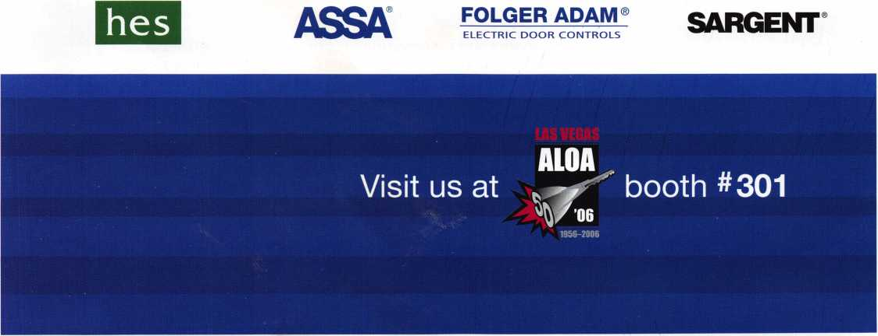

**Adesco Fi reking/Gary Meilink**

l/or safes that fit every need and budget, count on the trusted

BRANDS OF FlREKlNG® SECURITY GROUP. ADESCO® OFFERS SAFES FOR GOVERNMENT, COMMERCIAL AND RESIDENTIAL CUSTOMERS. MEILINK® PROVIDES FIRE- AND BURGLARY-RATED SAFES FOR BANKS, SCHOOLS AND RETAIL ESTABLISHMENTS. AND FlREKlNG FEATURES UL®-RATED FIRE/ IMPACT/BURGLARY RESISTANT SAFES BACKED BY OVER 50YEARS OF SECURITY EXPERIENCE. PLUS, EACH BRAND COMES WITH EXCLUSIVE 24**/**7/365TECHNICAL SUPPORT. SO FIND OUT MORE ABOUT FlREKlNG SECURITY GROUP. YOUR CUSTOMERS TRUST YOU TO RECOMMEND THE BEST. TRUST US TO PROVIDE IT.

at

**FireKing**

<5Fr IIRITY RRm IP ^

SECURITY GROUP

[www.fireking.com](http://www.fireking.com)

